COMP 1011 Programming Fundamentals

Assignment Three - Group Project

Title: Hotel Management System (C program)

Group Member: Siu Lok Man Lian (14040502D)

Content

* Introduction
* Complete requirement specification
* Program design
  + 1. Functions and variables
    2. Pseudo code
* Debugging report
  + 1. Testing strategy
    2. Test cases

Introduction

This program is about the simulation on the basic operations on hotel management. The program will run as the front desk in a hotel and can serve both customers and administrators by providing different services. Admins are allowed to view the internal information of the hotel and can at the same time serve the customers. However, customers can only select the services provided, without the authority to view any internal data of the hotel.

Since this program is aimed to simulate a front desk service in the hotel, there are less complicated factors affecting the hotel management environment. This is the reason why the hotel can only provide limited services which is different from the reality. (E.g. Hotel restaurant only provides set-meal, hotel rooms only provide basic services, etc.)

To facilitate the debugging and building process of the program, and the understanding of the users, assumptions which may not be very close to reality are made to fit this simple system. This program is already built as flexible as possible in order to enhance its maintenance efficiency with lowest time cost. The details of the assumptions are stated clearly in the next session and also in the beginning of the program.

Program requirements

**General requirements on:**

Hotel

* Hotel front desk simulation (the program)
* Hotel has:
* a name
* an address
* rooms (can be removed or added)
* a restaurant
* Hotel restaurant provides one kind of meal only (a set meal costs HK$50)
* Provide basic services:
* check-in
* check-out
* dine (HK$50.0/set meal)
* club

Hotel rooms

* Every room has:
  + - A room number
    - A room type (Luxury/Standard)
    - A telephone
    - Two single beds or a twin bed
* Luxury room:
* Long distance calls available (HK$5.0/min)
* Local phone calls available (HK$0.5/min)
* Cocktail bar available (HK$90.0/wine)
* Club entrance available (HK$50.0/visit)
* Standard room:
* Local phone calls available (HK$0.5/min)
* All rooms rates HK$700/day (with daily 10% room service charge)
* Only cash payment is acceptable (no credit card is accepted)

Users

* Program will ask if user is the admin at the beginning of the program
* All names besides “admin” are considered as a customer
* Provide internal services for both admins and customers:
* Check-in
* Check-out
* Dine (set-meals ordering)
* Make a phone call
* Wine ordering
* Club entrance
* Role switching
* Quit the system
* Provide internal services only for admins:
* find room numbers
* find room occupiers
* view customers’ information
* view hotel’s information
* view hotel room’s information
* build or remove room(s)

Database/records on data

* Hotel database set as a structure in the program
* Room database set as a nested structure in the program
* Customer database set as a structure in the program
* Customers’ and hotel’s data (e.g. accumulated charges on customers, room vacancies and total room numbers, etc.) will be stored in two text file separately

Check-in:

* Customer must provide his/her:
* Name
* Address
* ID/Passport number
* Check-in date

Check-out:

* Customer must provide his/her:
* Check-in date

**Assumptions:**

* Customers check-in and check-out in the same month
* There are 31 days in the month
* For facilitate debugging and testing, there are already some customers checked-in and the data in stored in customerSim.txt , the rooms information (vacancies, room distribution, etc.) are stored in hotelSim.txt
* User should set the file location with the file containing the above two text files BEFORE executing the program in order to load the data into the program (set at line 53, 55, 104, 1117, 1119, 1120, 1127, 1128)
* The file name in swapPath (at line 54) should be named similar to customerSim.txt (e.g. customerSim2.txt)
* Hotel’s information including hotel names, address, restaurant names, initial total number of rooms, number of luxury and standard rooms, are stated at line 85
* In fact, only the name, address and the restaurant name of the hotel are needed in the program as the updated room numbers and vacancies details are loaded using the text file
* User should set the hotelPath (at line 55) as the file containing the file hotelSim.txt
* Initially, half of the total rooms will be standard type and the other half will be luxury type
* The maximum number of the rooms is assumed to be 100, and that’s why the integer arrays are set with size 100 (can be modified)
* Room numbers counts from 101 (the first room) to 200 (the 100th room), assumed that the number of rooms is 100
* New customers can choose a specific room type and bed type once the beds and rooms are available
* If number of available rooms are more than 1, the room numbers will be generated randomly
* For the initially built rooms, room numbers of standard rooms came first than those of luxury rooms, but it won’t limit the newly built rooms
* In the assumed case, room 101-110 will be standard type, 111-120 will be luxury type
* Since the bed types cannot change rapidly in the same room, it is assumed that all even room numbers are with a twin bed and those odd room numbers are with two single beds
* The number of standard rooms and luxury rooms can be modified at line 85, or user can directly modify in the text file as the updated rooms data will be loaded from the text file
* E.g. in the assumed case:
* 20 rooms in total
* 10 for luxury
* 10 for standard
* Room numbers: 101-110 (standard), 111-120 (luxury)

Program Design

**Functions and variables**

There are 30 functions in total, 6 global variables and 2 structures set for storing the hotel’s and customers’ records. The functions are divided into four groups and they will be explained in details in next part.

1. File opening functions (Writing and reading from text files)

|  |  |
| --- | --- |
| Functions | Function features |
| customerWrite() [line 102] | 1. called at the end of the program 2. write the current updated customers’ records in the program into a text file with the path same as the one used in the next time at file opening (set as customerSim.txt in this case) |
| hotelWrite() [line133] | 1. called at the end of the program 2. write the current updated hotel rooms’ data in the program into a text file with the path same as the one used in the next time at file opening (set as hotelSim.txt) |
| hotelInput() [line 312] | 1. called at the beginning of the program 2. open the text file storing the updated hotel rooms’ data and load them into the program for further operations |
| customerInput() [line 418] | 1. called at the beginning of the program 2. open the text file storing the updated customers’ records and load them into the program for further operations 3. return a number, indicating the number of customers currently in the hotel |

1. Coordinating system functions

|  |  |
| --- | --- |
| Functions | Function features |
| sortArray (array, total number of items in array)  [line 118] | 1. function used to sort the room numbers before writing into the text file 2. return 0 |
| input_Check (input)  [line 206] | 1. called to validates user’s input when program asked for user’s confirmation 2. return 1 (input is “Y”)/0 (input is “N”)/2 (input is not “Y” or “N”) 3. return 2 but not NULL because it is defined that NULL is 0 |
| removeRoomNum  (array, total, room number)  [line 470] | 1. called to remove a specified room number from an array given in the parameter 2. return 0 |
| findCustomer (customer name) [line 488] | 1. called to find customer index before doing any other operations 2. returns a value, indicating customer index (if return 1, it means customer has a record at line 2 of the text file/2nd record in the program) |
| customerSort (total of customerse)  [line 534] | 1. called when customers’ information display is required 2. this function sort the customers’ record according to alphabetic order of their names and print the sorted result after sorting 3. return 0 |
| newRoom (room number, room type) [line 663] | 1. function used to insert new room numbers into the given array in the parameter 2. return 0 |
| rand_Room (array, total, bed type)  [line 807] | 1. used to generate a random room number from an array storing the room numbers 2. the array is given in the parameter, bed type is used to determine whether the generated number can fits the bed requirement (if user chose twin bed, room number should be even) 3. returns room number successfully generated |
| checkDate (date) [line 1085] | 1. called to validates the date input from user (given in parameter when function is called) 2. date should be in string format (Day xx) 3. return 0 if input is valid/1 if invalid |
| customerRemove (customer name, room number)  [line 1102] | 1. called to remove a customer record from the customer text file with a particular customer name and his/her room number (given in parameter) 2. return 0 |
| customerAppend (customer name, address, id, check-in date, room number) [line 1277] | 1. called to append a new row of record into the customer text file with customer’s personal information (given in parameters) 2. return a value, indicating the customer index of the customer newly added |

1. Program Logic functions

|  |  |
| --- | --- |
| Functions | Function features |
| findType(room number)  [line218] | 1. Called to find the room type of a room number (given in the parameter) 2. Return the found room type of the room |
| findBed (room number)  [line 249] | 1. Called to find the bed type of a room number (given in the parameter) 2. Return the found bed type of the room |
| roomInfo (room number)  [line 264] | 1. Called to display the details of a room (room number given in the parameter) 2. Return 0 |
| customers (number of customers)  [line 584] | 1. called when admin choose to display all customers’ information 2. Call another function to sort and print the result 3. Return 0 |
| hotelInfo()  [line 594] | 1. called when admin choose to view hotel’s information 2. Return 0 |
| findRoom (customer name)  [line 607] | 1. called to find the room number of a particular customer by his/her name (given in the parameter) 2. Return 0 |
| findOccupier (room number)  [line 620] | 1. called to find the room occupier of a specified room (given in the parameter) 2. Return 0 |
| buildNewRoom (room type)  [line 679] | 1. called when admin choose to build a new room in the hotel due to expansion 2. Return 0 |
| removeRoom (room number)  [line 735] | 1. called when admin choose to remove a particular room in the hotel due to renovation 2. Return 0 |
| enter_club (customer name, room number, customer index)  [line 835] | 1. called when user choose to enter the club 2. only available to customers in luxury rooms 3. Return 0 |
| drink (customer name, order amount, customer index)  [line 887] | 1. called when user choose to order wine 2. only available to customers in luxury rooms 3. Assumed that maximum order each time is 10 bottles 4. Return 0 |
| phone_call (customer name, duration of call, customer index)  [line 952] | 1. called when user choose to make a phone call 2. Local call available for all customers 3. Long distance phone call only available to customers in luxury rooms 4. Return 0 |
| dine (customer name, order amount, customer index)  [line 1031] | 1. called when user choose to order set-meal(s) in hotel restaurant 2. Assumed that maximum order each time is 5 set-meals 3. Return 0 |
| check_out (customer name, check-out date, customer index, number of customers)  [line 1161] | 1. called when user choose to check-out 2. check-out date must be stated 3. Return 0 |
| check_in (customer name, check-in date, customer index)  [line 1306] | 1. called when user choose to check-in, check-in date must be stated 2. Customer’s name, address, ID/Passport must be provided 3. Customer can choose the room type and bed type if rooms are available |

1. Main function

|  |  |
| --- | --- |
| Function | Function features |
| main()  [line 1496] | 1. Simulating a front desk of a hotel 2. mainly used for displaying menu and provide service selection to users 3. Call function to input/load the updated data into the program before menu display 4. Provide available services (showed in a menu) to user 5. Display different menu between customers and admins 6. Return 0 (after user choose to quit) |

**Pseudo code**

1. File opening functions (Writing and reading from text files)

|  |  |
| --- | --- |
| Function | Pseudo code |
| customerWrite()  [line102] | 1. Create file pointer  2. Open the file for writing  3. FOR each customer in customer records  (i) write the name, address, id, check-in date, room number, room extra  charges and room fee in the same line with each of the element separate by  “#”  4. Close file pointer |
| hotelWrite()  [line 133] | 1. Create file pointer 2. Open the file for writing 3. IF file pointer if NULL   (i) Print error message   1. Write the statistics of room numbers in the same line 2. Call function to sort the arrays of room numbers 3. Use FOR loops to write the data into 7 arrays 4. Close file pointer |
| hotelInput()  [line 312] | 1. Create file pointer 2. Initialize row, tok pointer, count=0, nex=false 3. Open the file for reading 4. IF file pointer is NULL   (i) Print error message   1. Use WHILE loop to write all data in all room number arrays into different lines 2. Close file pointer |
| customerInput()  [line 418] | 1. Create file pointer 2. Initialize line, split pointer, count=0 3. Open the file for reading 4. IF file pointer is NULL   (i) Print error message   1. Use WHILE loop to read every row of customer’s record and store customer’s data into variables in customer’s structure 2. Close file pointer |

1. Coordinating system functions

|  |  |
| --- | --- |
| Function | Pseudo code |
| sortArray (array, total number of items in array)  [line 118] | 1. FOR each (total number-1)  (i) FOR each (total number-1)  (ii) IF j+1-th item in the array is smaller than j-th item  (iii)Swap them |
| input_Check (input)  [line 206] | 1. IF input is “Y”   (i) Return 1   1. ELSE IF input is “N”   (i) Return 0   1. ELSE   (i) Return 2 |
| removeRoomNum (array, total, room number)  [line 470] | 1. Initialize c, r 2. FOR each room number in the array   (i) IF room number equals the room number in the array  (i) Use FOR loop and IF statement to move every item after that item  forward |
| findCustomer (customer name)  [line 488] | 1. Create file pointer 2. Initialize line, split pointer, x=0, name, room, check=false, chec=false 3. Open the file for reading 4. IF file pointer is NULL   (i) Print error message   1. Use WHILE loop to read every row of customer’s record   (i) IF customer record’s name matches the parameter’s customer name  (ii) Set check to true, x is now the row number   1. IF check is FALSE   (i) Use FOR loop to search every record in the program  (ii) IF match case found  (i) Set x to row number  (ii) Set chec to TRUE  (iii) IF chec is FALSE  (i) Set x to 9999v   1. Close file pointer 2. Return x |
| customerSort (total of customerse)  [line 534] | 1. Create a structure with just name inside, structure named copy 2. Initialize r, order array 3. Use FOR loop to copy all customer’s name to copy 4. Initialize cpy array, a, y, z 5. Use FOR loops and IF statement to search if cpy[z-1] has a higher alphabetic order compare with cpy[z], if yes, swap their order index and swap in cpy[] 6. After sorting, print out all customer records using the order array’s index on sorted customer index |
| newRoom (room number, room type)  [line 663] | 1. IF type is “Standard”   (i) Increment on h.standardAvailable and totalStandard  Insert the room number to the end of arrays h.availableStandard and  h.standardRoomNumbers  ELSE  (i) Increment on h.luxuryAvailable and totalLuxury  Insert the room number to the end of arrays h.availableLuxury and  h.luxuryRoomNumbers |
| rand_Room (array, total, bed type)  [line 807] | 1. Using srand(time(0)) for rand() at next step 2. Initialize num=0, ok=false 3. IF bed type is “Twin”   (i) WHILE ok is FALSE  (ii) Generate new room number  (iii) IF new number is even  (iv) Set ok to TRUE  (v) Return num  ELSE IF bed type is “Two Single”  (i) WHILE ok is FALSE  (ii) Generate new room number  (iii) IF new number is odd  (iv) Set ok to TRUE  (v) Return num |
| checkDate (date)  [line 1085] | 1. Initialize day, buffer, ret=1 2. Use FOR loop to check of date format is valid   (i) IF valid case found  (i) Set ret to 0   1. Return ret |
| customerRemove (customer name, room number)  [line 1102] | 1. Create file pointers 2. Initialize line, split pointer, name, cpy, newLine, empty=NULL, swap, len, x=1 3. Use IF-ELSE statement to set currentPath to the most updated text file 4. Open the two files for reading and writing separately 5. Swap currentPath and swapPath 6. IF input file pointer is NULL AND output file pointer is NOT NULL   (i) Print error message   1. Use WHILE loop to search every line and search for required customer’s line   (i) IF customer is found in that line  (i) Replace that row with empty (NULL)   1. Close the two file pointers 2. Decrement on customerCount (global variable used to count current customer number in the hotel) |
| customerAppend (customer name, address, id, check-in date, room number)  [line 1277] | 1. Create file pointer 2. Open the file for appending 3. Append all the customer’s data specified in the parameters in the same line, separate by a “#” and end the line with a “\n” 4. Close the file pointer 5. Increment on customerCount 6. Initialize w=0 7. Call function to find customer index for the newly added customer and store the returning value to w 8. Copy the registered customer’s information to the variables in the customer structure, used within the program 9. Return w, indicating the customer index of the newly added customer |

1. Program Logic functions

|  |  |
| --- | --- |
| Function | Pseudo code |
| findType(room number)  [line218] | 1. Initialize ty, lux=false, std=false 2. Use FOR loop to search the room number in both arrays storing the room numbers with different types   (i) IF room number found in h.luxuryRoomNumbers  Set lux to TRUE  (ii) IF room number found in h.standardRoomNumbers  Set std to TRUE   1. IF lux is TRUE   (i) Copy the string “Luxury” to ty  ELSE IF std is TRUE  (i) Copy the string “Standard” to ty  ELSE  (i) Copy the string “ERROR” to ty   1. Return ty |
| findBed (room number)  [line 249] | 1. Initialize bed 2. IF room number is even   (i) Copy the string “Twin” to bed  ELSE IF room number is odd  (i) Copy the string “Two Single” to bed   1. Return bed |
| roomInfo (room number)  [line 264] | 1. Initialize exist=false 2. IF room number is greater than or equals to 101   (i) Use FOR loop to search if room number can be found in the  array storing all room numbers  (i) IF match case found  (i) Set exist to TRUE  (ii) IF exist is TRUE  (i) Initialize occ, typ, bed, r  (ii) Print room number  (iii) Call function to find bed and room type  (iv) Print found details  (v) Use FOR loop to search if room is currently available or  occupied  (vi) Print the result  ELSE  (i) Print error message (invalid room number) |
| customers (number of customers)  [line 584] | 1. Print the stars (for nice-looking format) 2. Print the statement telling user customers are sorted in alphabetic order 3. Call function to sort the customers’ records and print the result 4. Print the stars again |
| hotelInfo()  [line 594] | 1. Print the stars (for nice-looking format) 2. Print the hotel information with hotel structure’s variables 3. Print the stars again |
| findRoom (customer name)  [line 607] | 1. Initialize d 2. Call function to find customer index and store the returned value in d 3. IF d is not 9999 (no record in program)   (i) Print searching result  ELSE  (i) Print error message |
| findOccupier (room number)  [line 620] | 1. Initialize occupier, r, I, k, host=NULL, exis=false 2. Use FOR loop to search the array containing all room numbers to check if room number entered is valid and exist   (i) IF match case found (anyone in the array matches room  number)  (i) Set exis to TRUE (room exists)   1. IF (room number greater than or equal to 101) AND   (it is smaller than or equal to 100+total number of rooms) AND  (exis is TRUE)  (i) Use FOR loop to search the available room numbers array  (i) IF match case found (anyone in array matches room  number)  (i) Set host to 1  (ii) IF host is 1 (room is available)  (i) Print result message  (iii) ELSE (room is occupied)  (i) Use FOR loop to search over customer’s record  (ii) IF any customer’s room number matches the given one  (i) Print result message with that customer name  ELSE  (i) Print error message (invalid room number) |
| buildNewRoom (room type)  [line 679] | 1. Initialize confirm, newRoomNumber=0 2. IF (room type is “Standard”) OR (room type is “Luxury”)   Ask for user’s confirmation on building the new room  Call function to validates user’s input and get the returned value  (i) IF returned value is 1 (input is “Y”)  (i) Initialize roomCpy  (ii) Increment on hotel total rooms number  (iii) Increment on hotel available room numbers  (iv) Use FOR loop to copy all room numbers to roomCpy for  sorting  (v) Call function to sort array roomCpy  (vi) Initialize q=0  (vii) Use WHILE loop to find if any room numbers has been  skipped  (i) Increment on q if numbers did not skipped  (ii) WHILE loop will stop when a number is skipped or all  numbers did not skipped  (viii) Set newRoomNumber to 102+q  (ix) Update the arrays with the newRoomNumber  (x) Call function to insert newRoomNumber into appropriate  arrays according to room type  (xi) Print result message  (ii) ELSE IF returned value is 0 (input is “N”)  (i) Print result message (cancel to build a room)  (iii) ELSE IF returned value is 2 (input is not “N” or “Y”)  (ii) Print input error message and recall this function  ELSE  (i) Print error message (Invalid input) |
| removeRoom (room number)  [line 735] | 1. Initialize confirm, own=false 2. IF (room number is greater than or equals to 101) AND   (it is smaller than or equals to 100+total number of rooms)  (i) Use FOR loop to search the occupied room numbers array  (i) IF match case found (anyone in array matches room number)  (i) Set own to TRUE  (ii) IF own is TRUE (room is occupied)  (i) Print error message (room is occupied, cannot be removed)  (iii) ELSE (room is available)  (i) Ask for user’s confirmation on removing the room  (ii) Call function to validates user’s input and get returned  value  (iii) IF returned value is 1 (input is “Y”)  (i) Initialize find=false  (ii) Use FOR loop to search the standard rooms array  (iii) IF any match case found (it is a standard room)  (i) Set find to TRUE  (iv) IF find is TRUE  (i) Decrement on standard available room numbers  (ii) Decrement on total standard room numbers  (iii) Call function to remove the room number of the  (iv) removed room from the standard rooms’ arrays  (v) ELSE (it is a luxury room)  (i) Decrement on luxury available room numbers  (ii) Decrement on total luxury room numbers  (iii) Call function to remove the room number of the  (iv) removed room from the luxury rooms’ arrays  (vi) Call function to remove room number of the removed  (vii) room from all room numbers array and the rooms  available array  (viii) Decrement on total room numbers  (ix) Decrement on available room numbers  (x) Print result message  (iv) ELSE IF returned value is 0 (input is “N”)  (i) Print result message (cancel to remove a room)  (v) ELSE IF returned value is 2 (input is not “N” or “Y”)  (i) Print input error message and recall this function |
| enter_club (customer name, room number, customer index)  [line 835] | 1. Initialize entranceCost=50, confirm, rmn=0 2. Set rmn to the integer format of customer’s room number 3. IF (customer index is not 9999) AND (room number inputs match)   (i) IF customer’s room type is “Luxury”  (i) Print message showing entrance cost  (ii) Ask for user’s confirmation  (iii) Call function to validates user’s input and get returned value  (iv) IF returned value is 1 (input is “Y”)  (i) Add entrance cost to customer’s room charges  (ii) Print result message  (v) ELSE IF returned value is 0 (input is “N”)  (i) Print result message (cancel club entrance)  (vi) ELSE IF returned value is 2 (input is not “N” or “Y”)  (i) Print input error message and recall this function  (ii) ELSE IF customer index is 9999  (i) Print error message (customer has not checked-in)  (iii) ELSE IF room number inputs did not match  (i) Print error message (Invalid membership number)  (iv) ELSE  (i) Print error message (Invalid input) |
| drink (customer name, order amount, customer index)  [line 887] | 1. Initialize wineCost=90, totalCost=0, confirm, room 2. Ask for user’s membership number 3. IF (customer index is not 9999) AND   (order amount is valid (1-10)) AND  (membership number matches customer’s room number)  (i) IF customer’s room type is “Luxury”  (i) Calculate total cost of wine ordering  (ii) Print total cost  (iii) Ask for user’s confirmation  (iv) Call function to validates user’s input and get returned value  (v) IF returned value is 1 (input is “Y”)  (i) Add total cost to customer’s room charges  (ii) Print result message  (vi) ELSE IF returned value is 0 (input is “N”)  (i) Print result message (cancel to order wine)  (vii) ELSE IF returned value is 2 (input is not “N” or “Y”)  (i) Print input error message and recall this function  (ii) ELSE  (i) Print error message (cocktail bar is not available)  ELSE IF customer index is 9999  (i) Print error message (customer has not checked-in)  ELSE IF room number inputs did not match  (i) Print error message (Invalid membership number)  ELSE IF order amount is less than or equals to 0  (i) Print error message (Invalid order amount)  ELSE IF order amount exceeds 10  (i) Print error message (maximum order amount is 10)  ELSE  (i) Print error message (Invalid input) |
| phone_call (customer name, duration of call, customer index)  [line 952] | 1. Initialize localCost=0.5, longdisCost=5, choice=0, confirm, totalCost, gt 2. IF (customer index is not 9999) AND   (duration of phone call is valid (1-60))  Print local phone call rate  (i) IF customer’s room type is “Luxury”  Print long distance phone call rate  Ask for user’s choice on phone call  Get and convert user’s choice in integer format, store at choice  (ii) ELSE  Set choice is 1  (iii) IF (choice is 1) OR (choice is 2) (valid choice)  (i) IF choice is 1  (i) Calculate total cost for local phone cost  (ii) Print total cost  (ii) ELSE IF choice is 2  (i) Calculate total cost for long distance phone cost  (ii) Print total cost  (iii) Ask for user’s confirmation  (iv) Call function to validates user’s input and get returned value  (iv) IF returned value is 1 (input is “Y”)  (i) Add total cost to customer’s room charges  (ii) Print result message  (vi) ELSE IF returned value is 0 (input is “N”)  (i) Print result message (cancel to make a phone call)  (vii) ELSE IF returned value is 2 (input is not “N” or “Y”)  (i) Print input error message and recall this function  (iv) ELSE  (i) Print input error message (input should be 1/2)  (ii) Recall this function  ELSE IF customer index is 9999  (i) Print error message (customer has not checked-in)  ELSE IF input is not a number  (i) Print error message (Invalid number)  ELSE IF order amount is less than or equals to 0  (i) Print error message (Invalid duration number)  ELSE IF order amount exceeds 60  (i) Print error message (maximum duration is 60)  ELSE  (i) Print error message (Invalid input) |
| dine (customer name, order amount, customer index)  [line 1031] | 1. Initialize cost=50, total=0, confirm 2. IF (customer index is not 9999) AND   (order amount is valid (1-5))  (i) Calculate total cost of set-meal(s) ordering  (ii) Print total cost  (iii) Ask for user’s confirmation  (iv) Call function to validates user’s input and get returned value  (v) IF returned value is 1 (input is “Y”)  (i) Add total cost to customer’s room charges  (ii) Print result message  (vi) ELSE IF returned value is 0 (input is “N”)  (i) Print result message (cancel to order set-meal(s))  (vii) ELSE IF returned value is 2 (input is not “N” or “Y”)  (i) Print input error message and recall this function  ELSE IF customer index is 9999  (i) Print error message (customer has not checked-in)  ELSE IF input is not a number  (i) Print error message (Invalid number)  ELSE IF order amount is less than or equals to 0  (i) Print error message (Invalid order amount)  ELSE IF order amount exceeds 5  (i) Print error message (maximum order amount is 5)  ELSE  (i) Print error message (Invalid input) |
| check_out (customer name, check-out date, customer index, number of customers)  [line 1161] | 1. Initialize outday pointer, inday pointer, backupDate, rmNum, confirm, displayFee=0, na, tempDate 2. Use string operations to copy the dates for back up and break them into tokens to get day number 3. IF (customer index is not 9999) AND   (check-out is valid (not earlier than check-in date))  (i) Print the details of payment  (ii) Ask for user’s confirmation on check-out  (iii) Call function to validates user’s input and get returned value  (iv) IF returned value is 1 (input is “Y”)  (i) Increment on hotel available room numbers  (ii) Insert back the room number (of the customer checking-  out) into available room numbers array  (iii) Call function to remove room number from occupied room  numbers array  (iv) IF customer’s room type is “Luxury”  (i) Increment on hotel luxury available room numbers  (ii) Insert back the room number into available luxury room  (iii) numbers array  (v) IF customer’s room type is “Standard”  (i) Increment on hotel standard available room numbers  (ii) Insert back the room number into available standard  room numbers array  (vi) Call function to remove customer record in the text file  (vii) Use FOR loop to search for customer’s record in the  program and modify the customers’ record by moving  those after current customer’s forward  (viii) Call function to write the updated customer record into the  text file  (ix) Print result message  (v) ELSE IF returned value is 0 (input is “N”)  (i) Print result message (cancel to check-out)  (vi) ELSE IF returned value is 2 (input is not “N” or “Y”)  (i) Print input error message and recall this function  ELSE IF customer index is 9999  (i) Print error message (customer has not checked-in)  ELSE IF check-out date is earlier than check-in date  (i) Print error message (Invalid check-out date)  ELSE  (i) Print error message (Invalid input) |
| check_in (customer name, check-in date, customer index)  [line 1306] | 1. Initialize type, bed, twin=0, single=0, checkroom=false, checkbed=false, confirm 2. IF (customer index is 9999) AND   (hotel’s rooms available is greater than 0) AND  (customer name is valid) (not a space or empty)  (i) Ask for user’s choice on room type  (ii) IF input is valid (“S” or “L”)  (i) IF input is “S”  (i) IF standard rooms available is greater than 0  (i) Copy string “Standard” to type  (ii) Use FOR loop to search and count the number of  rooms with twin and single beds types  (i) IF room number is even  (i) Increment on twin  (ii) ELSE (odd)  (i) Increment on single  (iii) Set checkroom to TRUE  (ii) ELSE  (i) Print error message (No vacancies in standard rooms)  (ii) Recall this function  (ii) ELSE IF input is “L”  (i) IF luxury rooms available is greater than 0  (i) Copy string “Luxury” to type  (ii) Use FOR loop to search and count the number of  rooms with twin and single beds types  (i) IF room number is even  (i) Increment on twin  (ii) ELSE (odd)  (i) Increment on single  (iii) Set checkroom to TRUE  (ii) ELSE  (i) Print error message (No vacancies in luxury rooms)  (ii) Recall this function  (iii) IF checkroom is TRUE  (i) Print rooms available message  (ii) Ask user to choose bed type  (iii) IF input is valid (“T” or “S”)  (i) IF input is “T”  (i) IF twin is greater than 0  (i) Copy string “Twin” to bed  (ii) Set checkbed to TRUE  (ii) ELSE  (i) Print error message (No vacancies in twin bed)  (ii) Recall this function  (ii) IF input is “S”  (i) IF single is greater than 0  (i) Copy string “Two Single” to bed  (ii) Set checkbed to TRUE  (ii) ELSE  (i) Print error message (No vacancies in single beds)  (ii) Recall this function  (iii) IF checkbed is TRUE  (i) Print user choices  (ii) Ask for user’s confirmation  (iii) Call function to validates user’s input and get  returned value  (iv) IF returned value is 1 (input is “Y”)  (i) Initialize adr, id, room, buffer  (ii) Call function to generate room number with  specific room and bed type  (iii) Use WHILE loop to validates user’s input on  address and ID/Passport  (iv) call function to append customer record into  text file  (v) Update customer data and hotel’s data by  inserting new room numbers into arrays and  (vi) decrement on room numbers  (vii) Print result message  (v) ELSE IF returned value is 0 (input is “N”)  (i) Print result message (cancel to check-in)  (vi) ELSE IF returned value is 2 (input is not “N” or “Y”)  (i) Print input error message and recall this function  (iv) ELSE  (i) Print error message (input should be T/S)  (iii) ELSE  (i) Print error message (input should be L/S)  ELSE IF customer index is not 9999  (i) Print error message (customer has already checked-in)  ELSE IF hotel’s rooms available is 0  (i) Print error message (No vacancies)  ELSE IF customer name is invalid  (i) Print error message (Invalid customer name)  ELSE  (i) Print error message (Invalid input) |

1. Main function

|  |  |
| --- | --- |
| Function | Pseudo code |
| Main()  [line 1496] | 1. Call function to load the updated data on hotel’s rooms into the program 2. Call function to load the updated data on customers and get the returned value, stored in global variable customerCount 3. Print welcoming statement to introduce the system 4. Initialize role, cu, check=false, date, w=0, checkName=false 5. WHILE checkName is FALSE (until name input is valid)   (i) Ask user to enter current user’s name  (ii) IF name input is empty  (i) Print error message (Invalid name input)  (iii) ELSE IF name input is space(s)  (i) Print error message (Invalid name input)  (iv) ELSE (input is valid)  (i) Set checkName to TRUE (quit the WHILE loop)   1. WHILE quit is FALSE (until user choose to quit)   (i) WHILE check is FALSE (until choice input is valid)  (i) Initialize checkName1=false  (ii) Print current user name  (iii) IF role is “admin”  (i) Set w to 9999 (indicate admin has no customer record in the program)  (ii) Print the admin menu (available to admins only)  (iv) ELSE (role is not “admin”)  (i) Copy string role to variable cu  (ii) Call function to find customer index, store the return value to variable w  (v) Initialize ans, choice=0  (vi) Print service menu (available to both admins and customers)  (vii) Ask for user’s choice on service selection  (viii) Convert user’s input to integer format and store in variable choice  (ix) SWITCH (choice)  Case 100:  (i) Call function to print hotel information  (ii) Break  Case 200:  (i) Call function to print customers’ records in sorted order  (ii) Break  Case 300:  (i) Ask for user’s input on customer name  (ii) Call function to find customer’s room number  (iii) Break  Case 400:  (i) Ask for user’s input on room number  (ii) Call function to find room occupier  (iii) Break  Case 500:  (i) Ask for user’s input on room type of the room to be built  (ii) Call function to build a new room  (iii) Break  Case 600:  (i) Ask for user’s input on room number of the room to be removed  (ii) Call function to remove that room  (iii) Break  Case 700:  (i) Ask for user’s input on room number for room information access  (ii) Call function to search the room details and print the result  (iii) Break  Case 1:  (i) IF w is 9999 (customer has no record in the program)  (i) Ask for user’s input on customer name for check-in  (ii) IF name input is empty  (i) Print error message (Invalid name input)  (ii) Break  (iii) Call function to find customer index and store the returned value  to w  (ii) Ask user to input check-in date  (iii) Initialize val  (iv) Call function to validates date input, store the returned value to val  (v) IF input is valid  (i) Call function to check-in the customer  (vi) ELSE (invalid input)  (i) Print error message (invalid date input)  (vii) Break  Case 2:  (i) IF w is 9999 (customer has no record in the program)  (i) Ask for user’s input on customer name for check-out  (ii) IF name input is empty  (i) Print error message (Invalid name input)  (ii) Break  (iii) Call function to find customer index and store the returned value  to w  (i) IF w is 9999  (i) Print error message (customer has not checked-in)  (ii) Break  (ii) Ask user to input check-out date  (iii) Initialize valu  (iv) Call function to validates date input, store the returned value to valu  (v) IF input is valid  (i) Call function to check-out the customer  (vi) ELSE (invalid input)  (i) Print error message (invalid date input)  (vii) Break  Case 3:  (i) IF w is 9999 (customer has no record in the program)  (i) Ask for user’s input on customer name for meal ordering  (ii) Call function to find customer index and store the returned value  to w  (iii) IF w is 9999  (i) Print error message (Invalid customer name)  (ii) Break  (ii) Ask user to input order amount  (iii) Call function to order set-meal(s)  (iv) Break  Case 4:  (i) IF w is 9999 (customer has no record in the program)  (i) Ask for user’s input on customer name for phone calling  (ii) Call function to find customer index and store the returned value  to w  (iii) IF w is 9999  (i) Print error message (Invalid customer name)  (ii) Break  (ii) Ask user to input duration on phone call  (iii) Call function to make a phone call  (iv) Break  Case 5:  (i) IF w is 9999 (customer has no record in the program)  (i) Ask for user’s input on customer name for wine ordering  (ii) Call function to find customer index and store the returned value  to w  (iii) IF w is 9999  (i) Print error message (Invalid customer name)  (ii) Break  (ii) Ask user to input order amount  (iii) Call function to order wine  (iv) Break  Case 6:  (i) IF w is 9999 (customer has no record in the program)  (i) Ask for user’s input on customer name for club entrance  (ii) Call function to find customer index and store the returned value  to w  (iii) IF w is 9999  (i) Print error message (Invalid customer name)  (ii) Break  (ii) Ask user to input membership number for entrance  (iii) Call function for club entrance  (iv) Break  Case 7:  (i) WHILE checkName1 is FALSE  (i) Ask user to enter the new user’s name for role switching  (ii) IF name input is empty  (i) Print error message (Invalid name input)  (iii) ELSE IF name input is space(s)  (i) Print error message (Invalid name input)  (iv) ELSE (name input is valid)  (i) Set checkName1 to TRUE  (ii) Break  Case 8:  (i) Set check to TRUE (quit the WHILE loop)  (ii) Initialize confirm  (iii) Ask for user’s confirmation on exiting the system  (iv) Call function to validates user’s input and get the returned value  (i) IF returned value is 1 (input is “Y”)  (i) Call functions to write the current updated data into the text  files  (ii) Print goodbye statement  (iii) Set quit to TRUE  (iv) Call function to exit the system (exit(0))  (ii) ELSE IF returned value is 0 (input is “N”)  (i) Set check to FALSE  (ii) Print result message (Head back to menu)  (iii) Break  (iii) ELSE IF returned value is 2 (input is not “N” or “Y”)  (i) Set check to FALSE  (ii) Print error message (Invalid input)  (iii) Break  (v) Break  DEFAULT:  (i) Print error message (Invalid choice input)  Return 0 |

Debugging Report

Testing strategy (throughout the building process of the program)

Every inputs’ validation and the result are my first priority in the testing process. At the first stage of building this program, I build up the structures and the internal algorithms in each functions required. Some complicated functions like check-in and check-out are implemented in hard code to simplify my debugging process. I tried to loop the menu with different choices selection and quit the program without error.

After the menu can be loop properly and can quit normally, I worked on the input validation part. Since the result cannot be tested clearly if the program always terminates because of wrong inputs errors. Although there are many possible bugs in inputs, the functions providing services had similar inputs to be entered by user (room number, customer name, order amount, etc.). Therefore, I can easily modify the internal coding part to fits those functions that worked in a similar way.

Besides the input validation part, the most important part is the correct resulting output of every operations in the program. Especially the room numbers update problem on check-in and check-out. How the check-out customer’s room number can get back to the available room number list, and how the room number can be allocated out in an efficient way when customer check-in is a complicated logic problem. That’s also the reason why I decided to build few more arrays into the hotel structure for storing the room numbers with different characteristics (availability, room type, room numbers’ order). It’s quite complicated and difficult to handle but it is necessary. Or else the room numbers will be mixed up and cannot order properly and will cause error when build room or remove room function is called.

Another core problem is the synchronize issue, in the user point of view, the system should get the most updated data of customers and hotel rooms each tome when the program starts in order to take further operations (taking any services) for customers. Also update the records and data when the program ends. Therefore, I choose to build a mini-database by two text files, with one storing customers’ records and one storing hotel’s rooms’ data. So that, the program won’t be empty (with the same group of data when it starts running every time). “#” sign is used to separate every item in both text files. The “#” sign is preferred because the comma or simply a space are always included in customers’ addresses. Therefore, considering using string operation strtok when reading the data from the text files, a special symbol which may not appeared in customer’s address and ids should be chose to prevent reading error.

When the synchronize problem is solved, I can test the consistent result by reading the text files. One time, I found that the room numbers in the hotel text file is not listing in order after few times of check-ins, check-outs, building of rooms and removals of rooms. This will deviates the room numbers order when program tries to find a room number when a customer try to check-in or when admin tries to build a new room. For example, initially we have twenty rooms (room 101-120), after removals of room 105 and 114, there should be 18 rooms left. If admin tries to build a new room, it is assumed that the room number should be 105. However, the disordered room number list may confuse the function and returns room number 121 for the new room and that’s violates the rules and assumption made. Therefore, I have added a sorting function to sort the arrays and used it to sort all room number arrays before writing all of them into the text file.

Despite of the room data issue, the room fees accumulation is also another problem that causes incorrect result. Therefore, the room fee must be write to the text file at the end of the program and must be read from the text file at the beginning of the program at each time before customer taking any other services before the room charges is updated.

When the testing process nearly comes to the end, I had found another bugs on room numbers reading from text file, since initially there are 20 rooms only. But after I had some testing on building rooms and check-in and check-out, I built few more rooms in the hotel, and after the 25th room, the room numbers cannot be read properly. After few rounds of testing, I finally figured out that the room numbers (over 25) cannot be stored in the same line due to limited memory in a line. Therefore, I need to add few more statements to detect these cases and make few more assumptions to explain the statements.

Finally, I finished all the test cases by scanning through all services provide in the menu, in different roles. In total, there should be more than 100 test cases. However, in order to simplify the test cases part, some unnecessary input validations (same as other function) will be skipped. The complete test cases designed for this debugging report are stated in the next part.

Test cases

The designed test cases are planned according to the possible cases in the program, to simplify the process, I defined the test cases into four parts, (1) User: admin, (2) User: customer currently in the hotel, (3) User: new customer (with no record in hotel), (4) Special designed cases.

|  |  |
| --- | --- |
| Service selected/situation (Role: admin) | Test cases number |
| Initial text files | 0 |
| Input validations on user’s name input | 1 |
| 100 – view hotel’s information | 2.1 |
| 200 – view customers’ information in sorted order | 2.2 |
| 300 – find room number of a customer | 2.3 |
| 400 – find room occupier of a room | 2.4 |
| 500 – build a new room | 2.5 |
| 600 – remove a room | 2.6 |
| 700 – view room’s information | 2.7 |

|  |  |  |  |  |
| --- | --- | --- | --- | --- |
| Service selected\Role | admin | Exist customer (standard room) | Exist customer (luxury room) | New customer |
| 1 – check-in | 2.8 | 3.1 | 4.1 | 5.1 |
| 2 – check-out | 2.9 | 3.2 | 4.2 | 5.2 |
| 3 – order set-meal(s) | 2.10 | 3.3 | 4.3 | 5.3 |
| 4 – make a phone call | 2.11 | 3.4 | 4.4 | 5.4 |
| 5 – wine ordering | 2.12 | 3.5 | 4.5 | 5.5 |
| 6 -- club entrance | 2.13 | 3.6 | 4.6 | 5.6 |
| 7 – switch role | 2.14 | 3.7 | 4.7 | 5.7 |
| 8 – quit program | 2.15 | / | / | / |

**Test Cases**

1. Text files

hotelSim.txt

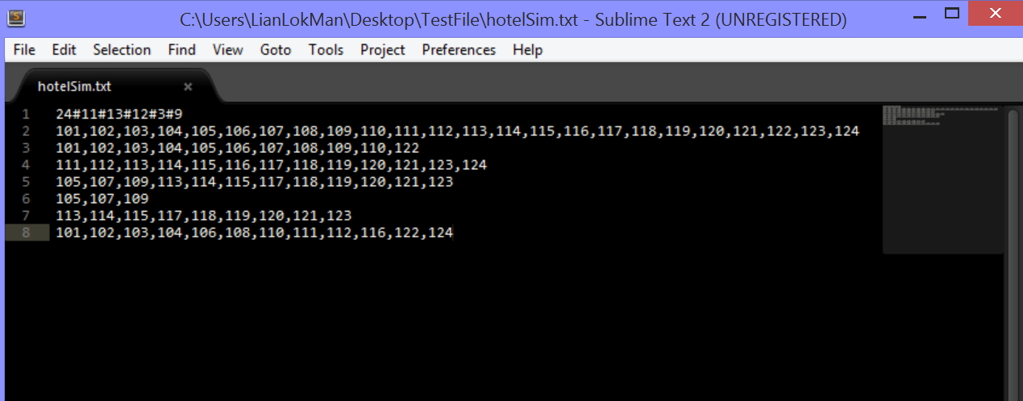

customerSim.txt

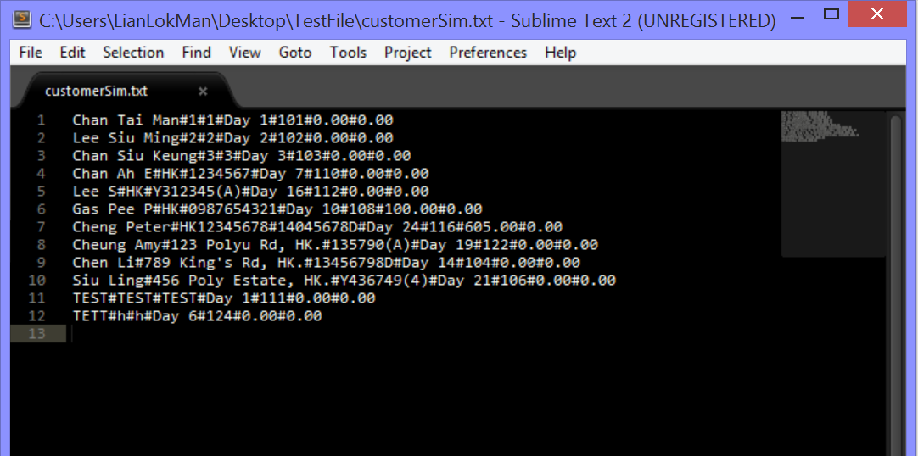

1. Input validations on user’s name and choices

Invalid case (empty or space)

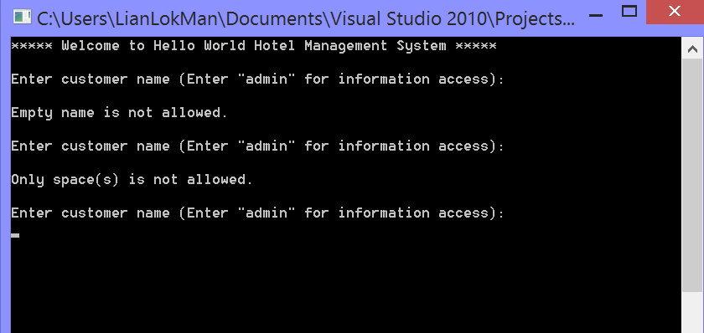

Valid (string input)

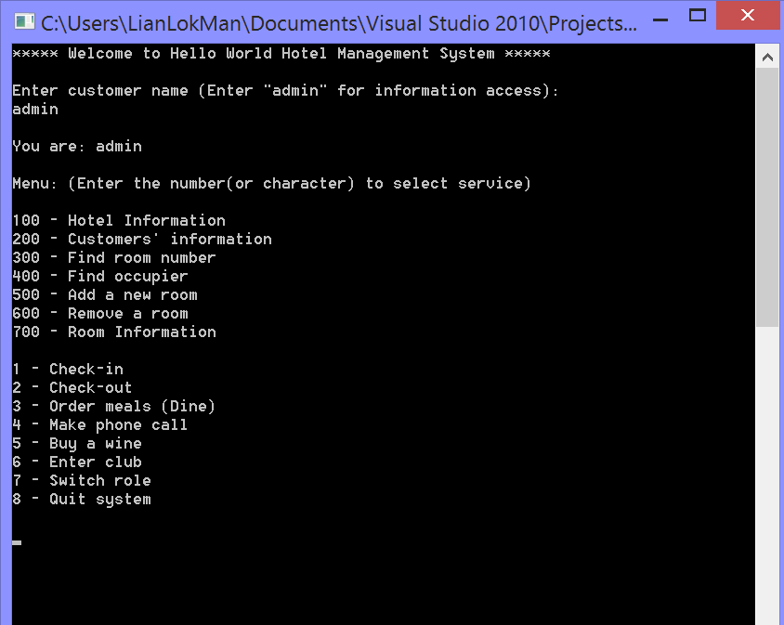

Invalid choice input 1

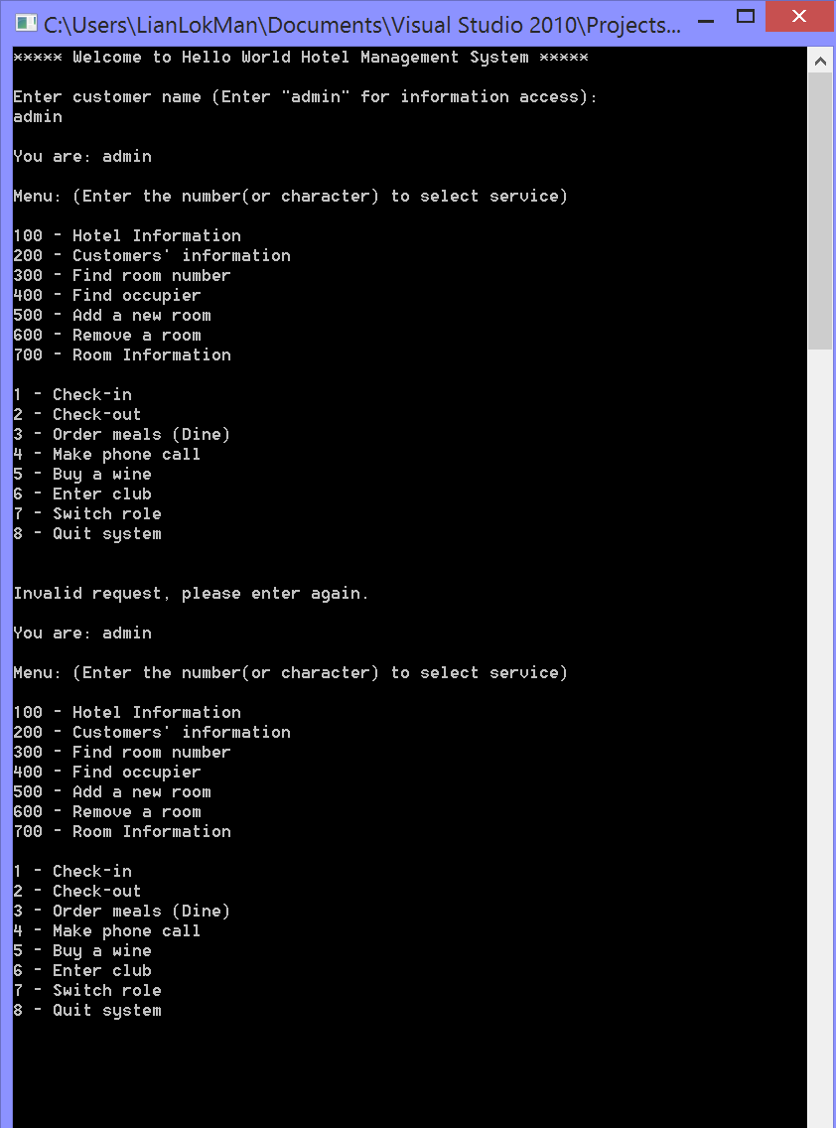

Invalid choice input 2

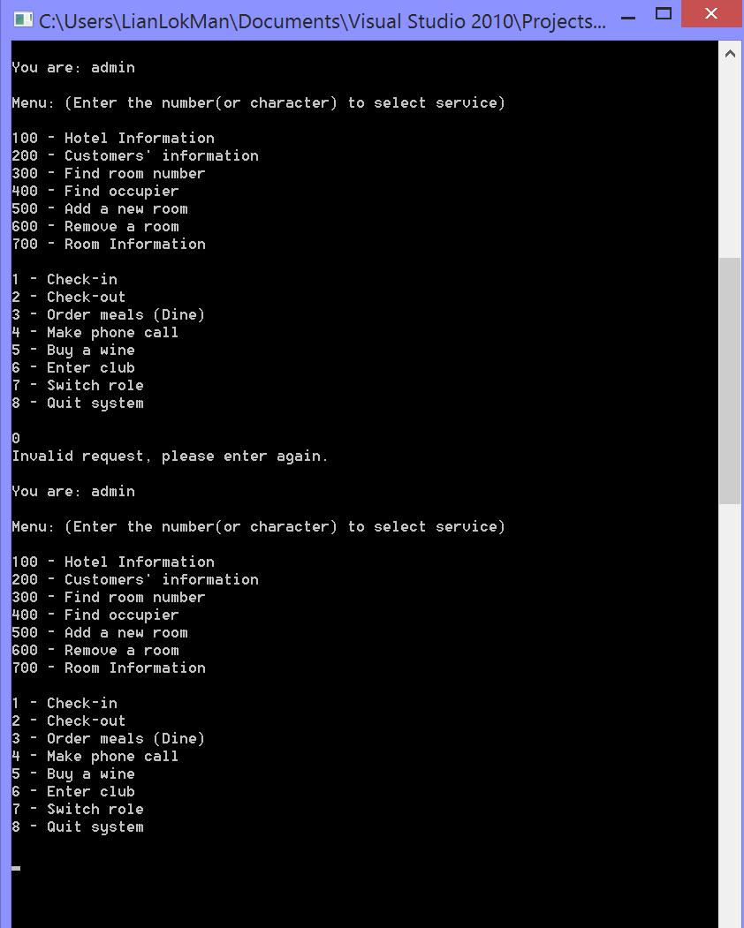

Invalid choice input 3

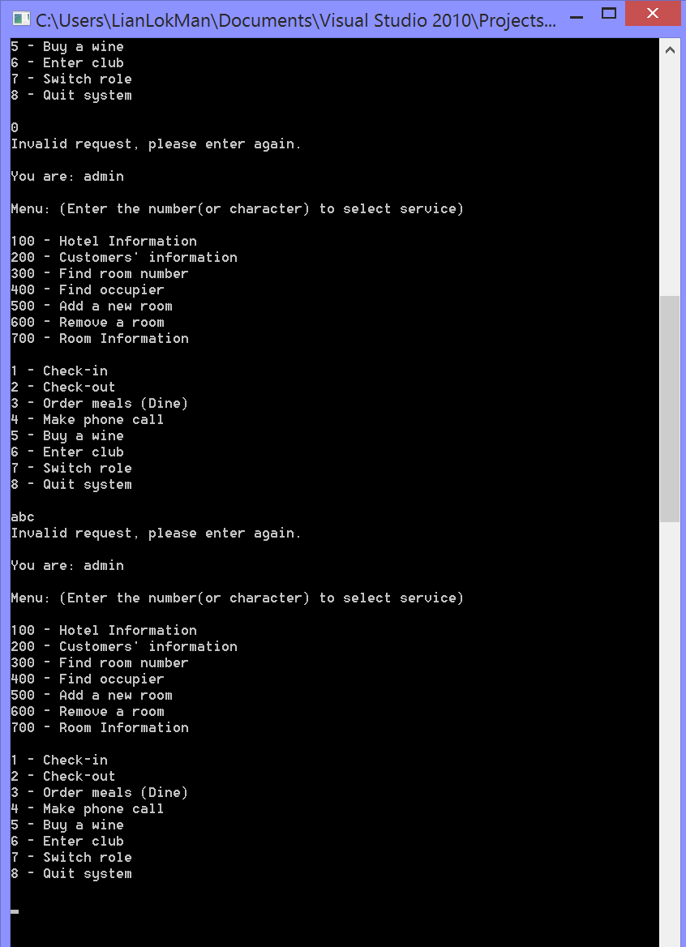

1. Role: admin

View hotel information

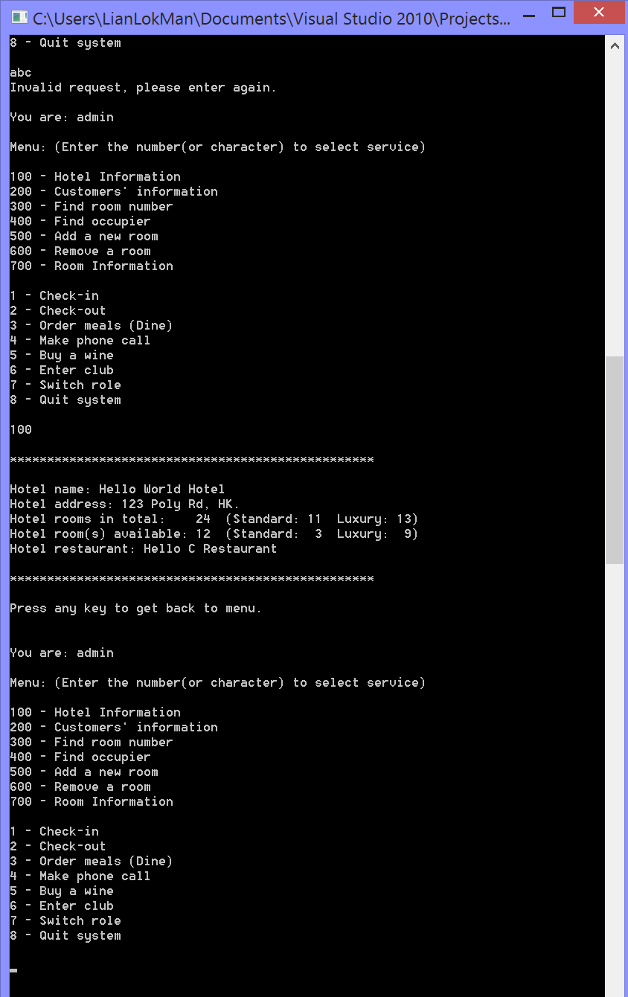

View customer information (open in another file for larger view)

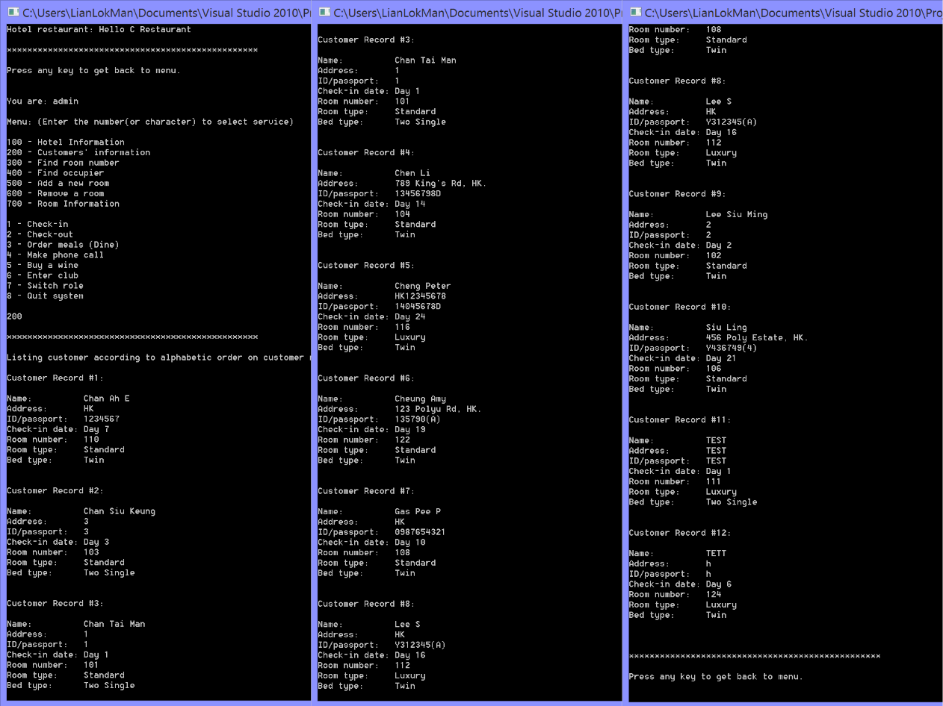

After that back to menu

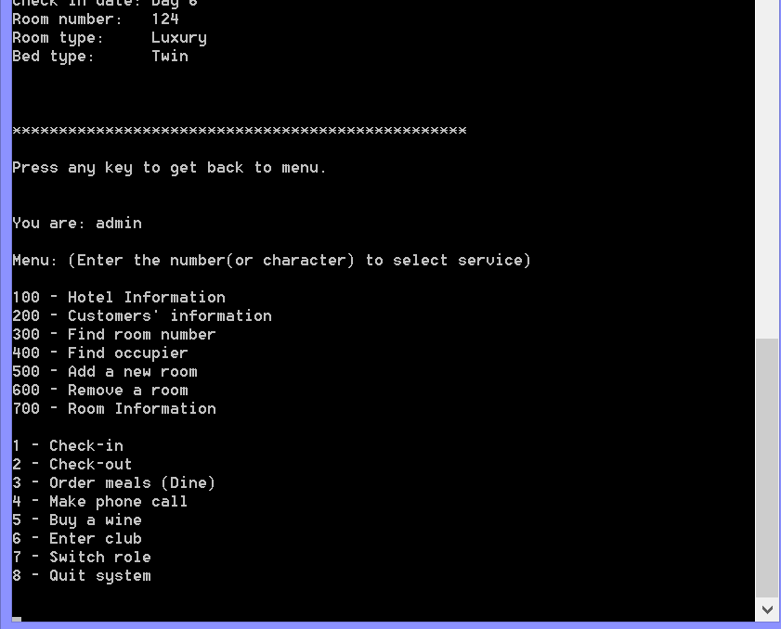

Find room number

Input validation 1 (empty/space input)

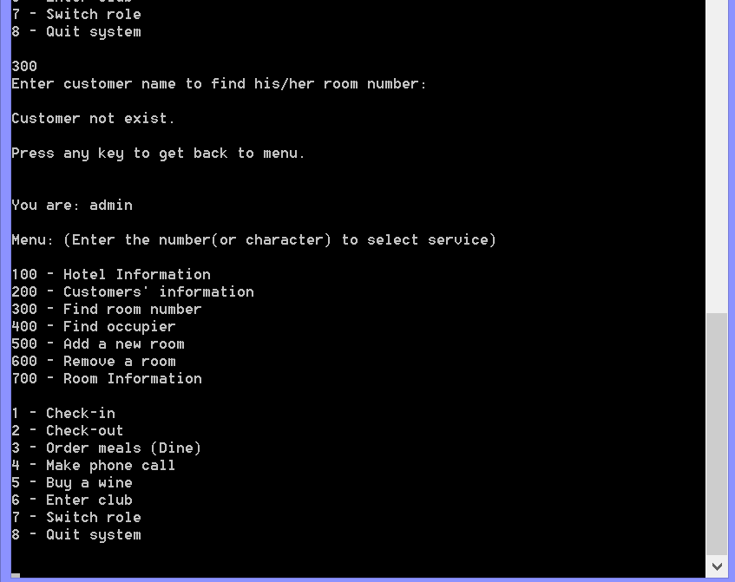

Customer with no record

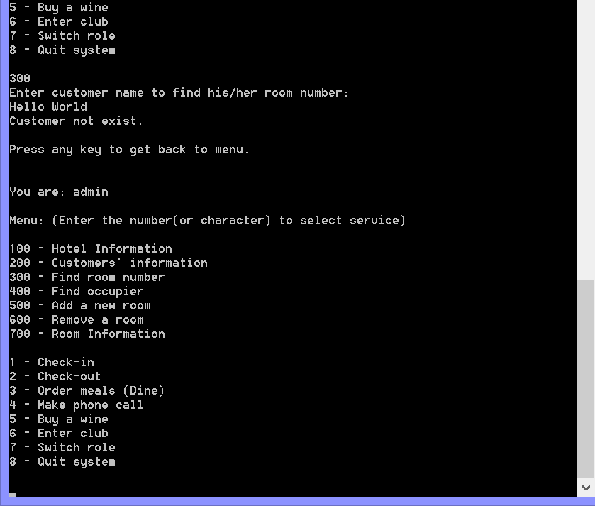

Valid case 1

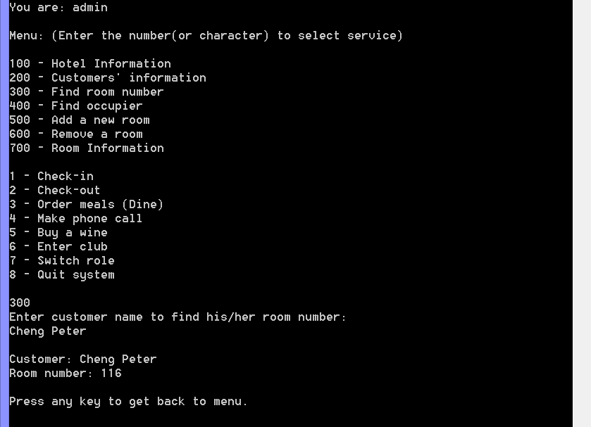

Valid case 2

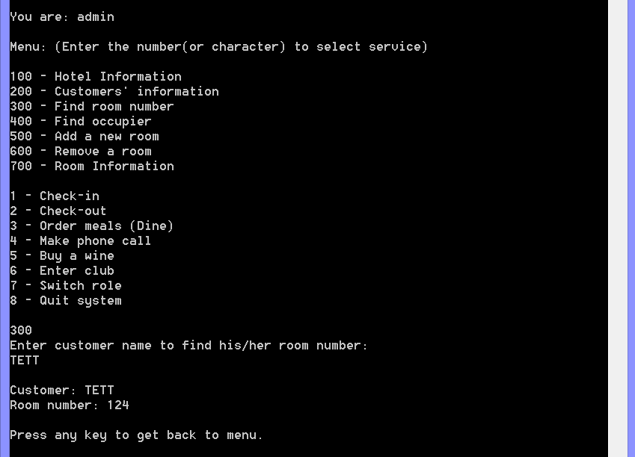

Find room occupier

Input validation 1 (empty/space input)

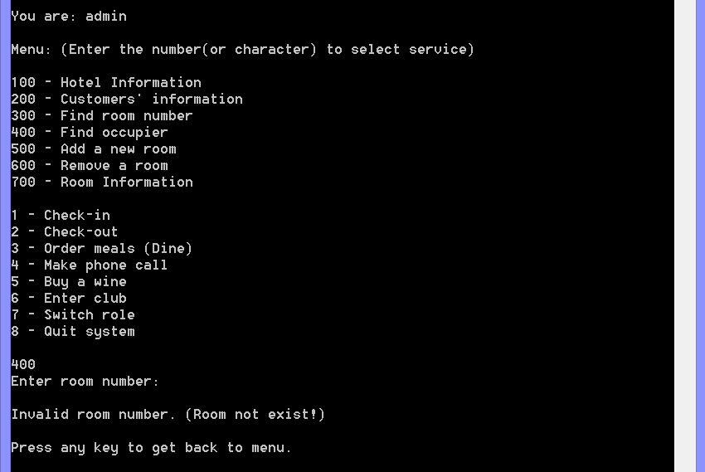

Input validation 2 (string input)

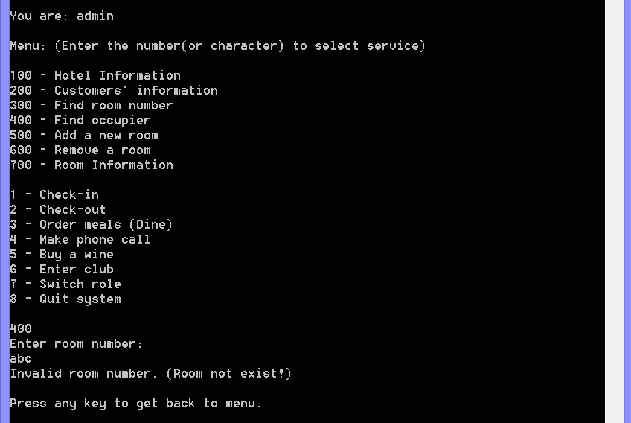

Input validation 3 (invalid room number)

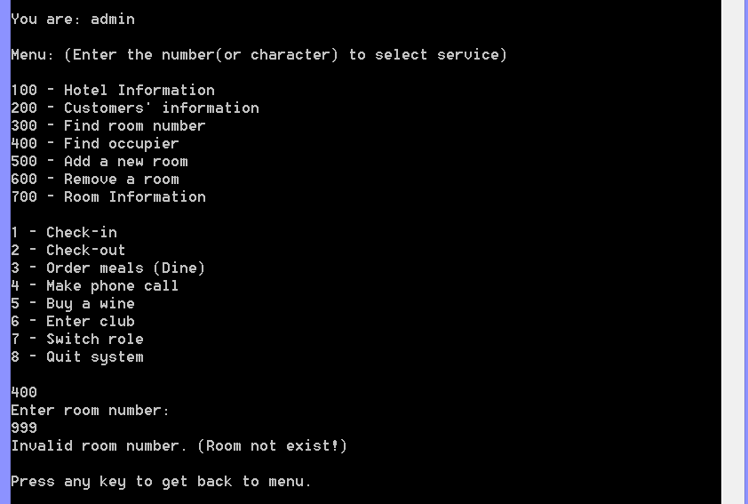

Valid case 1

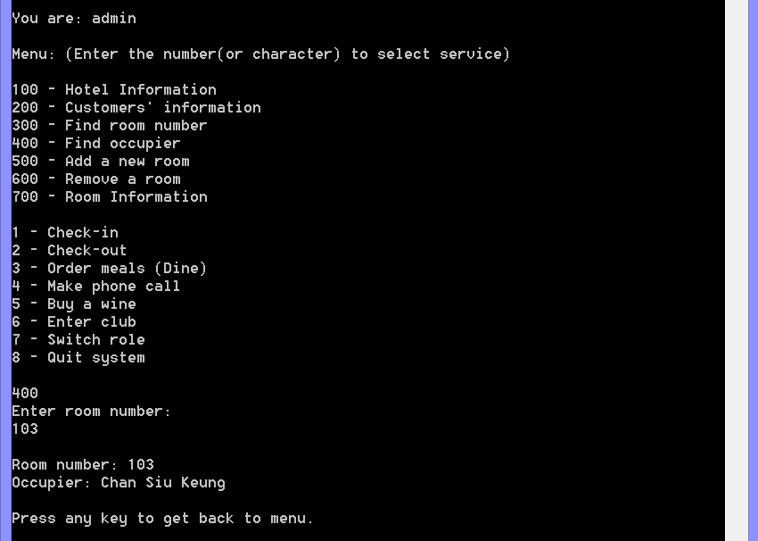

Valid case 2

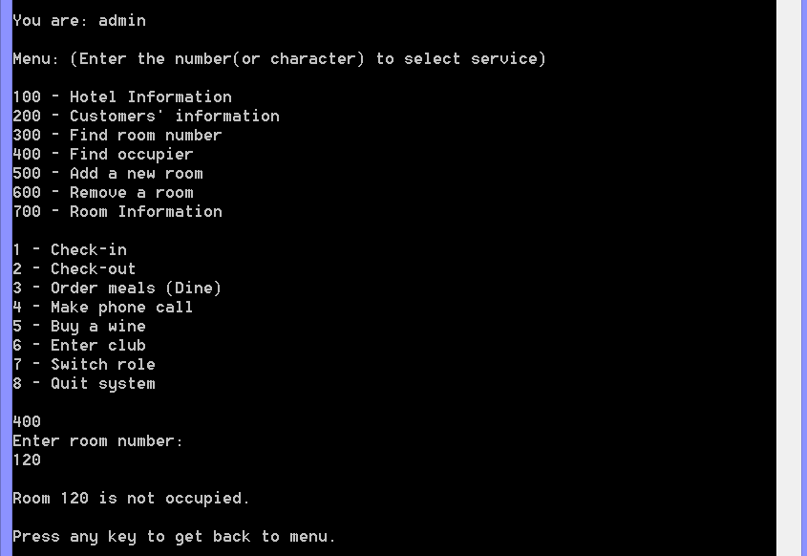

Build new room

Input validation 1 (empty/space input)

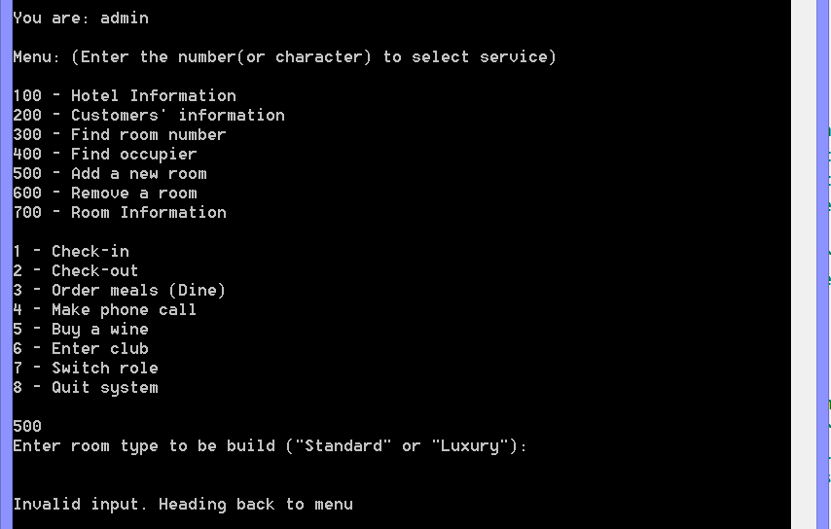

Input validation 2 (non-string input)

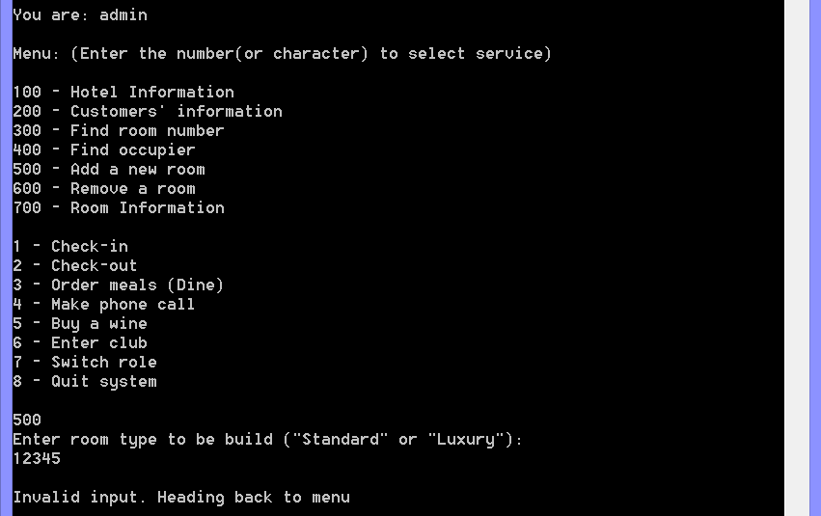

Input validation 3 (invalid string input)

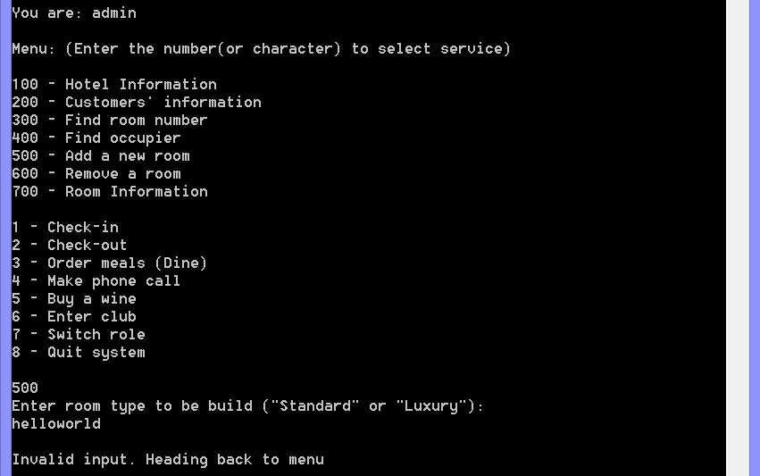

Cancel to build a new room

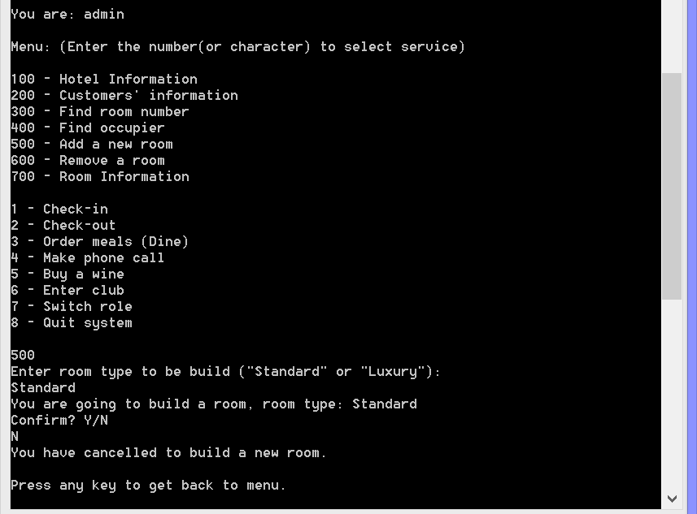

Result (no change) in text file: cancel remove successfully, no change in hotel text file

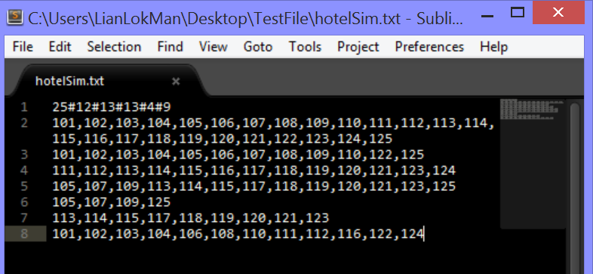

Successfully built a standard room

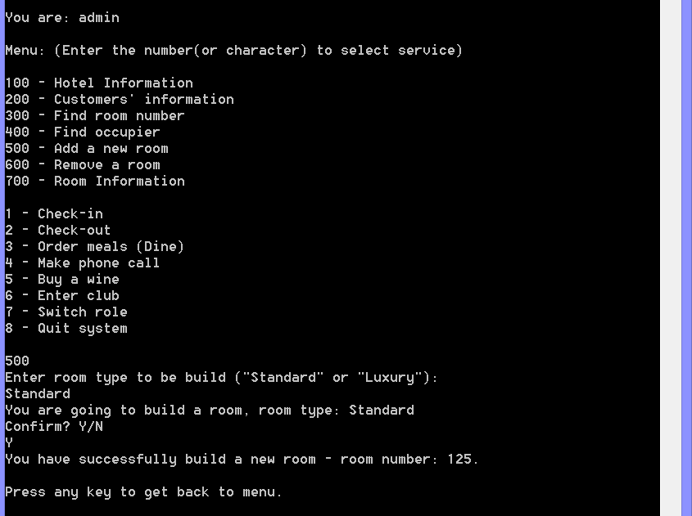

Result (inserted 125# in appropriate arrays) in text file

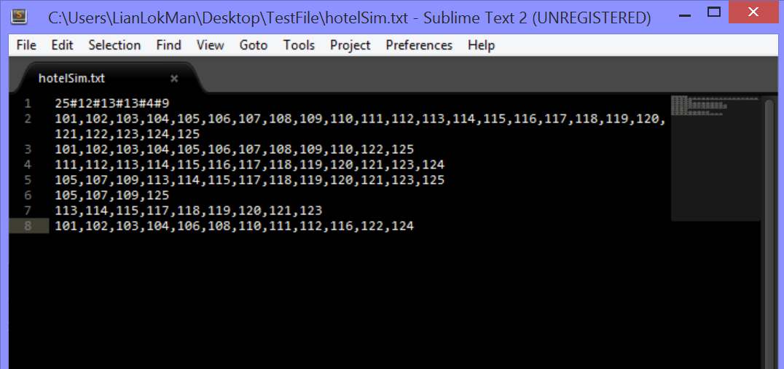

Hotel rooms incremented after new room is built

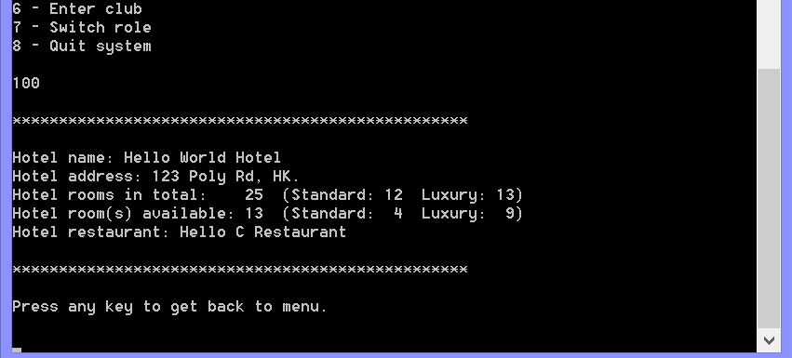

Room status updated successfully after the new room is built

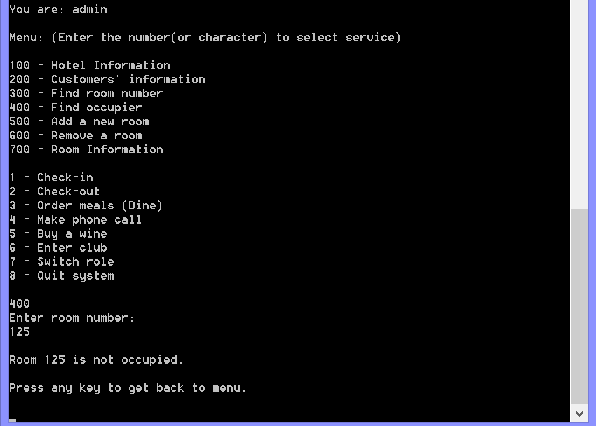

Successfully built a luxury room

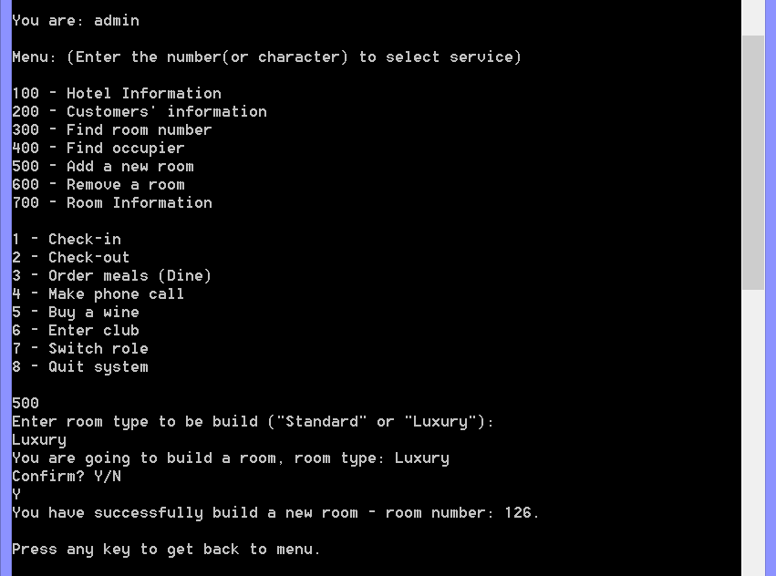

Result (inserted 126# in appropriate arrays) in text file

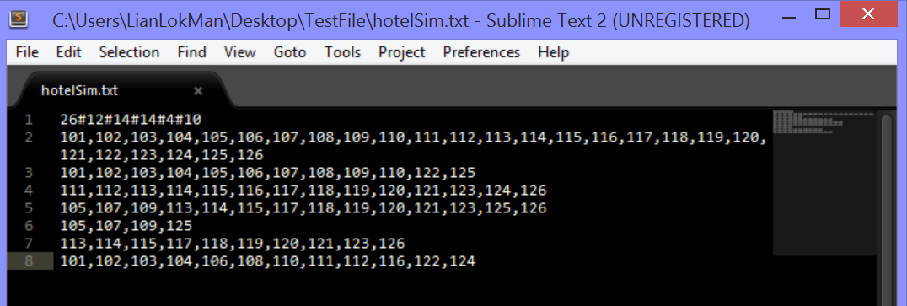

Hotel rooms incremented after new room is built

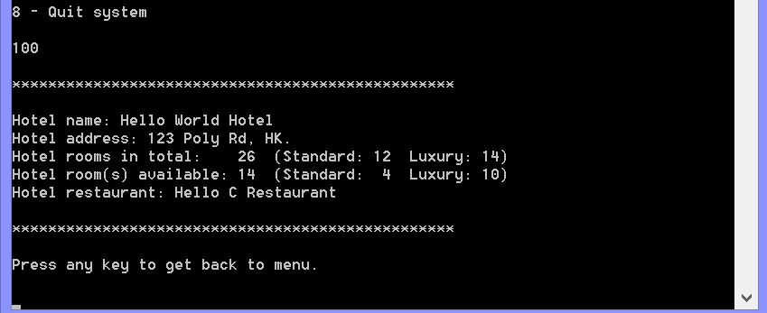

Room status updated successfully after the new room is built

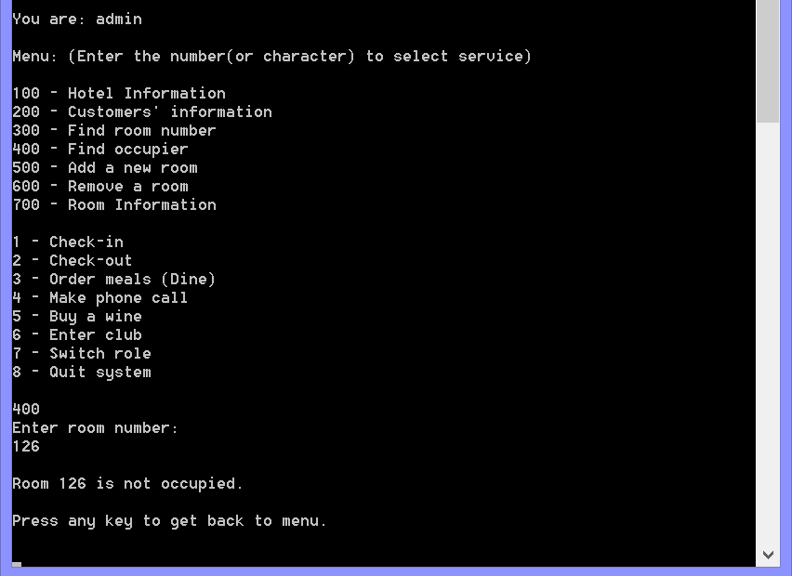

Remove a room

Input validation 1 (empty/space input)

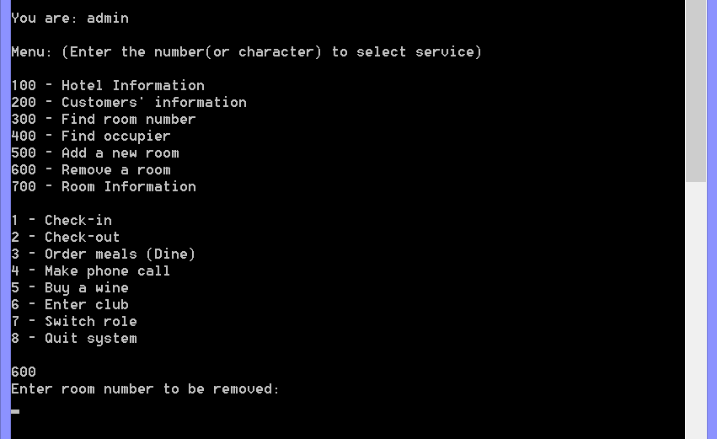

Input validation 2 (string input)

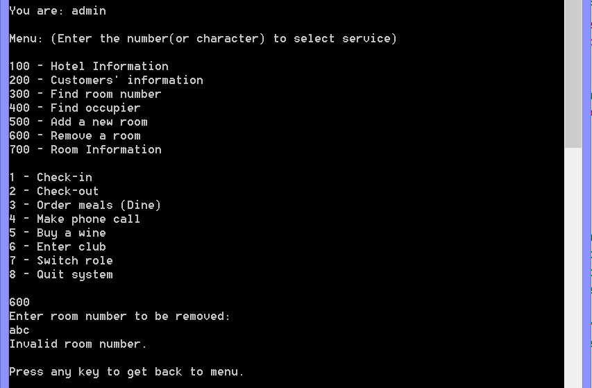

Input validation 3 (invalid room number)

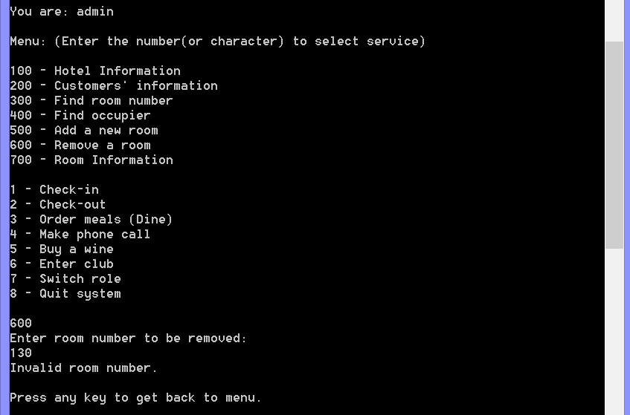

Cancel to remove a room

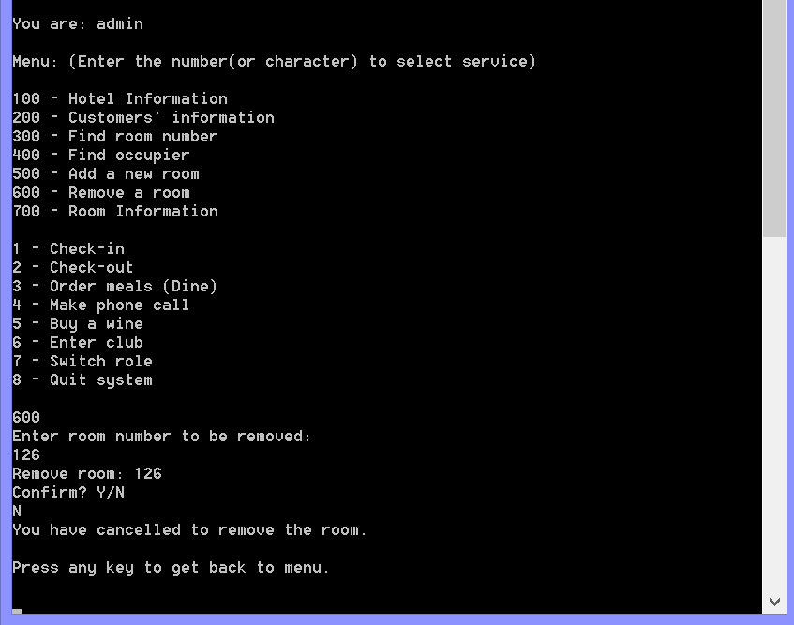

Cancel removal result: Hotel room number did not change

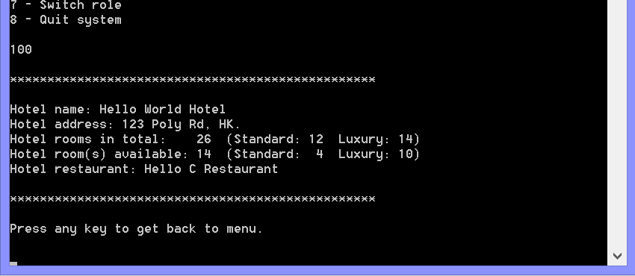

Cancel removal result: room 126 still exist

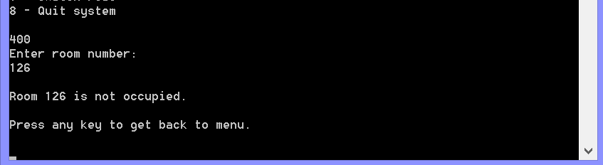

Remove the last room, room 126 successfully

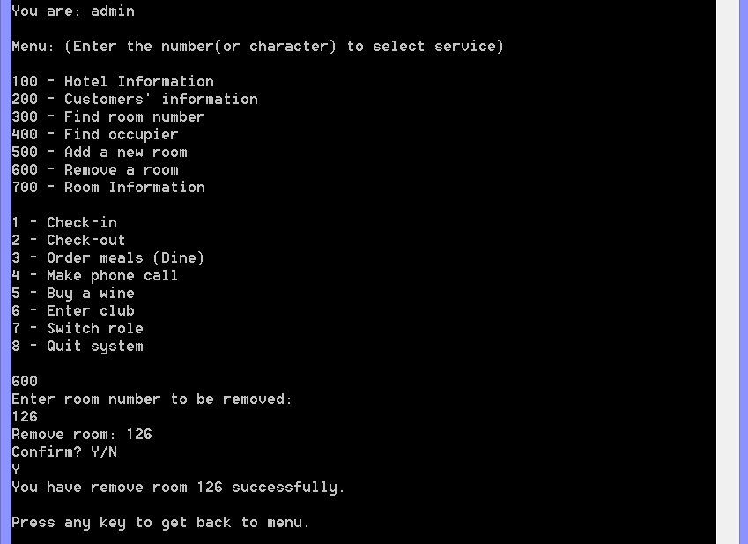

Remove room result: hotel rooms number decrement

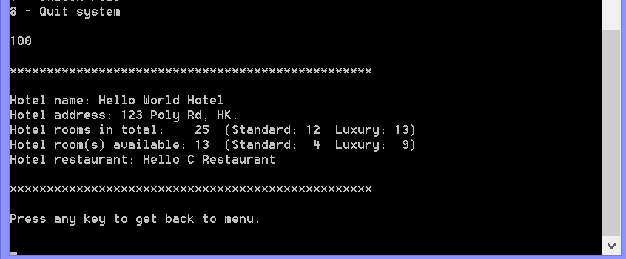

Remove room result: room 126 not exist any more

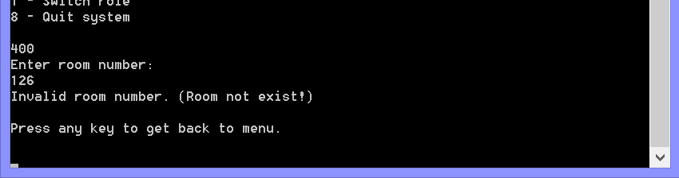

Remove room result: text file updated (removed 126# in appropriate arrays)

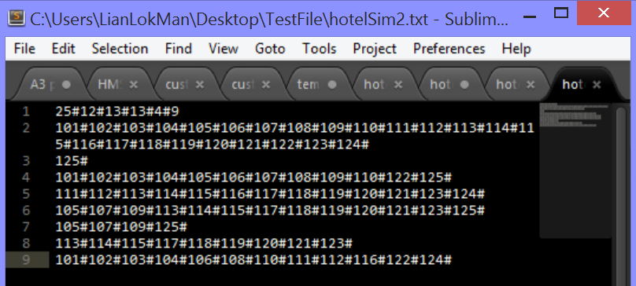

Remove the room in the middle of the room number list (room 123)

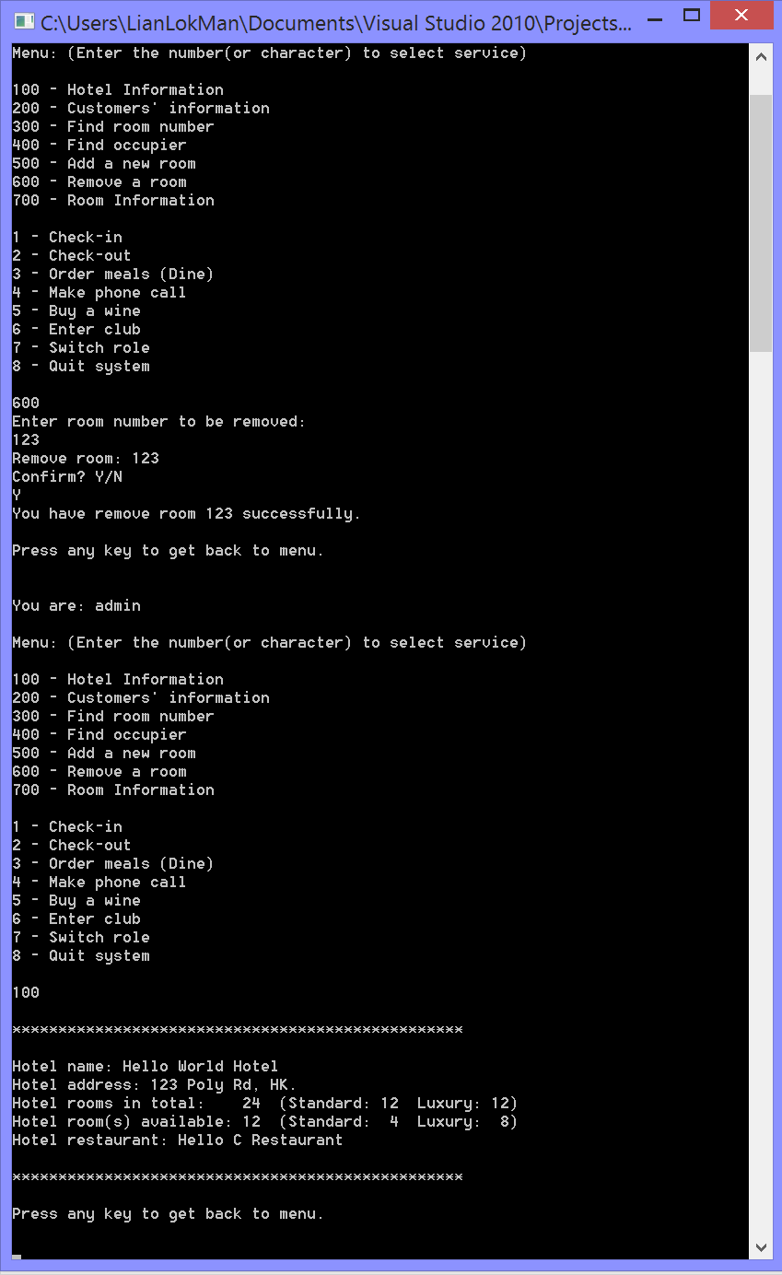

Result after removal: room 123 no longer exist

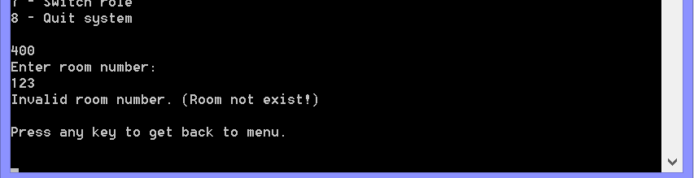

Result after removal: text file updated (remove 123# in appropriate arrays)

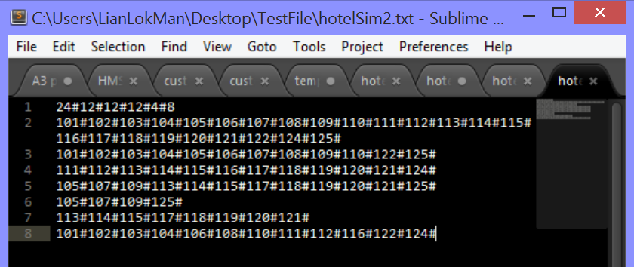

Request denied when admin tries to remove a room that is occupied, right hand-side is the text file of hotel rooms’ data

(The bottom row shows all the room numbers of occupied rooms)

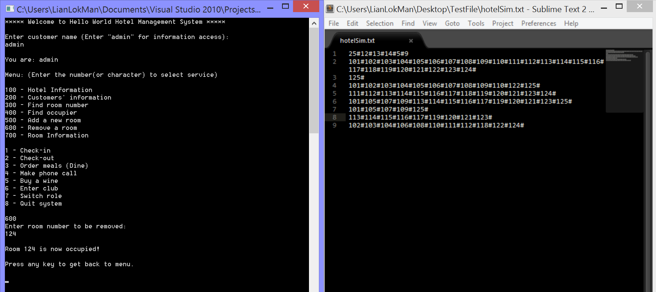

View room information

Input validation 1 (empty/space input)

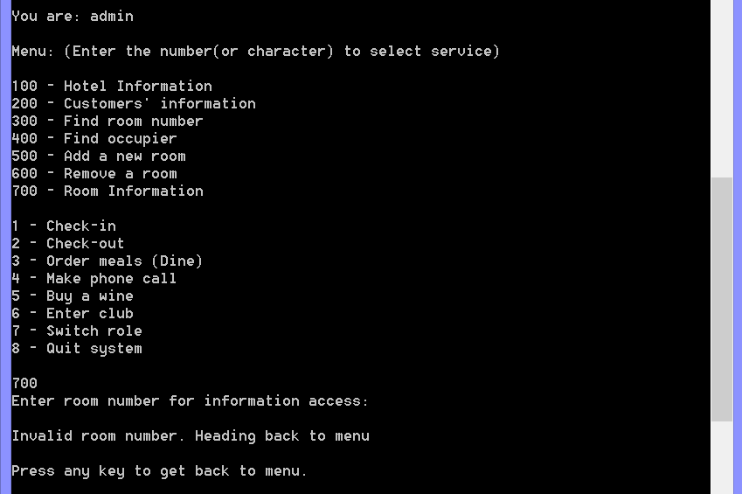

Input validation 2 (string input)

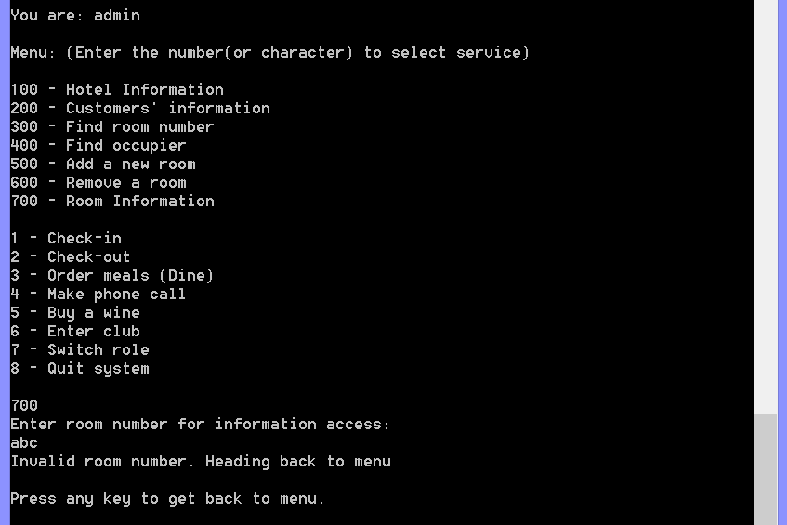

Input validation 3 (non-exist room number)

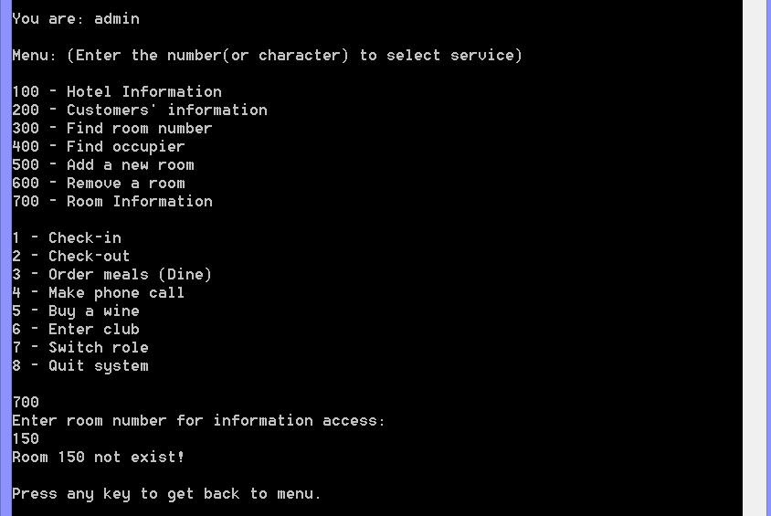

Input validation 4 (invalid room number)

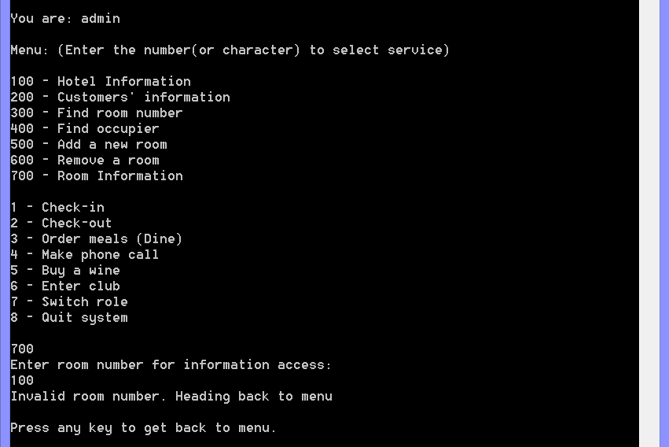

Valid case 1 (right hand-side is the hotel and customer text file to prove the output is correct)

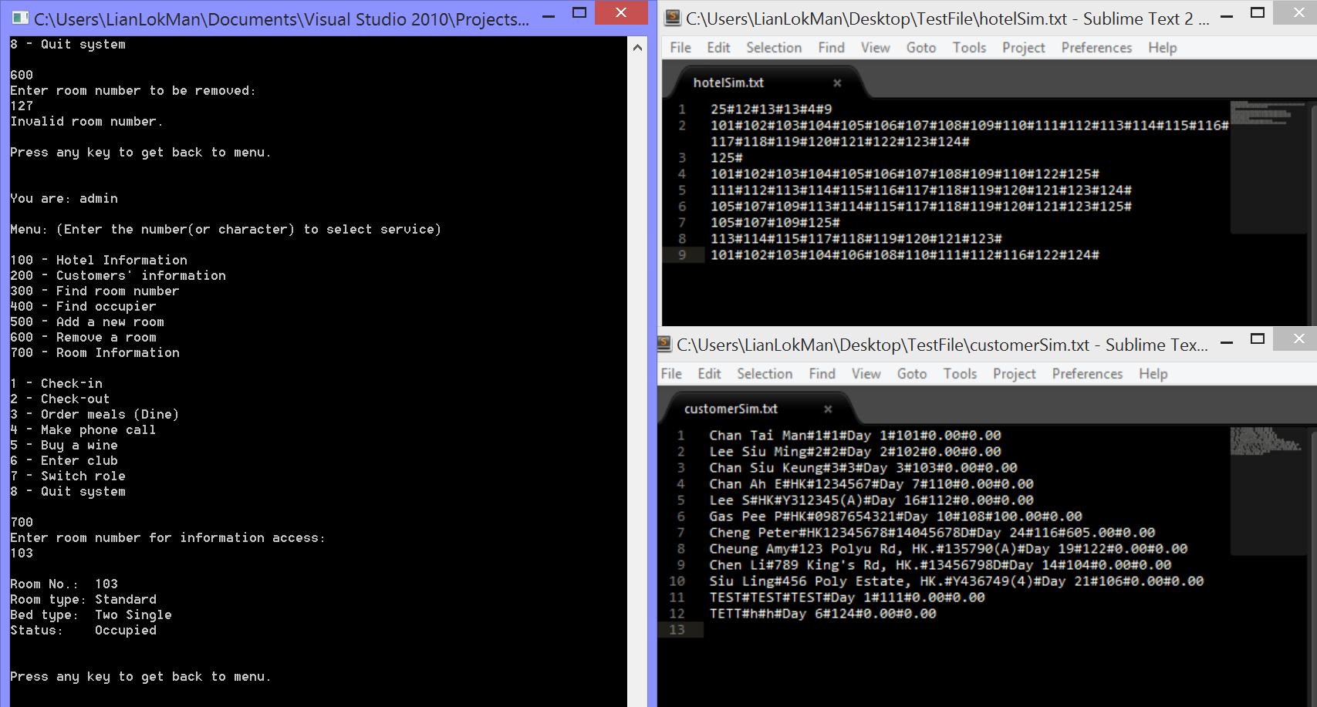

Valid case 2 (right hand-side is the hotel and customer text file to prove the output is correct)

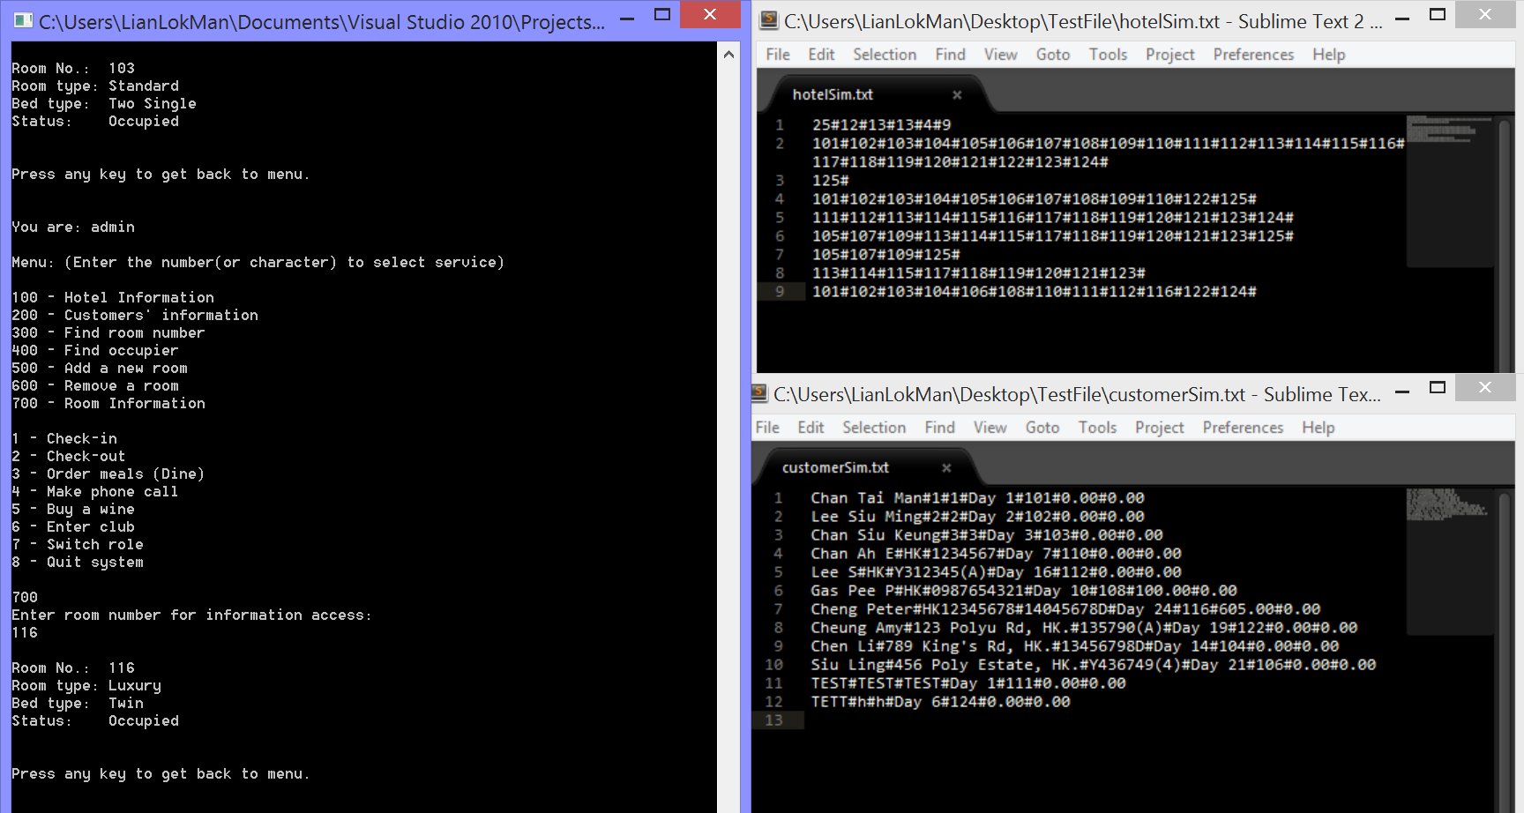

Valid case 3 (right hand-side is the hotel and customer text file to prove the output is correct)

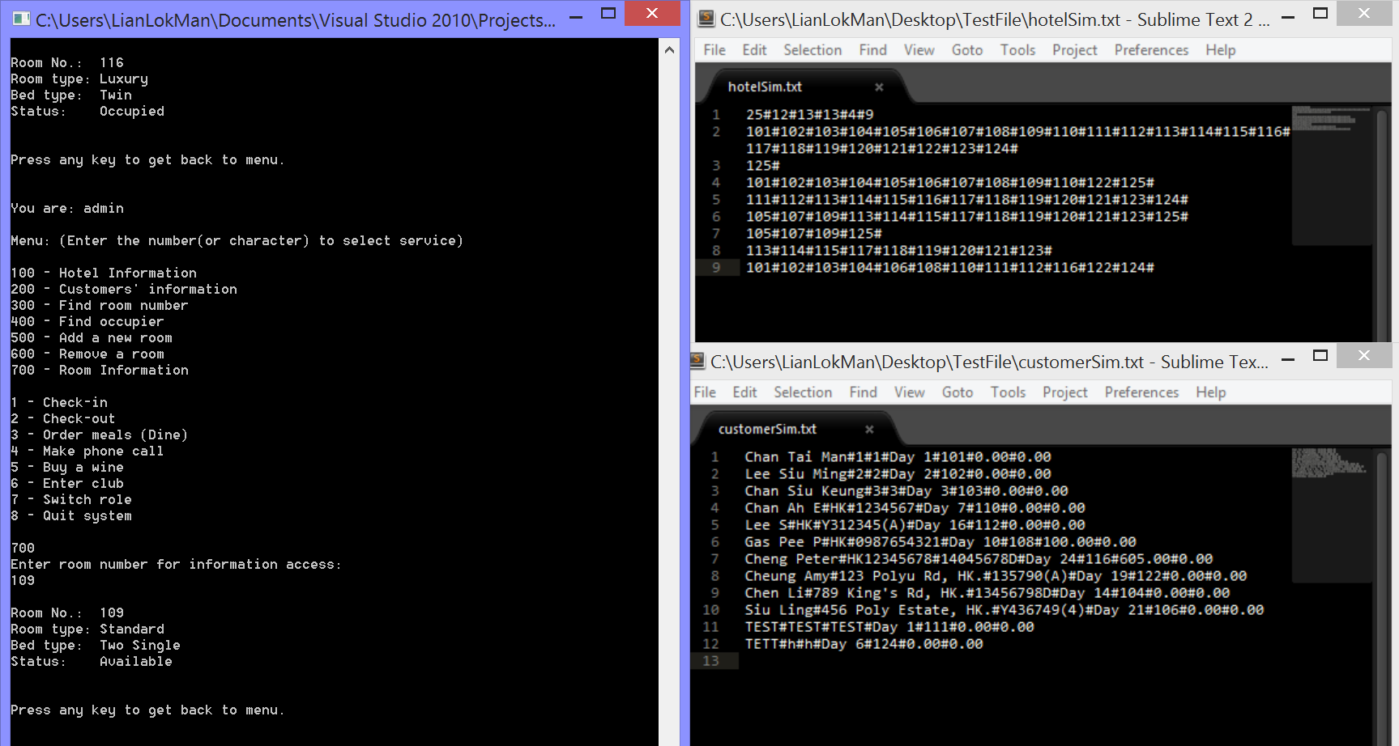

Valid case 4 (right hand-side is the hotel and customer text file to prove the output is correct)

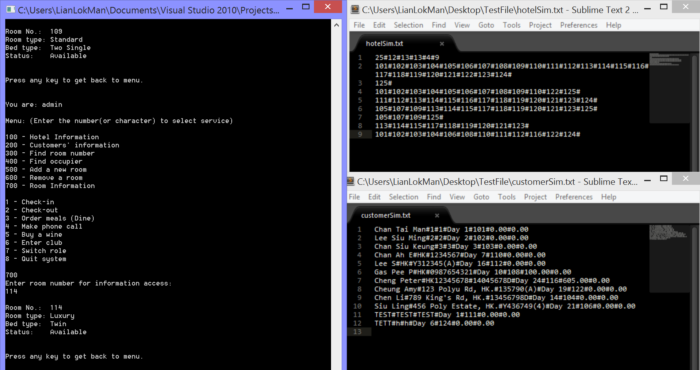

Check-in

Input validation 1 (empty input)

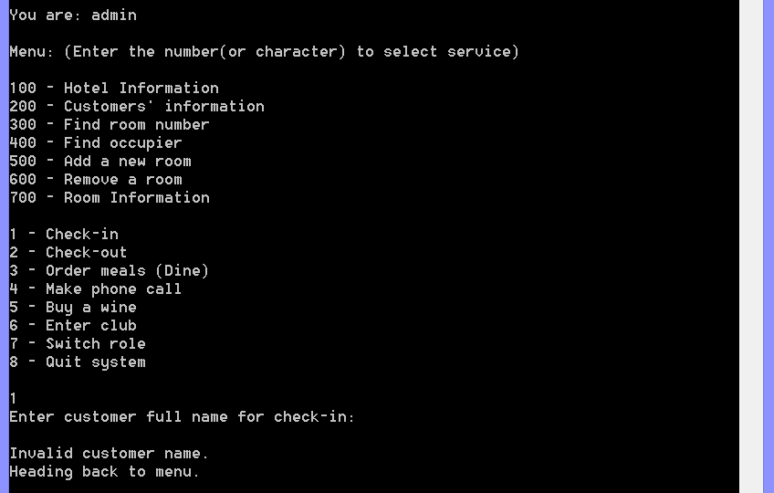

Input validation 2 (space input)

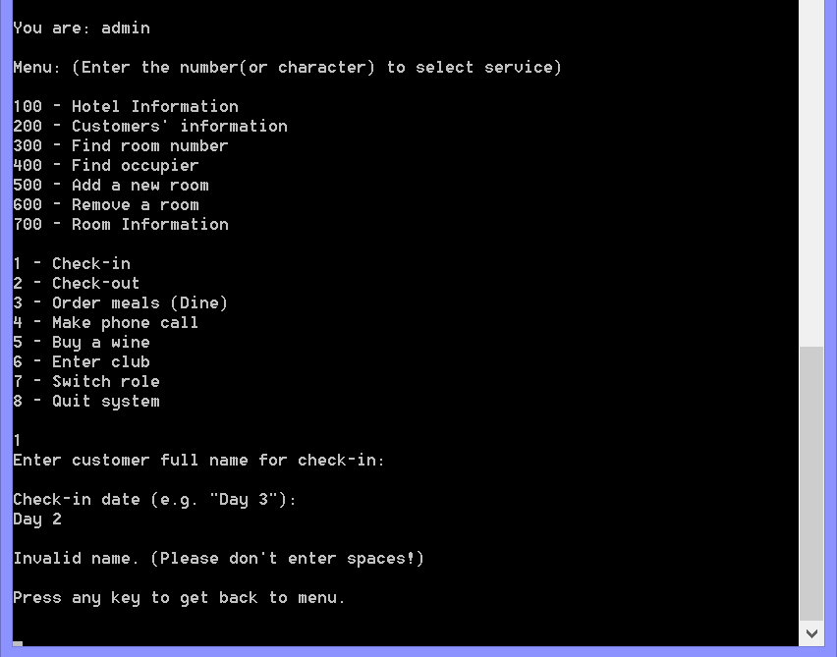

Input validation 3 (invalid date format)

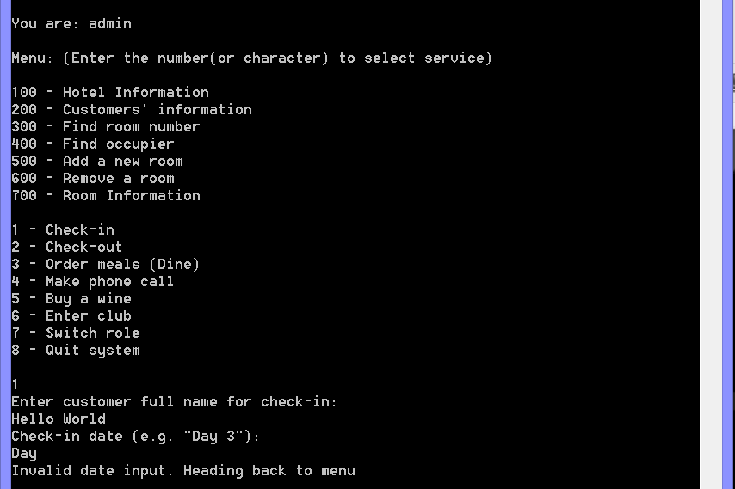

Input validation 4 (invalid day number)

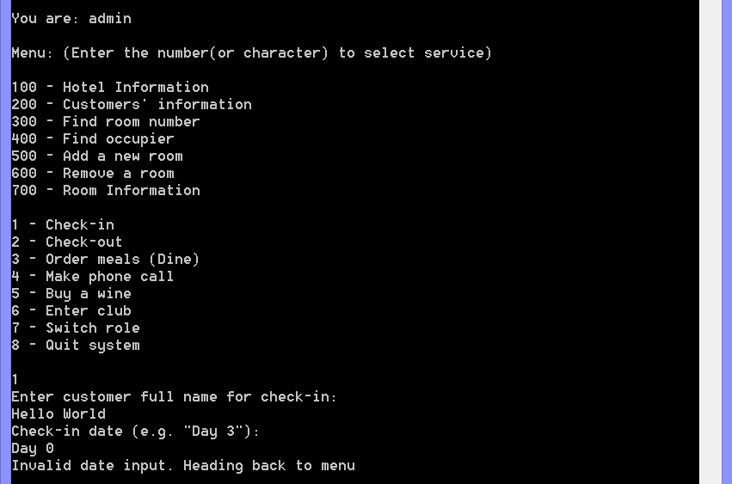

Input validation 5 (invalid day number)

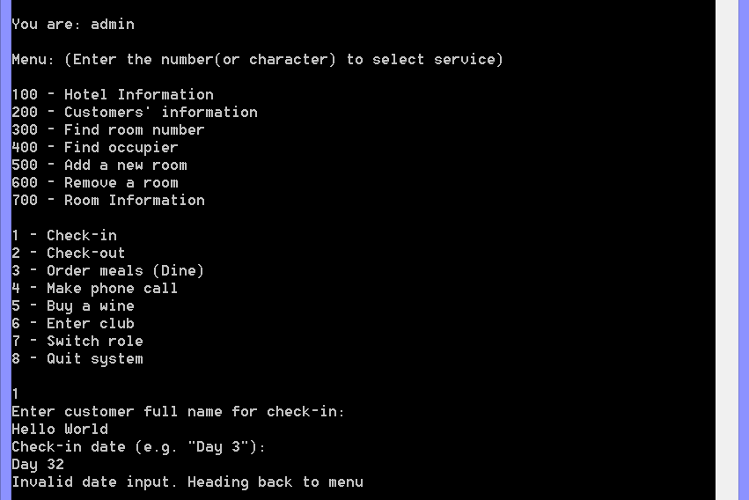

Input validation 6 (invalid room type input)

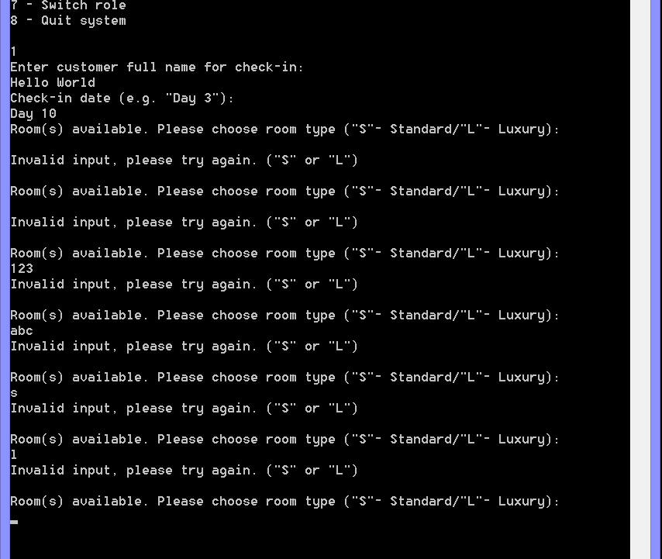

Input validation 7 (invalid bed type input)

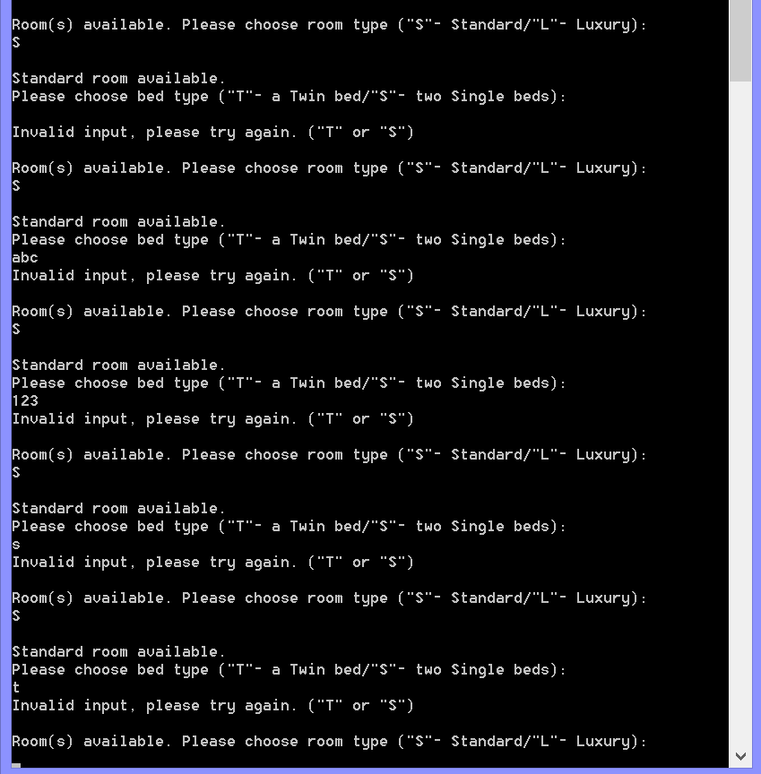

Print error message if no vacancies

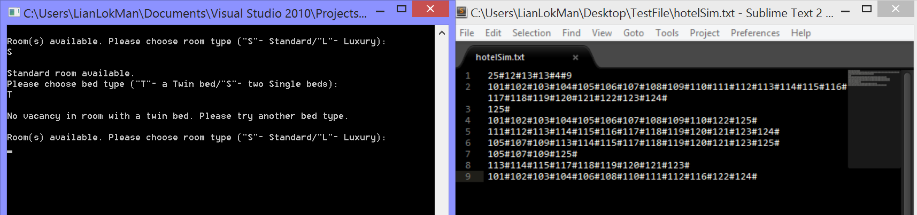

Cancel check-in

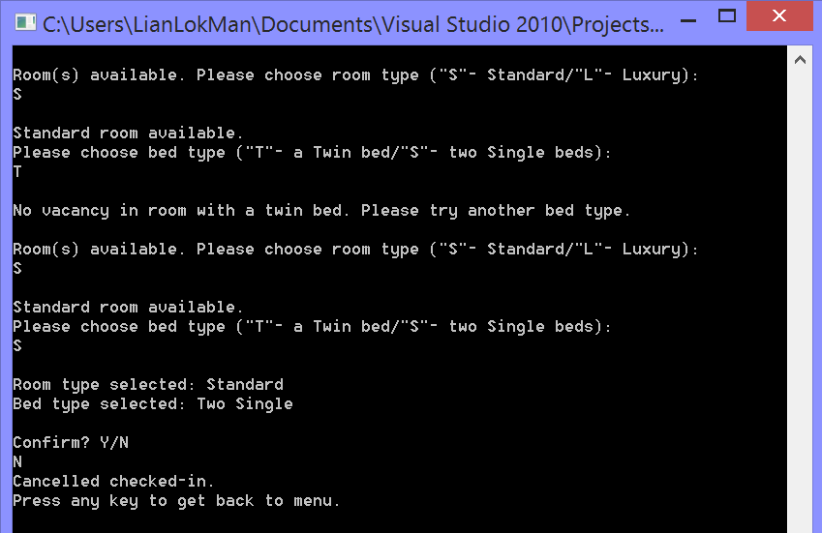

Result of cancellation of check-in: customer text file (no change)

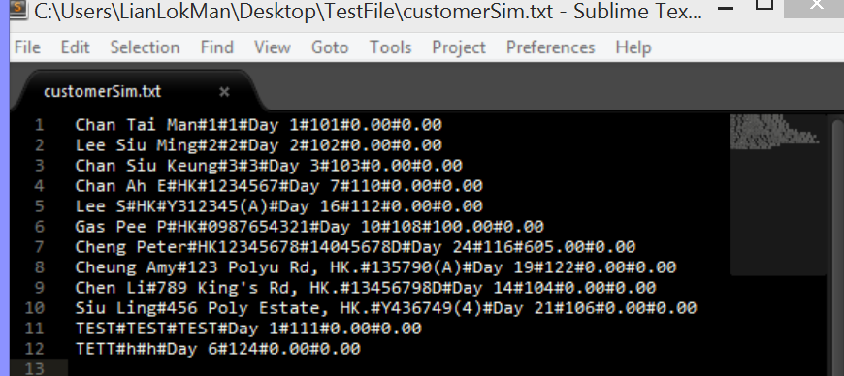

Input validation (two empty inputs on registration)

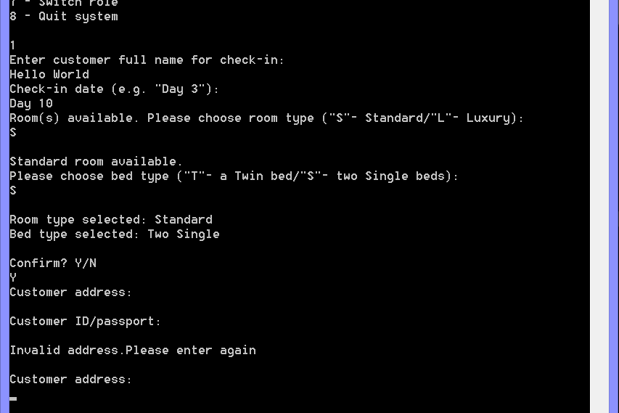

Input validation (empty address input)

Input validation (empty id input)

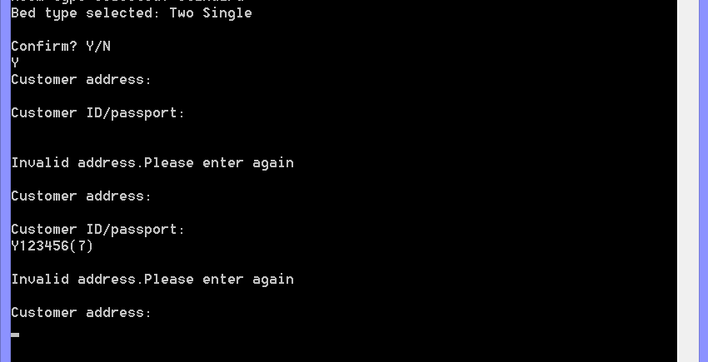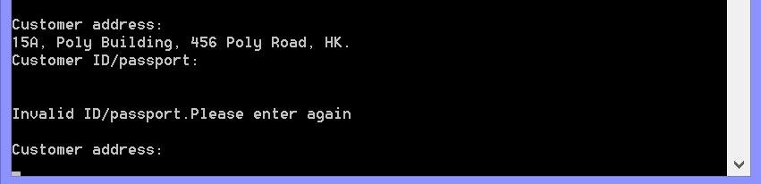

Valid check-in case 1 (Standard room)

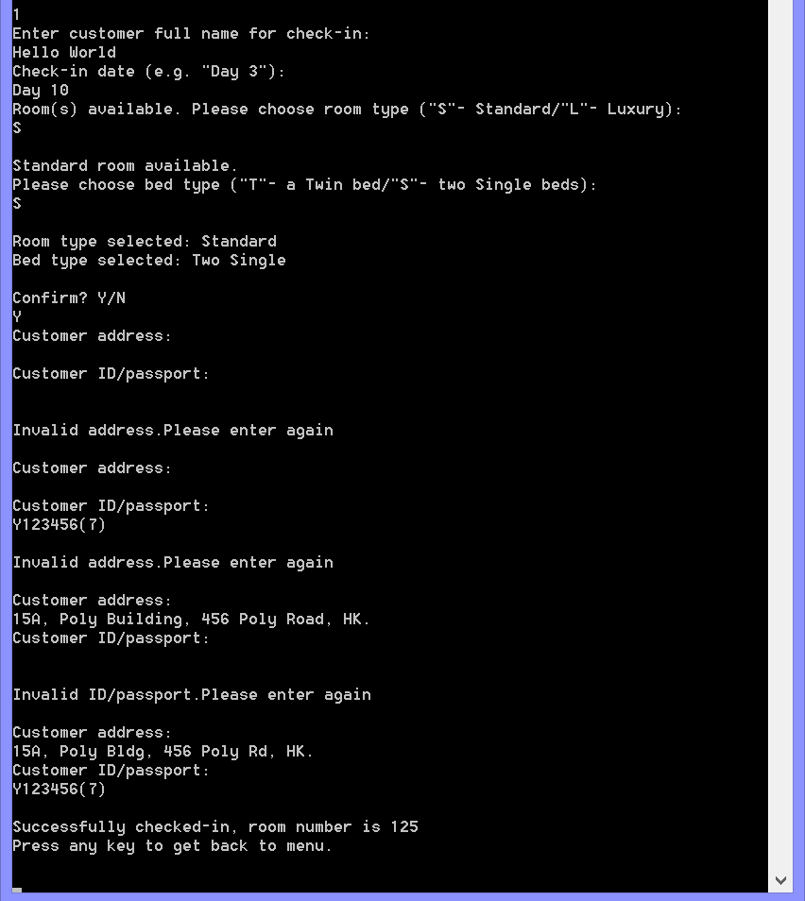

Updated hotel rooms data after check-in

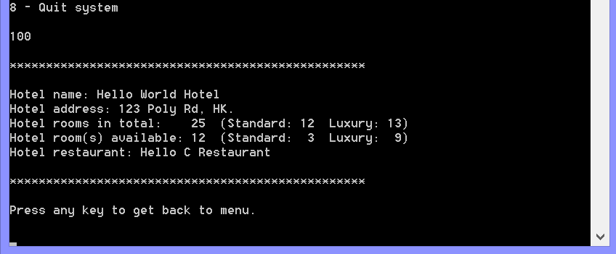

Updated customer record in the program after check-in

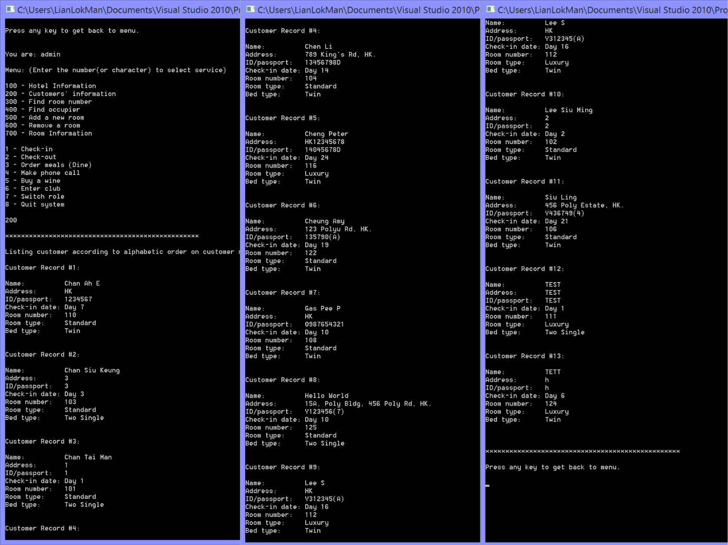

Check-in result: room number found

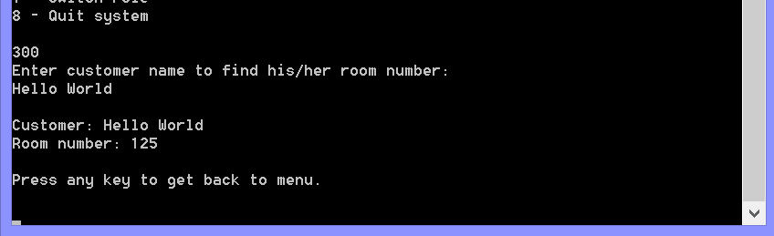

Check-in result: room occupier found

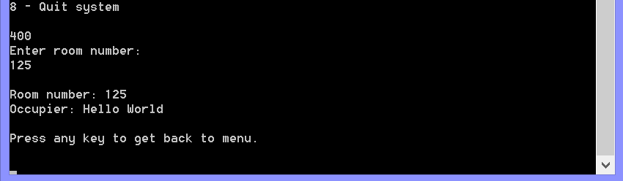

Check-in result: room status updated

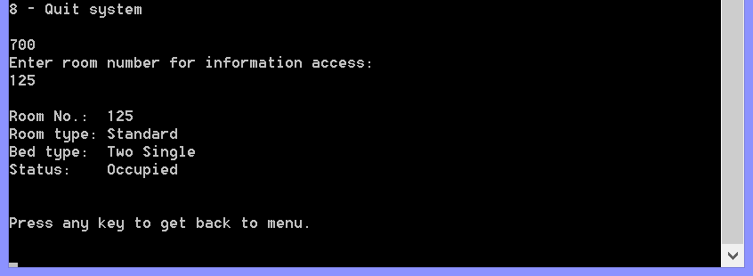

Check-in result: text files updated (arrays updated, customer records updated)

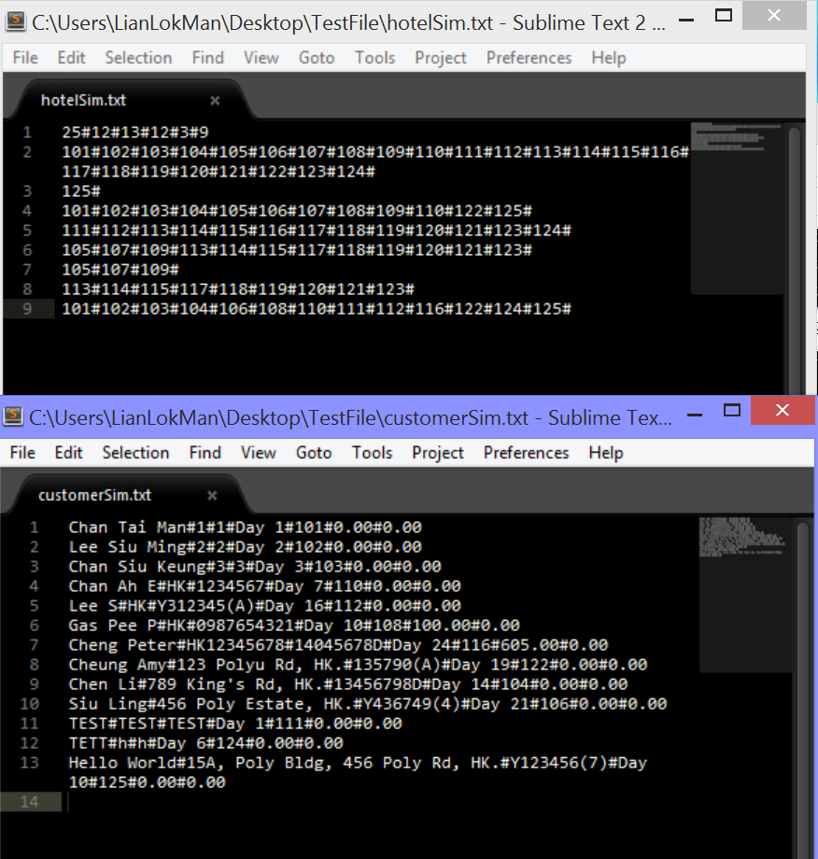

Valid check-in case 2 (Luxury room)

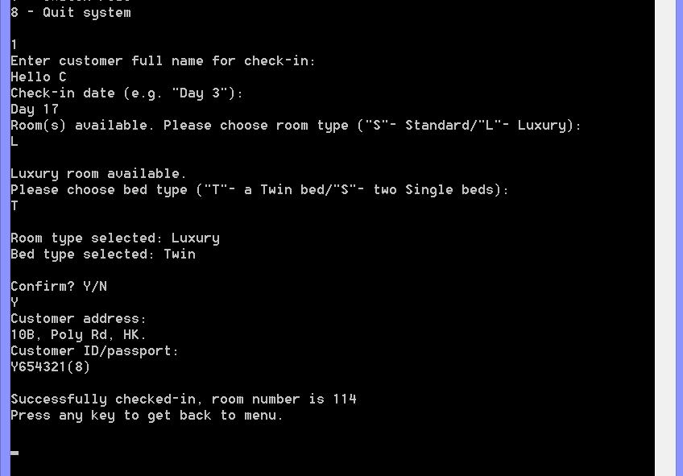

Updated hotel rooms data after check-in

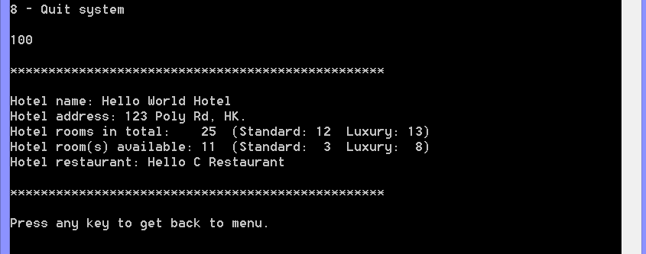

Updated customer record in the program after check-in

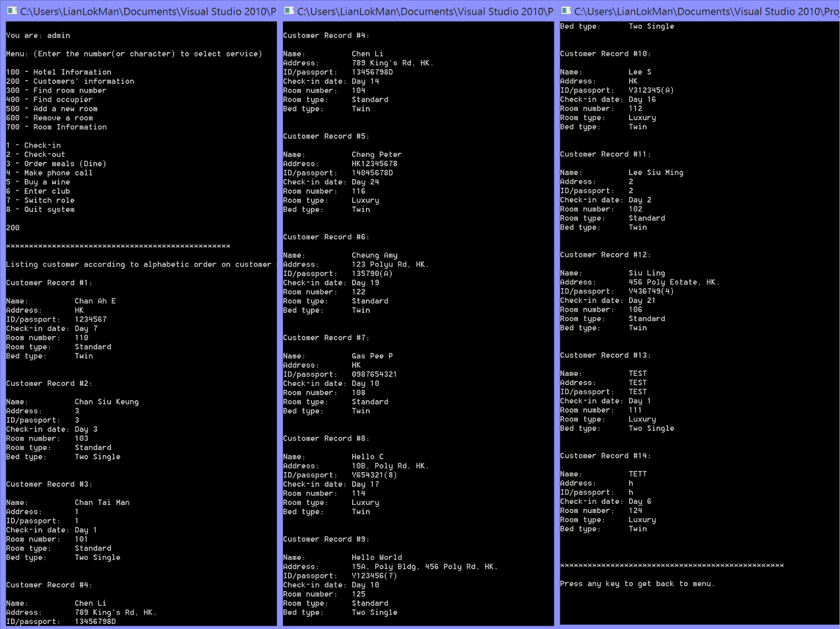

Check-in result: room number found

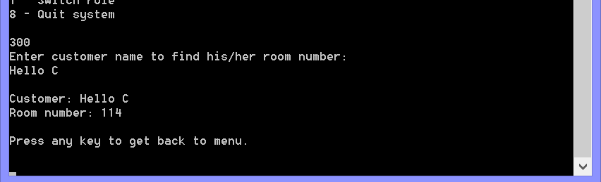

Check-in result: room occupier found

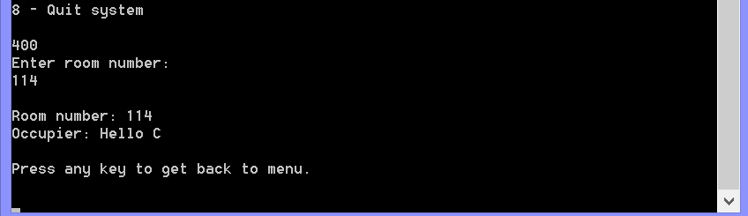

Check-in result: room status updated

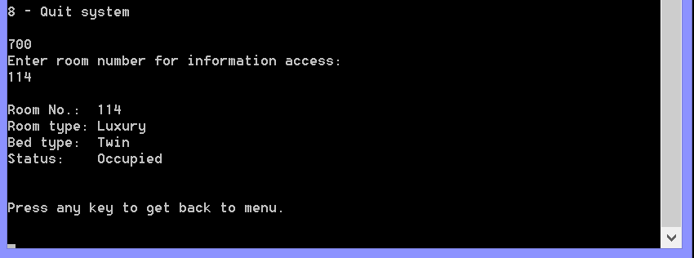

Check-in result: text files updated (arrays updated, customer records updated)

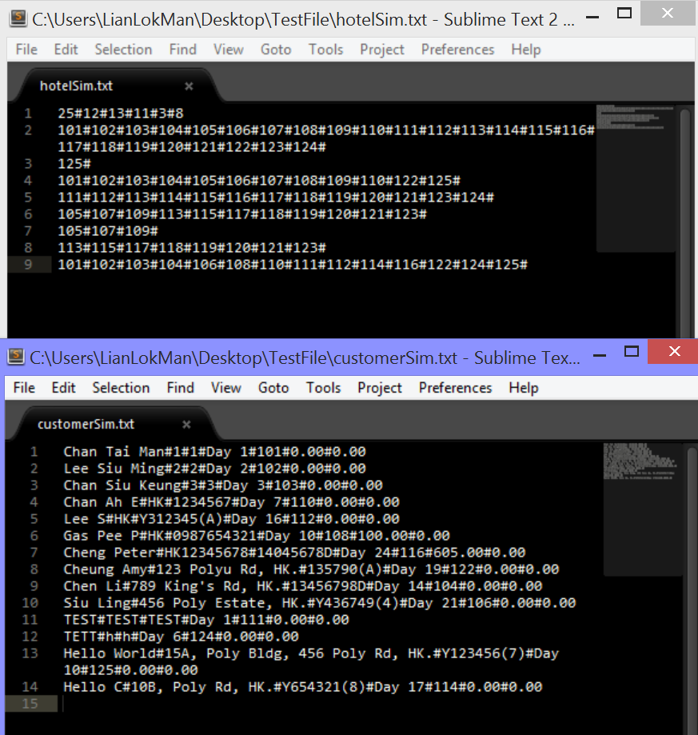

Check-in denied (check-in for an exist customer)

Right bottom-side shows the customer record, prove that customer checked-in

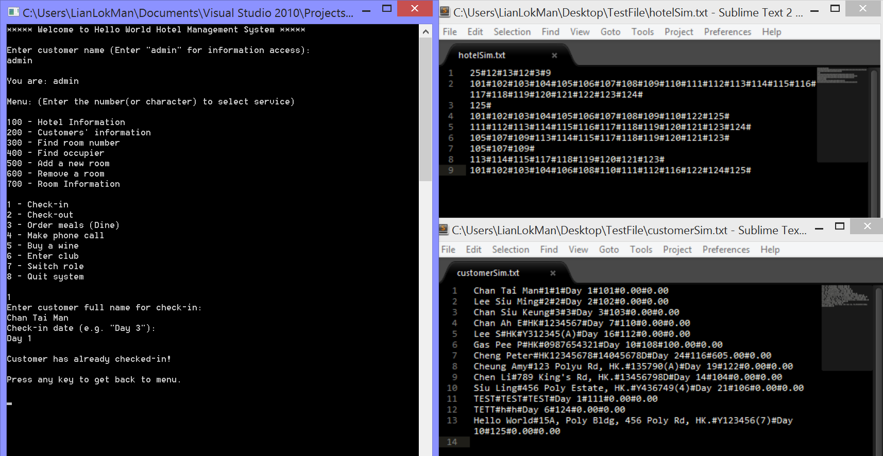

Check-out

Input validation 1 (empty/space input)

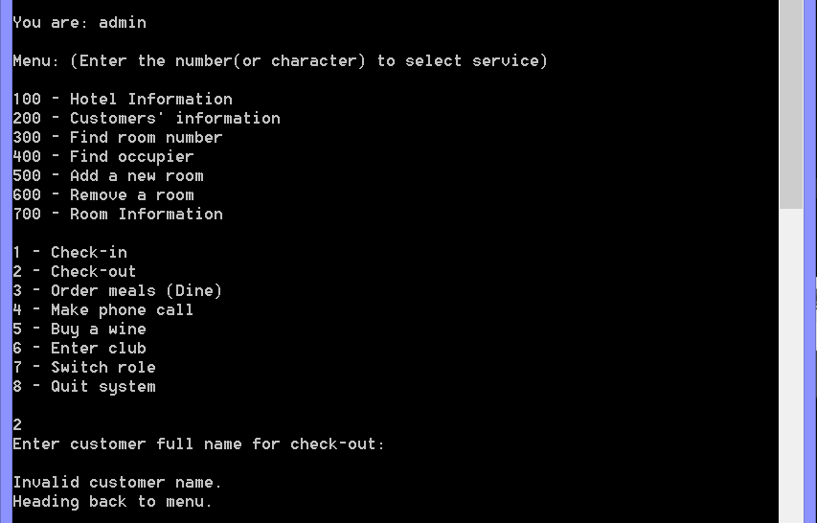

Input validation 2 (customer who had not checked-in)

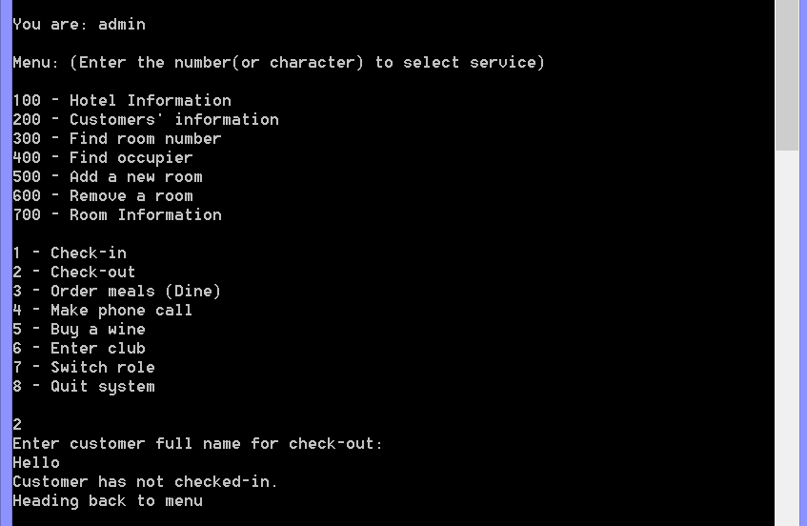

Input validation 3 (invalid check-out date: earlier than check-in date)

(Date format test skipped as its repeated)

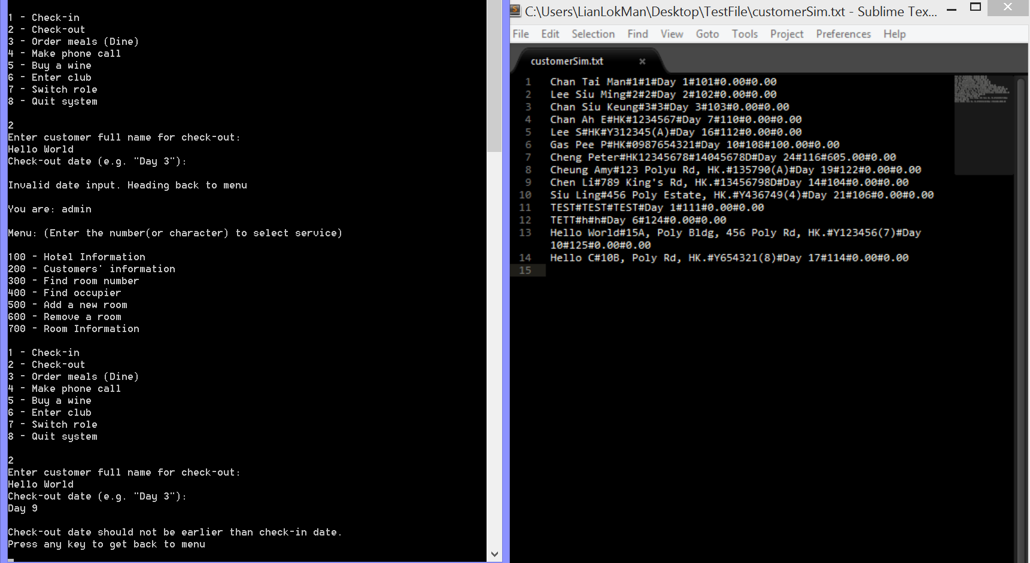

Cancel check-out

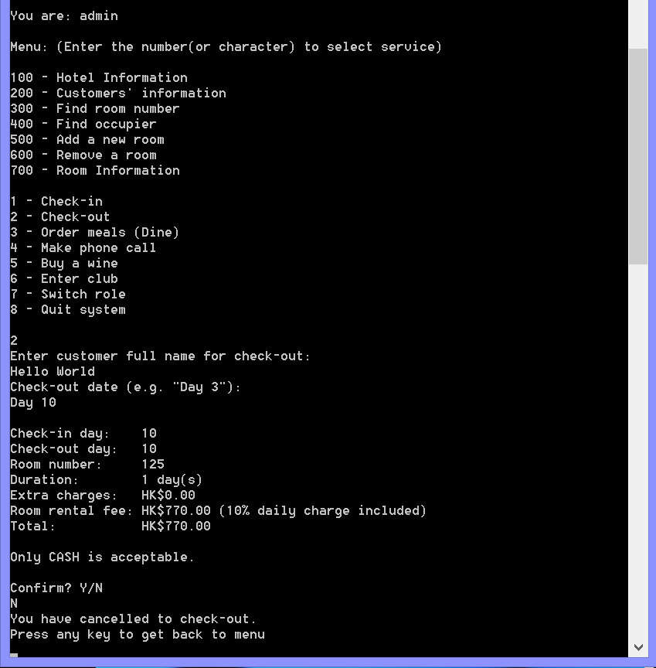

Check-out successfully

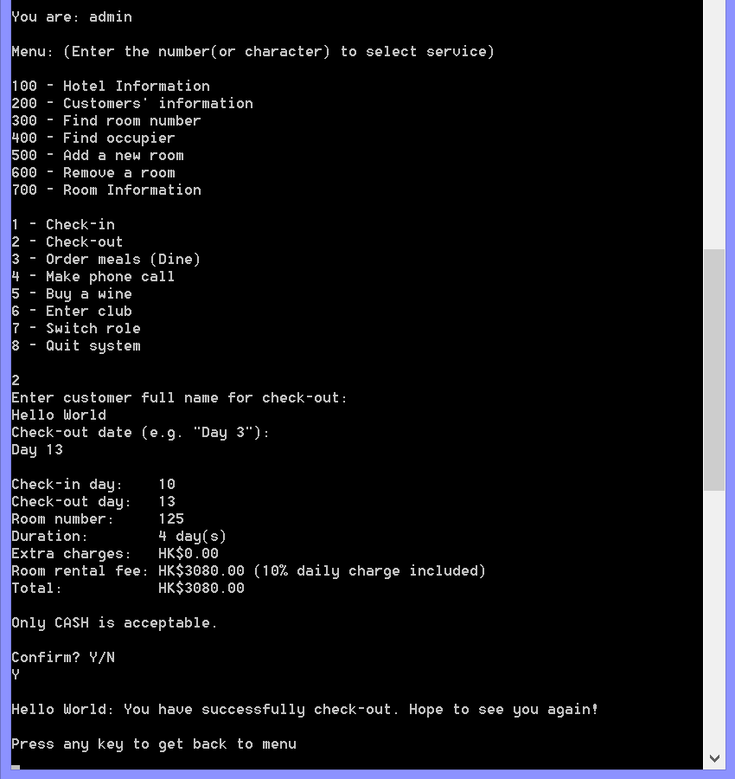

Result: increment on hotel room numbers after check-out

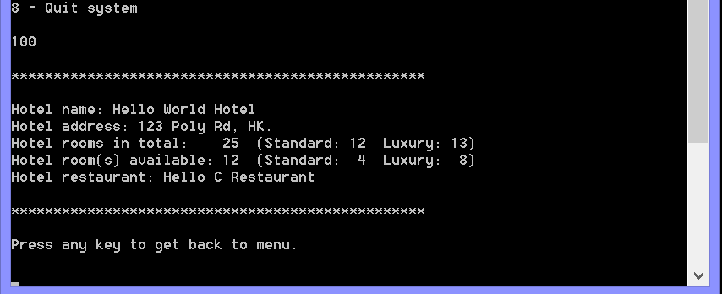

Result: updated customers’ records after check-out

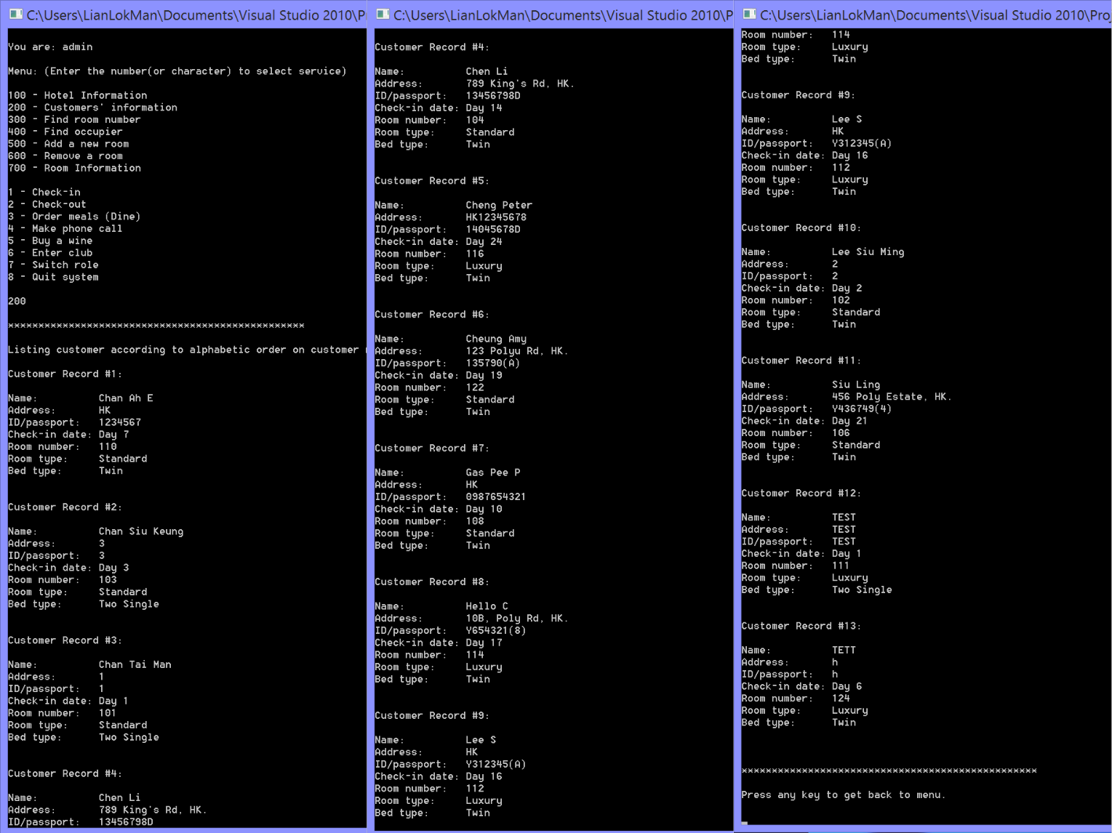

Result: customer’s (who checked-out) record is removed successfully

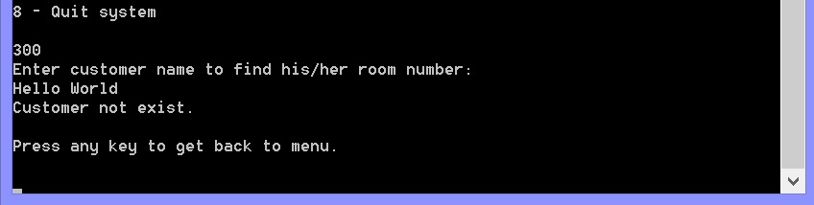

Result: customer’s room is now available

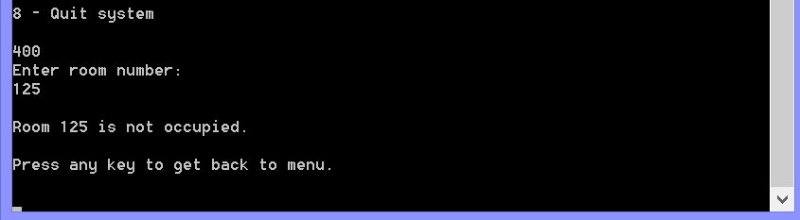

Result: updated room information on room 125

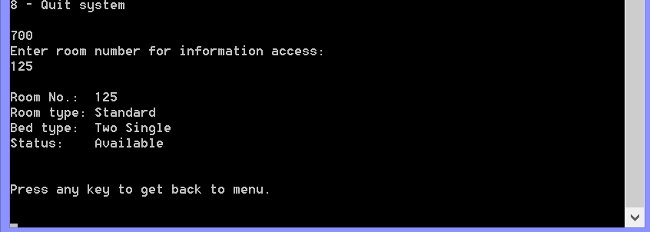

Result: updated text files after check-out

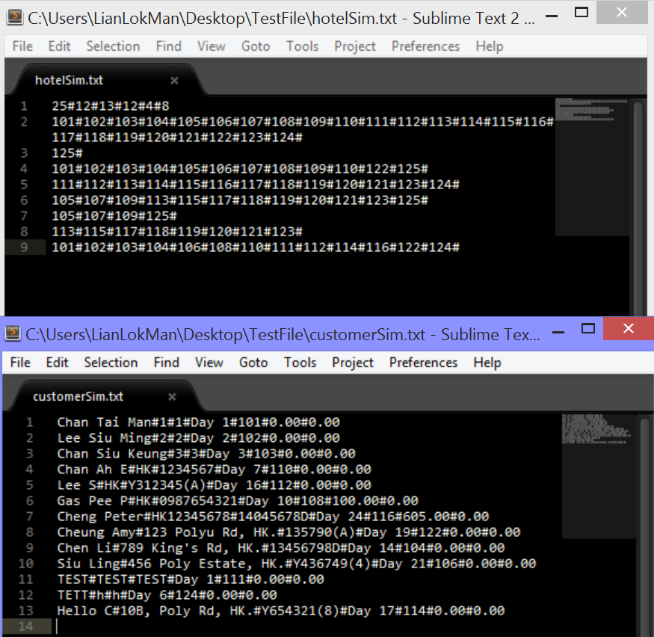

Check-out case 2 (customer with accumulated charges)

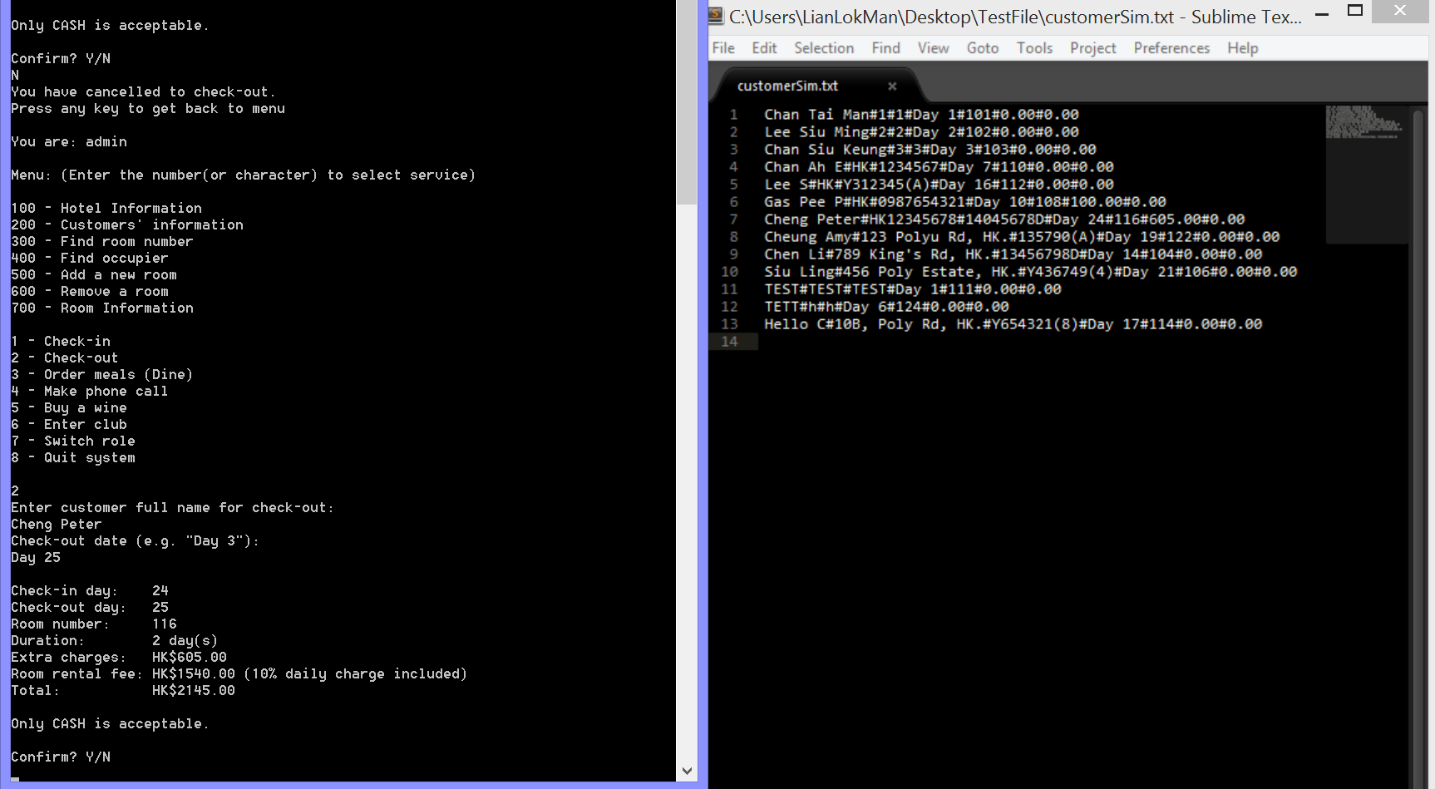

Input validation on confirmation (check-out function loop again if user’s input is not “Y” or “N”)

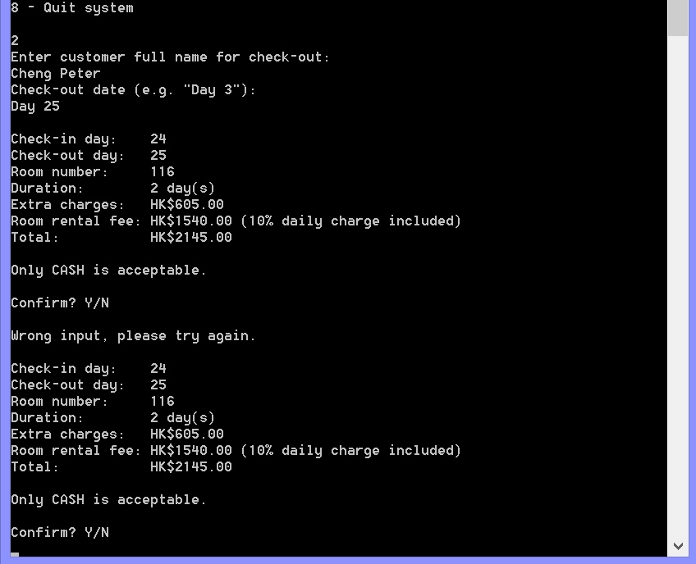

Check-out successfully

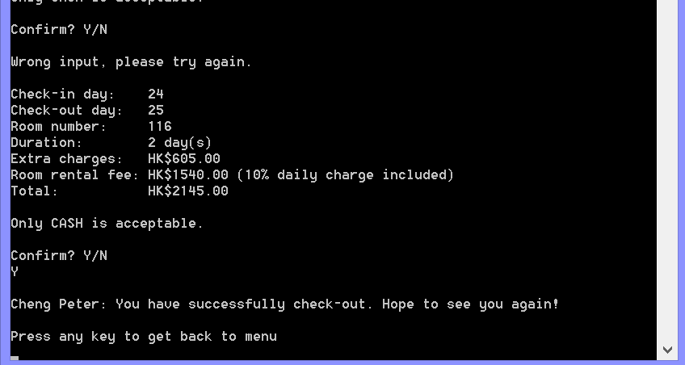

Updated text files

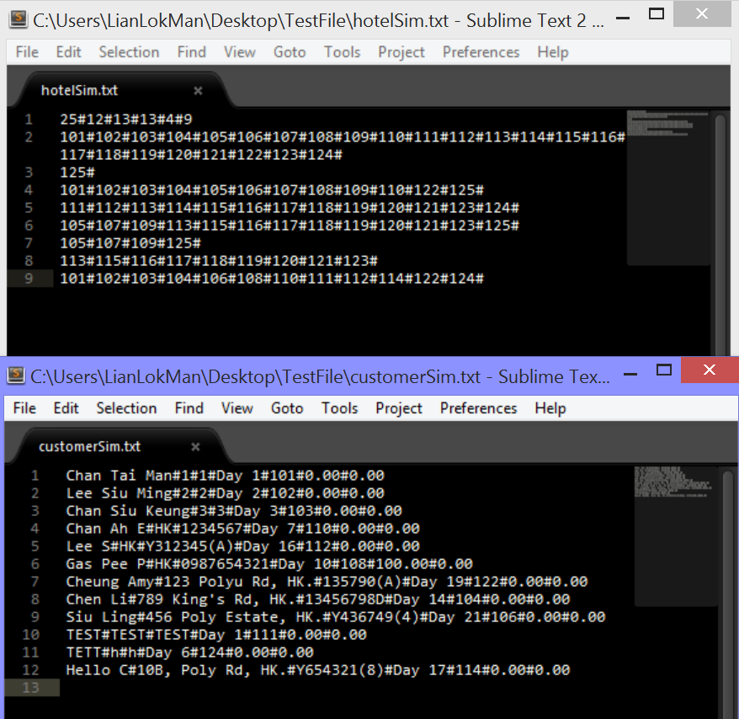

Order meal(s)

Input validation 1 (empty/space/invalid inputs)

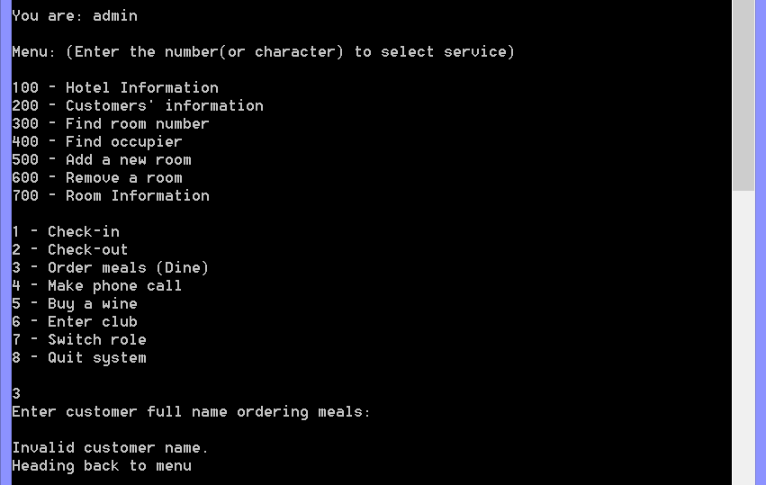

Input validation 2 (invalid number)

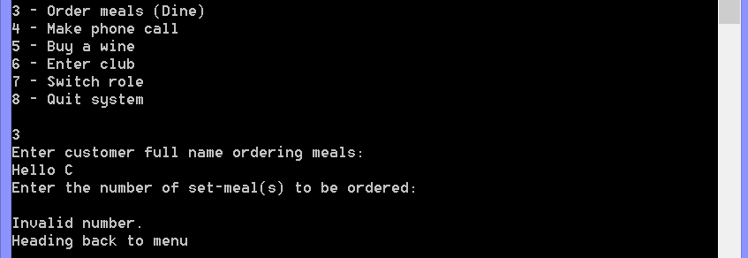

Input validation 3 (string input)

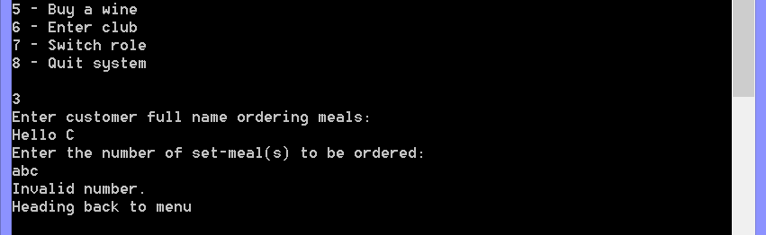

Input validation 4 (invalid order amount)

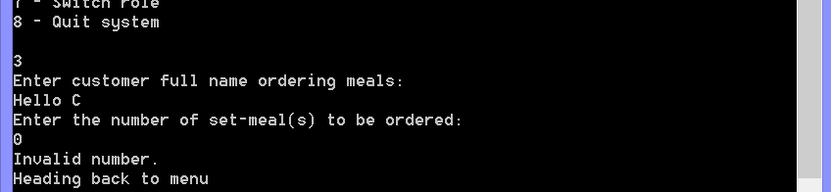

Input validation 5 (invalid order amount: exceeds maximum)

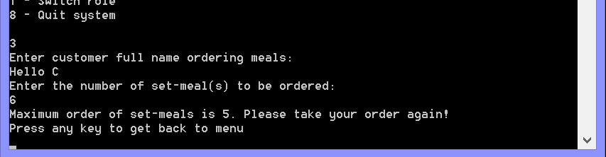

Input validation 6 (invalid confirm input (not “Y” or “N”)) and cancel ordering

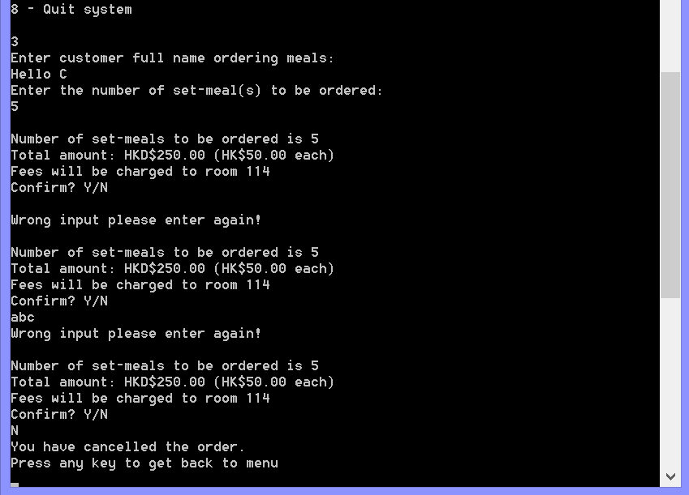

Order set-meals successfully

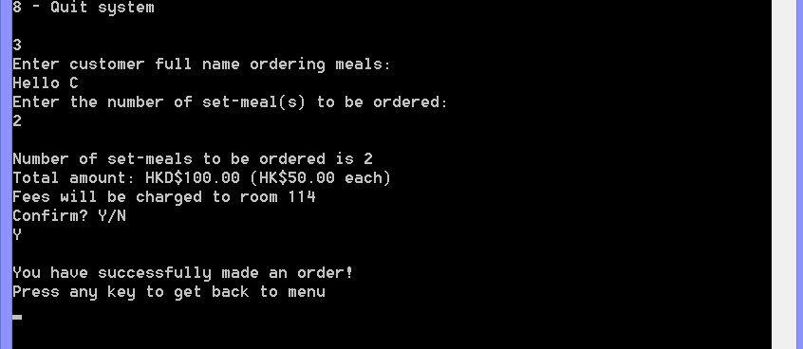

Updated customer text file (updated accumulated charges after order meals $100)

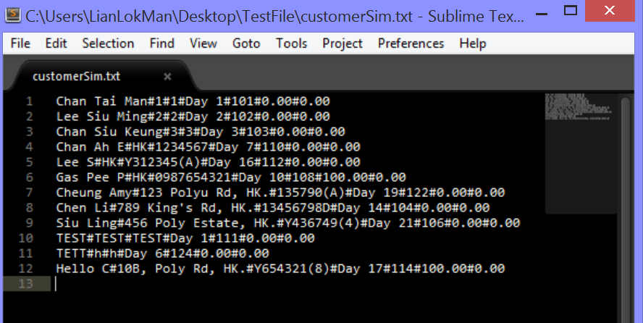

Make a phone call

Input validation 1 (empty/space inputs/invalid customer name (non-exist customer))

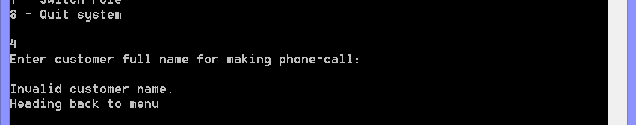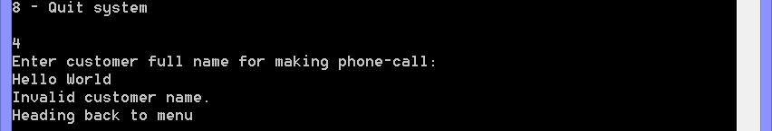

Input validation 2 (invalid duration on phone call)

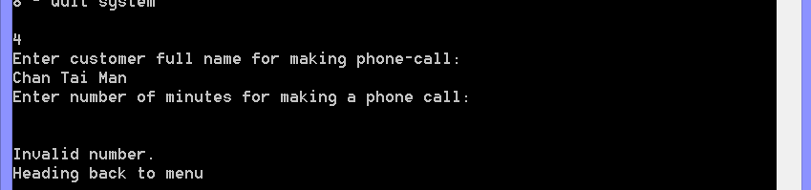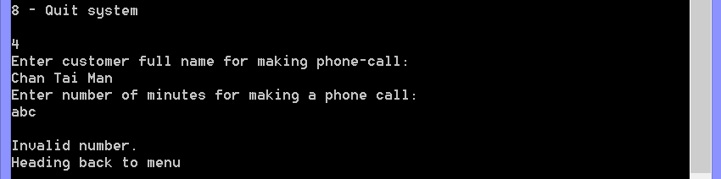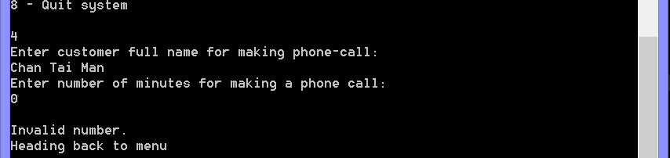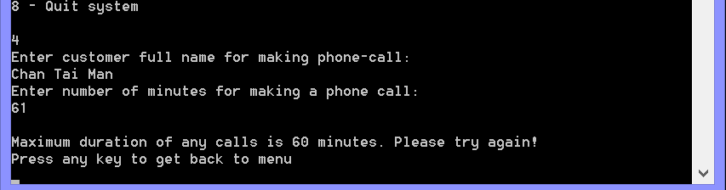

Input validation 3 (invalid input on confirmation)

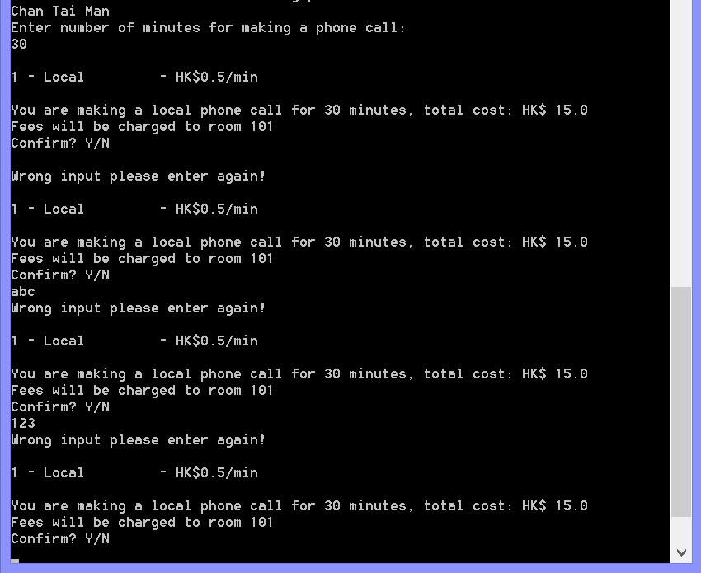

Cancel to make a phone call

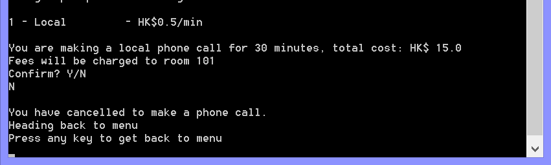

Make a local phone call successfully

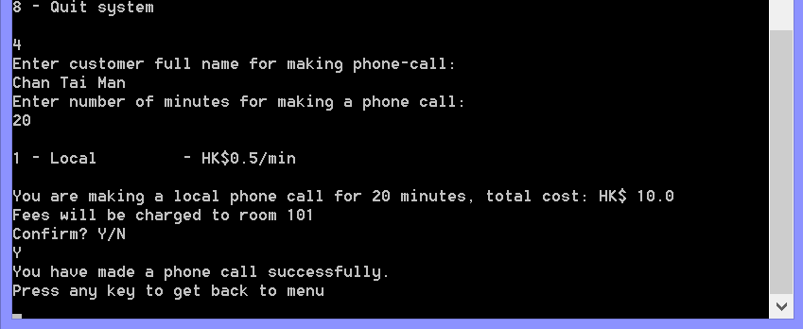

Updated customer text file: customer accumulated charges + $10 (row 1)

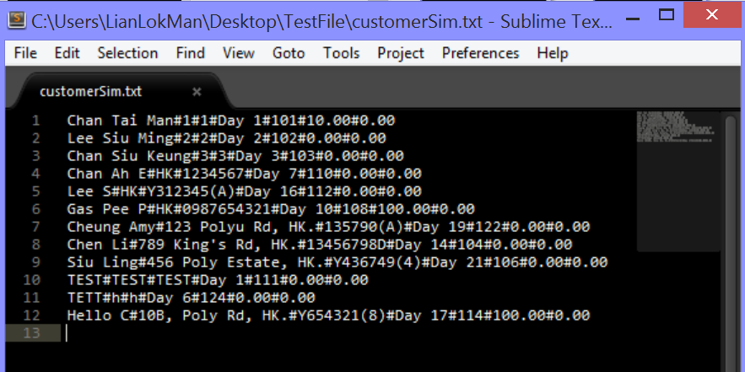

Choices provided to luxury customers

Input validation on choices

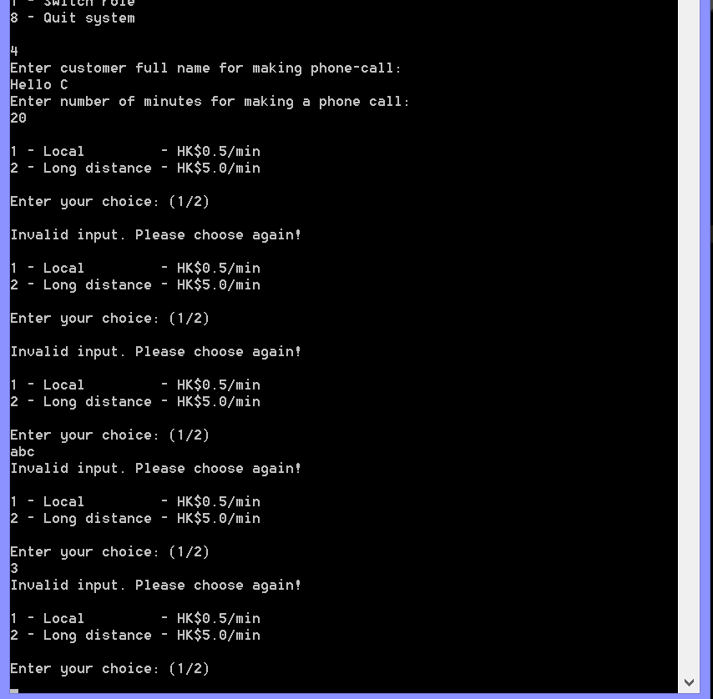

Make a long distance phone call successfully

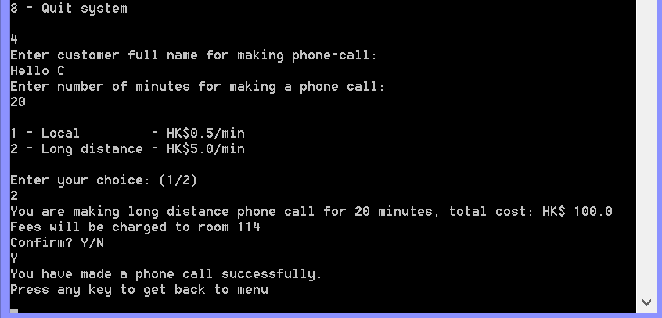

Updated customers text file: accumulated charges +$100 (row 12)

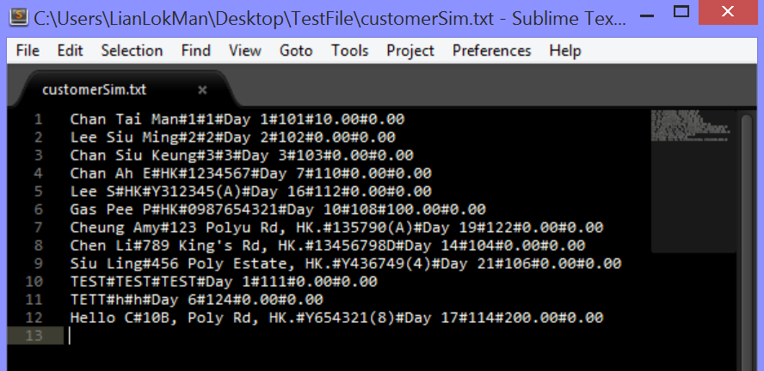

Order wine

Wine ordering denied (customer not in luxury room)

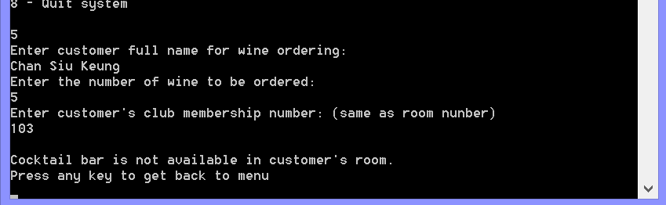

Input validation 1 (empty/space input, invalid order amount)

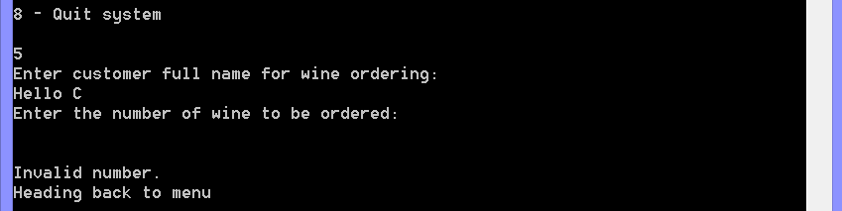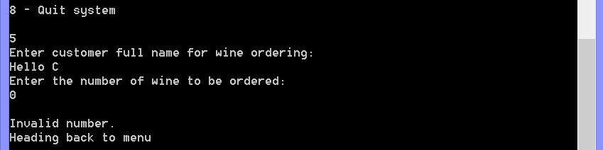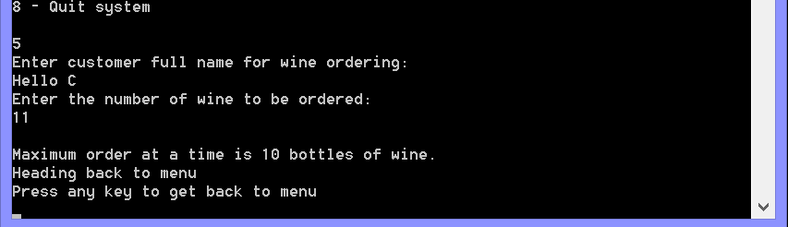

Input validation 2 (invalid club membership number (room number))

Room numbers listed on right-hand side

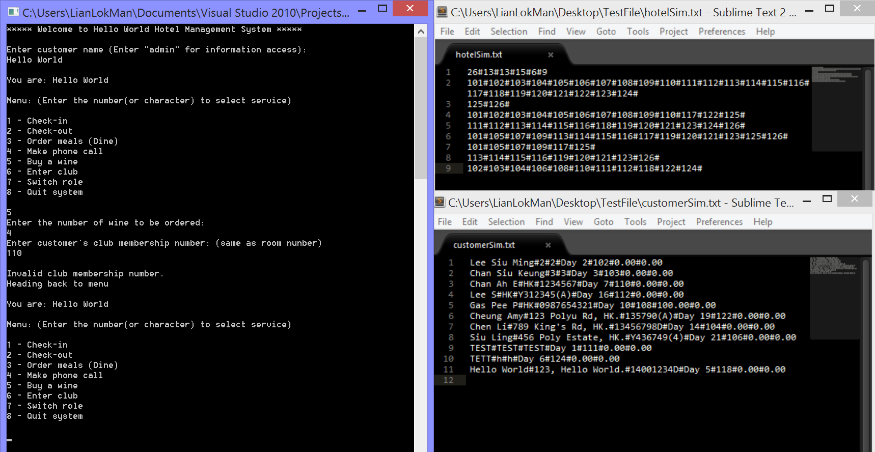

Cancel wine ordering

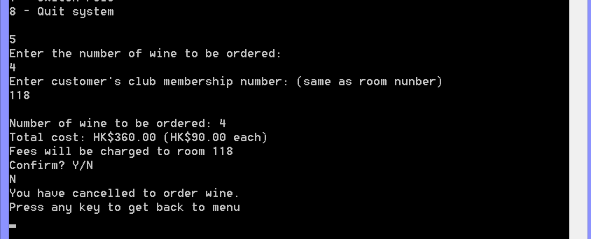

Order wine successfully

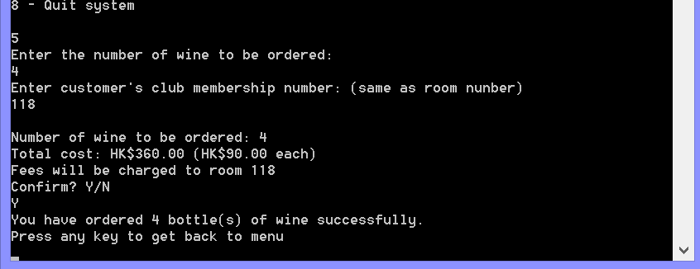

Updated customer text file: accumulated room charge = $360

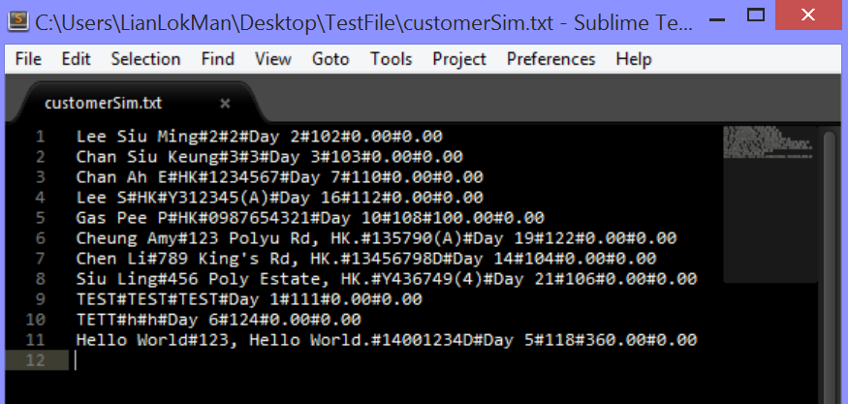

Enter club

Club entrance denied (customer not in luxury room)

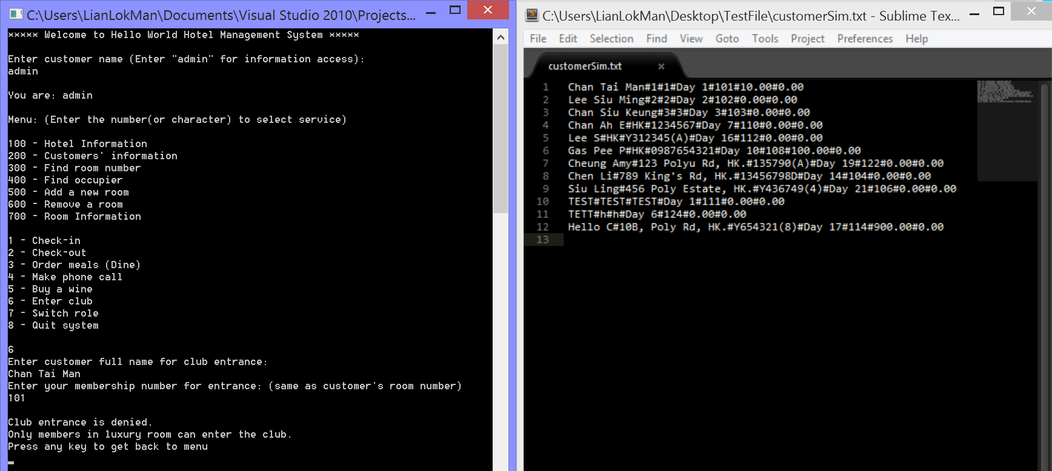

Input validation 1 (invalid membership number) (number and room number did not match)

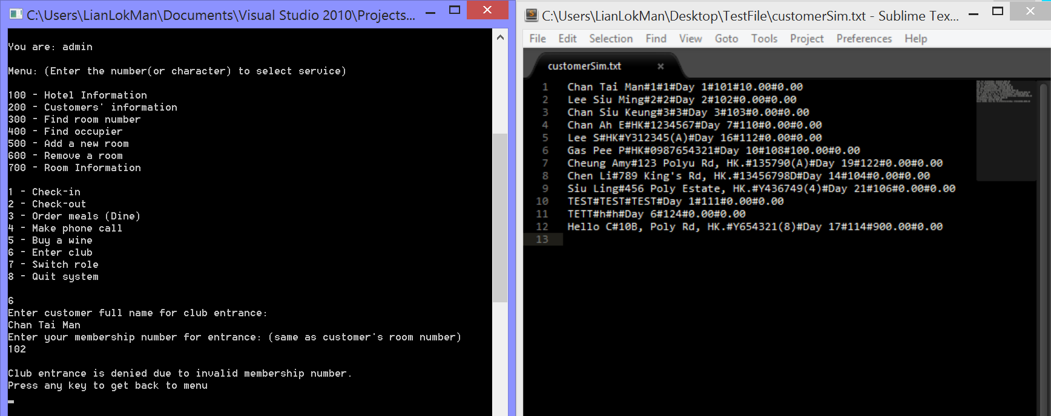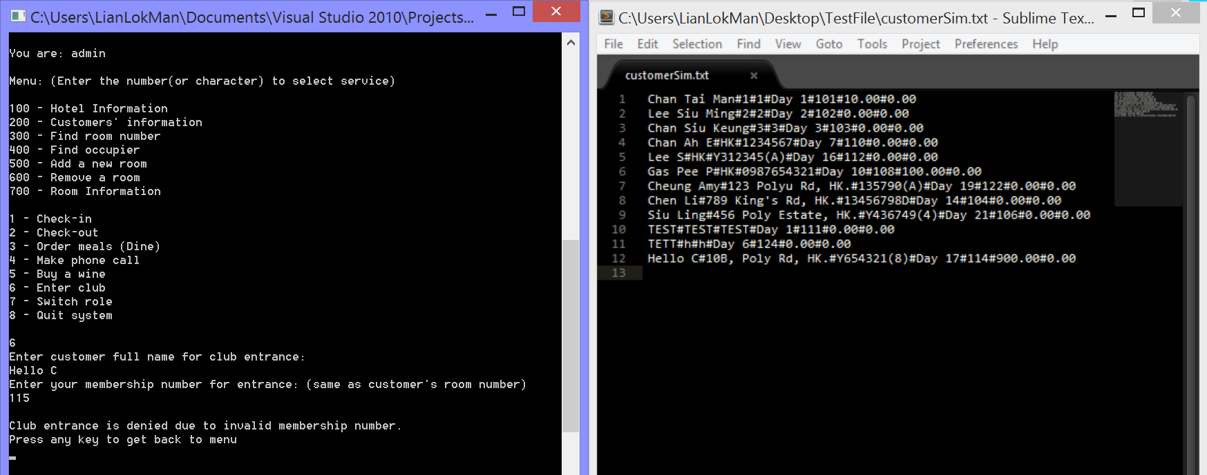

Cancel club entrance

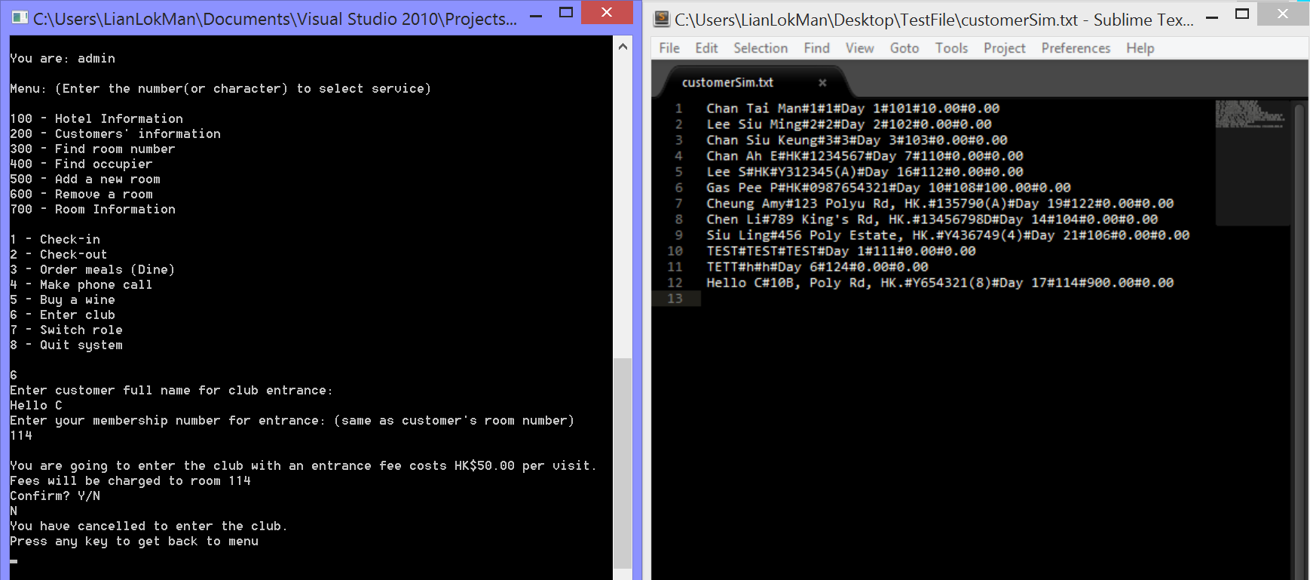

Enter the club successfully

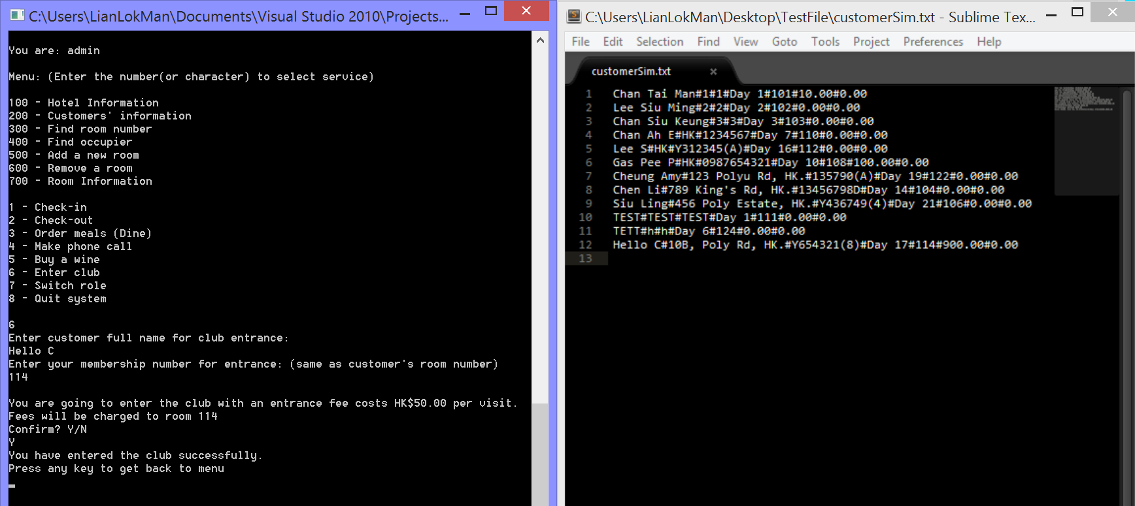

Updated customer text file: accumulated charge

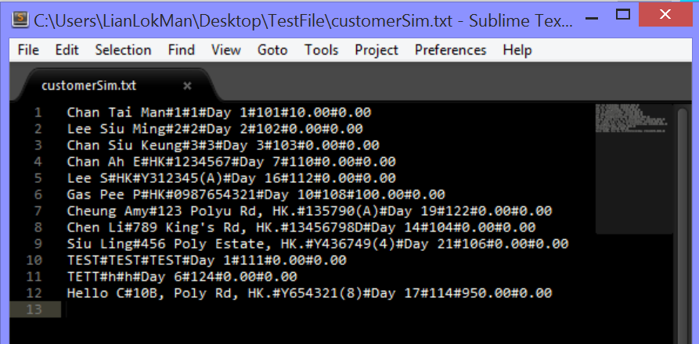

Switch role

Input validation 1 (empty/space inputs)

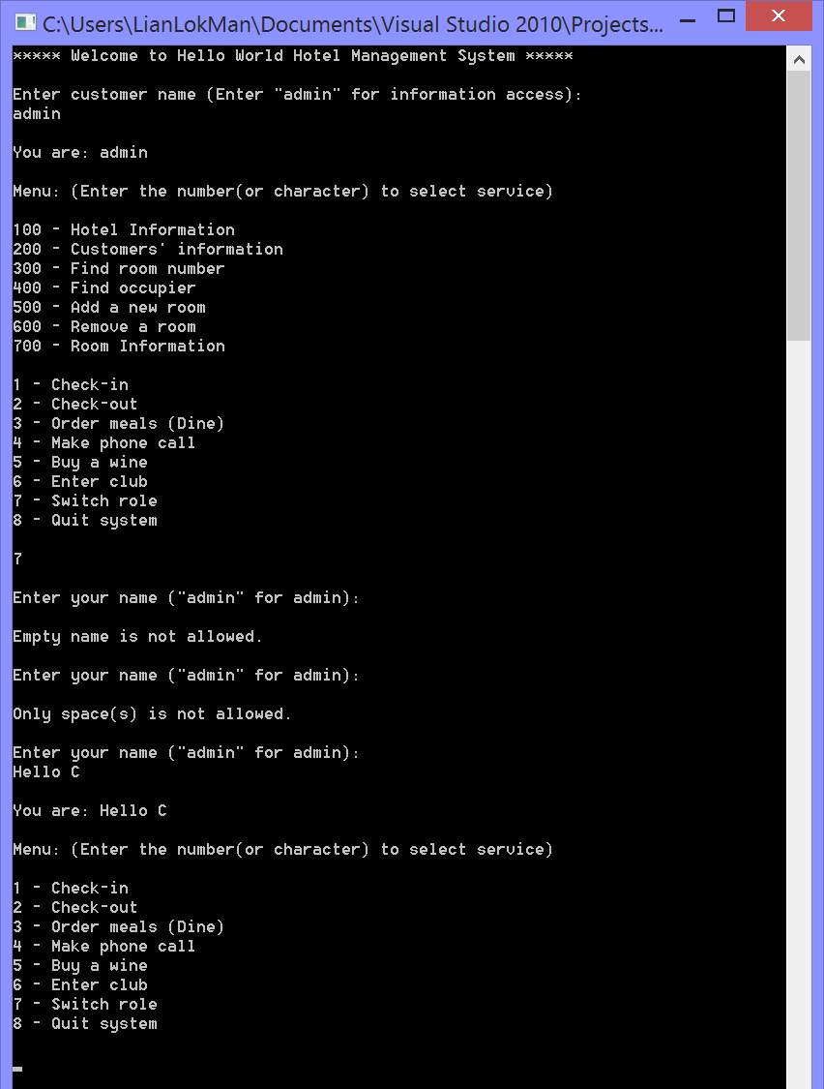

Role switched successfully (from customer to admin)

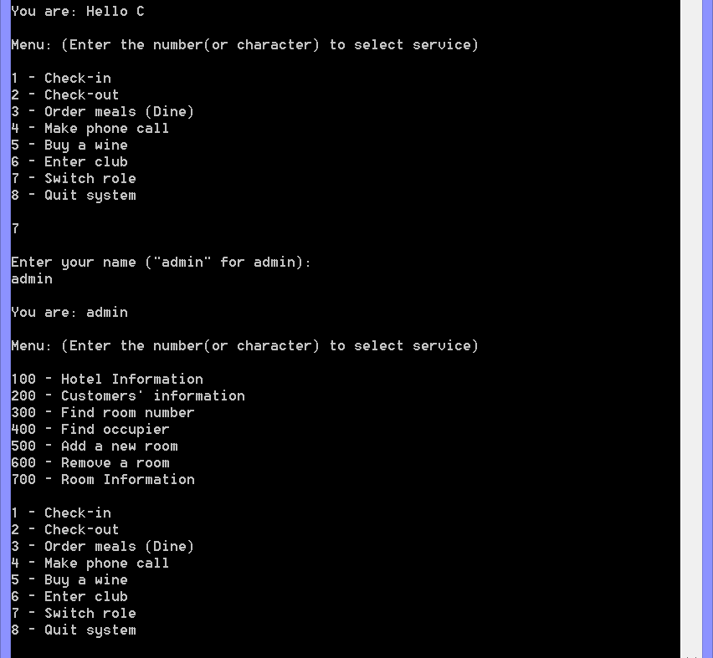

Quit system

Cancel quitting system

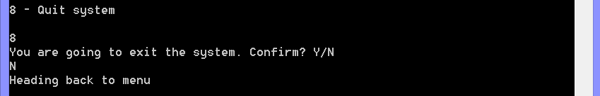

Quit system successfully

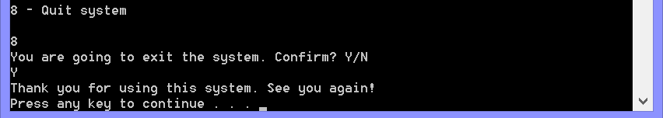

1. Role: Exist customer in standard room

Check-in

Input validation 1 (customer has already checked-in)

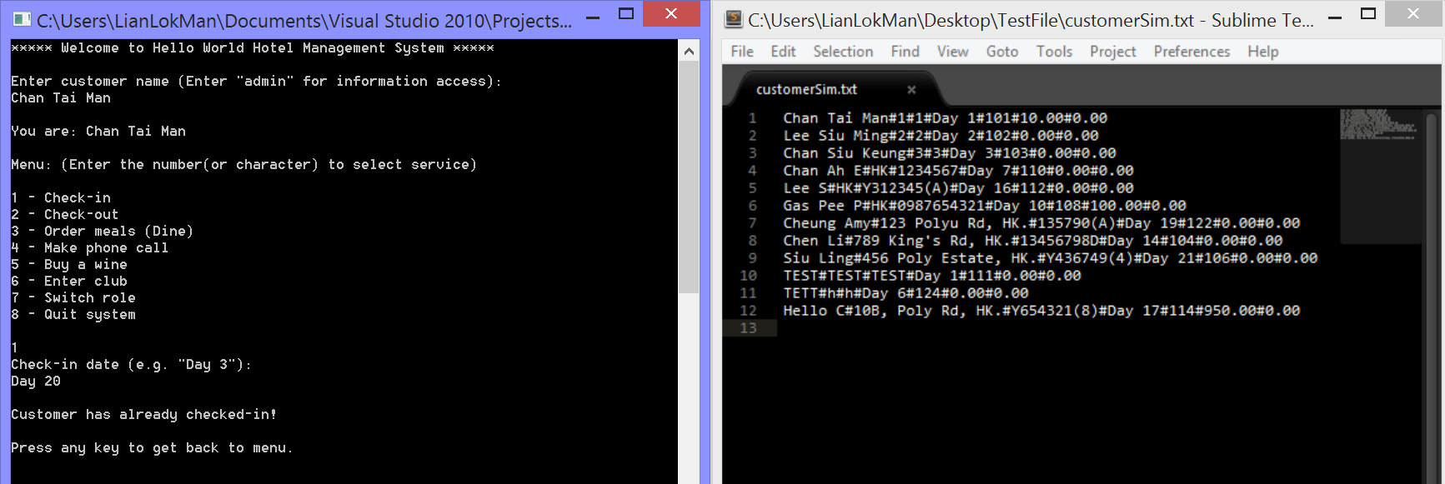

Order set-meal(s)

Meal ordering, accumulated charges + $150

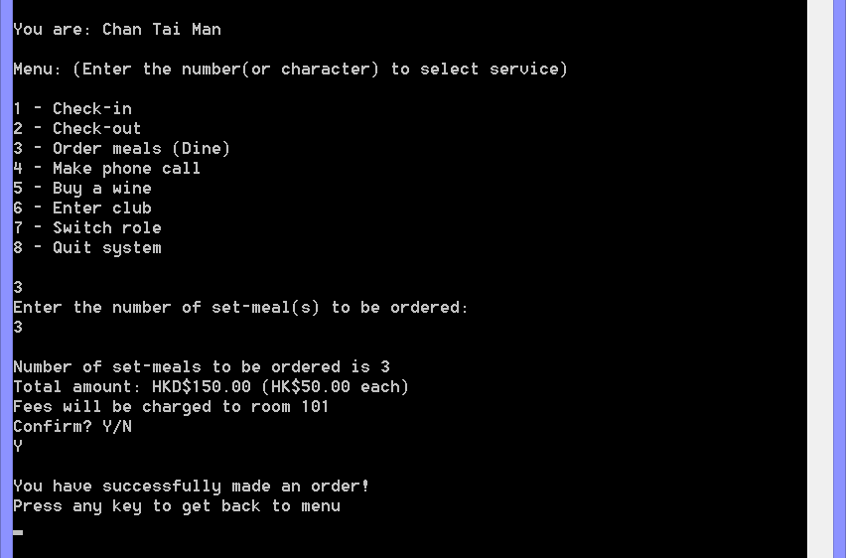

Make a phone call (local) +$25.0

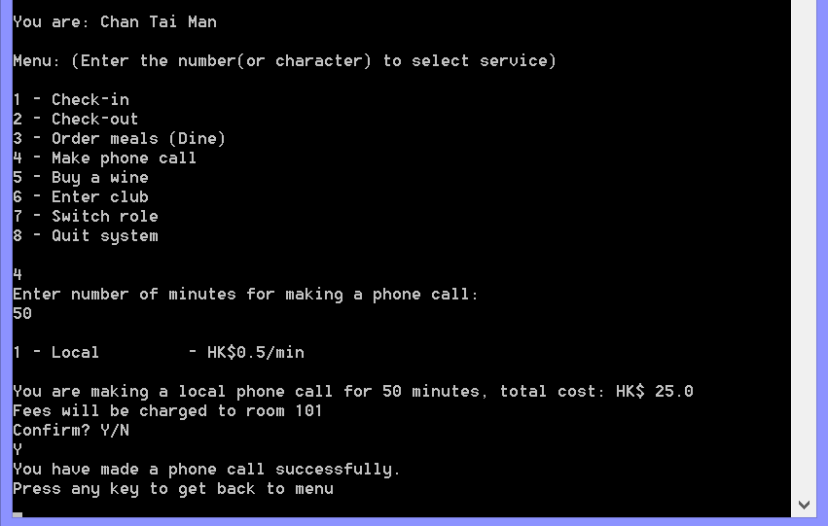

Order wine (denied)

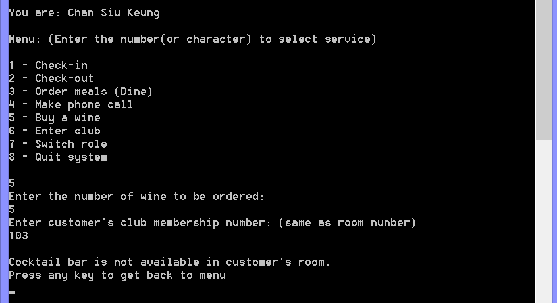

Club entrance (denied)

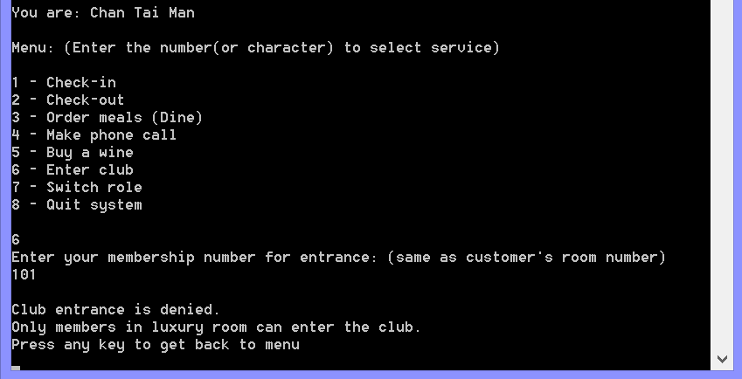

Check-out (in the same test case, without exiting the program)

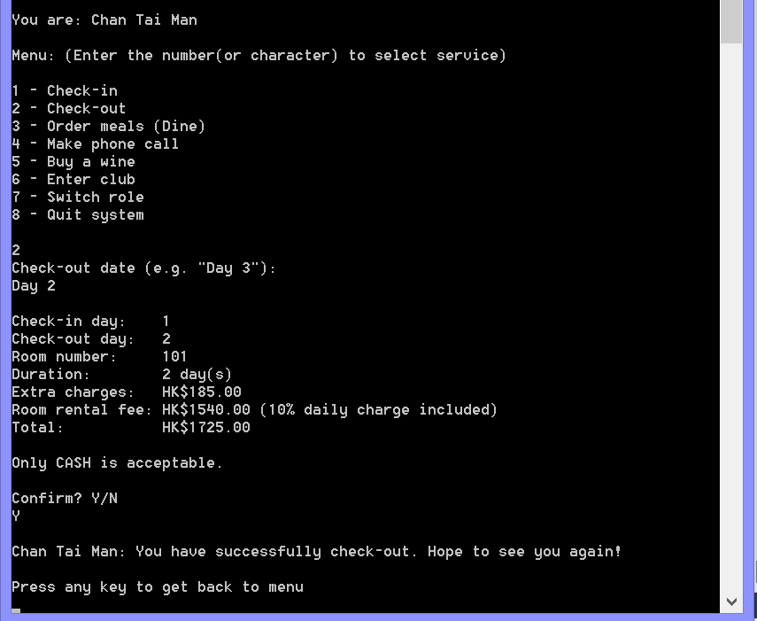

Updated customer text file

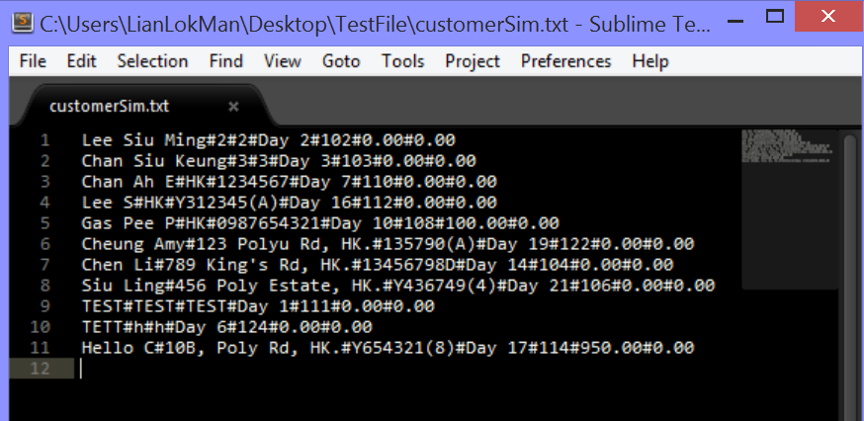

Current user name did not change, if choose check-out again, program will ask for customer name for check-out

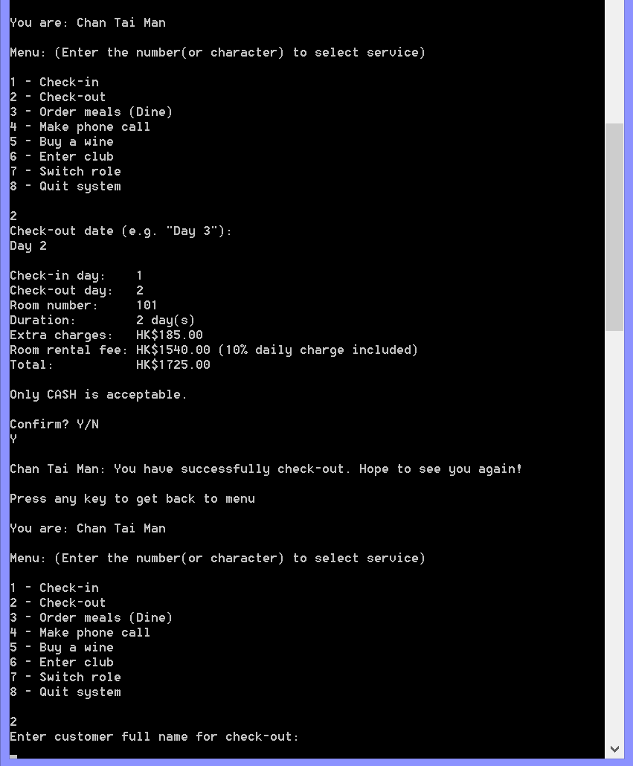

Check-out successfully (cannot check-out again)

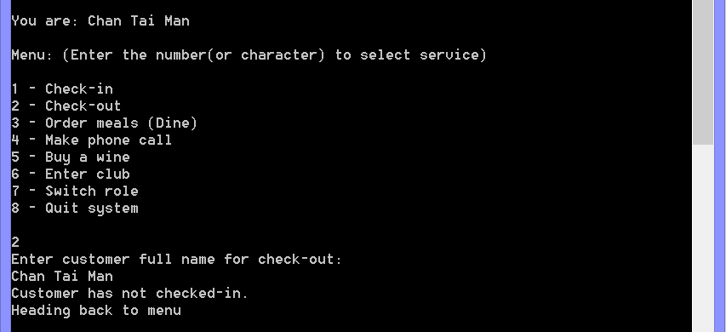

Updated customer records after checked-out

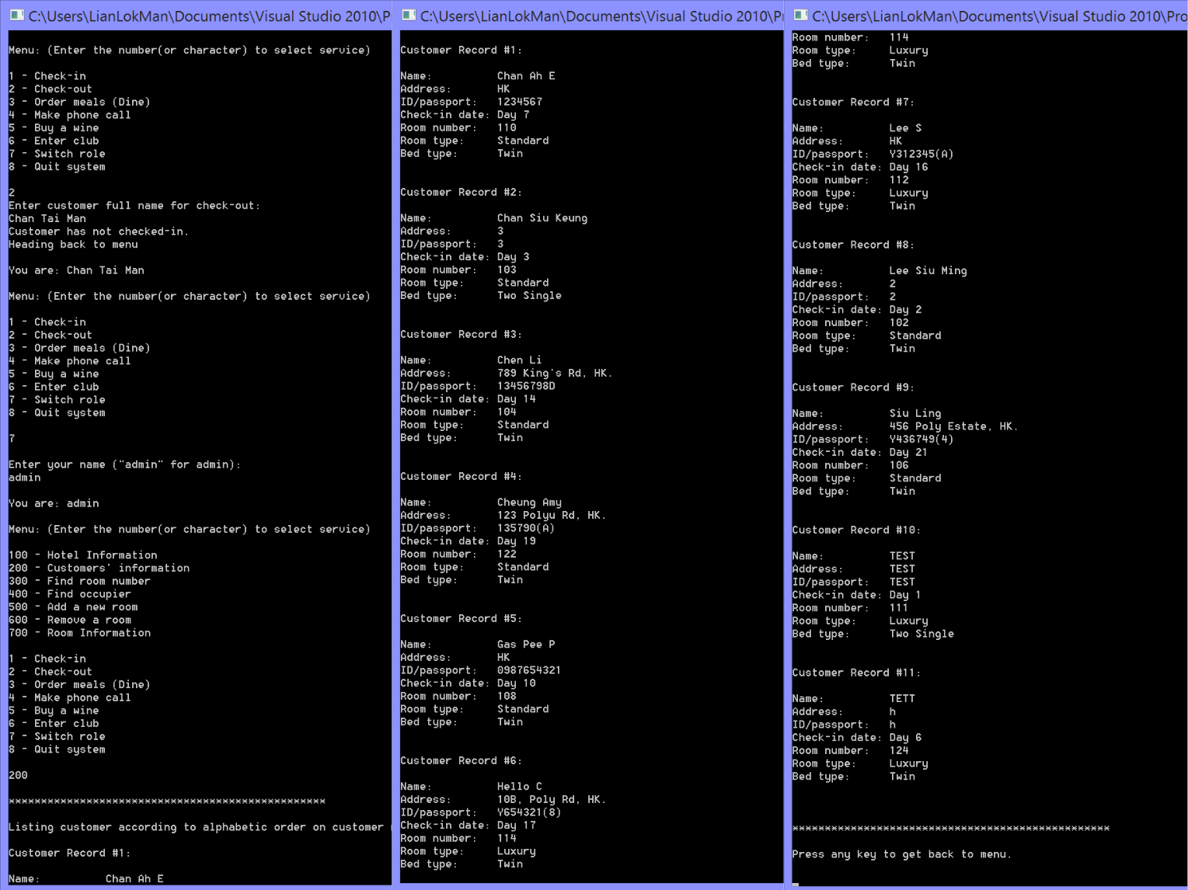

1. Role: Exist customer in luxury room

Check-in

Customer already checked-in

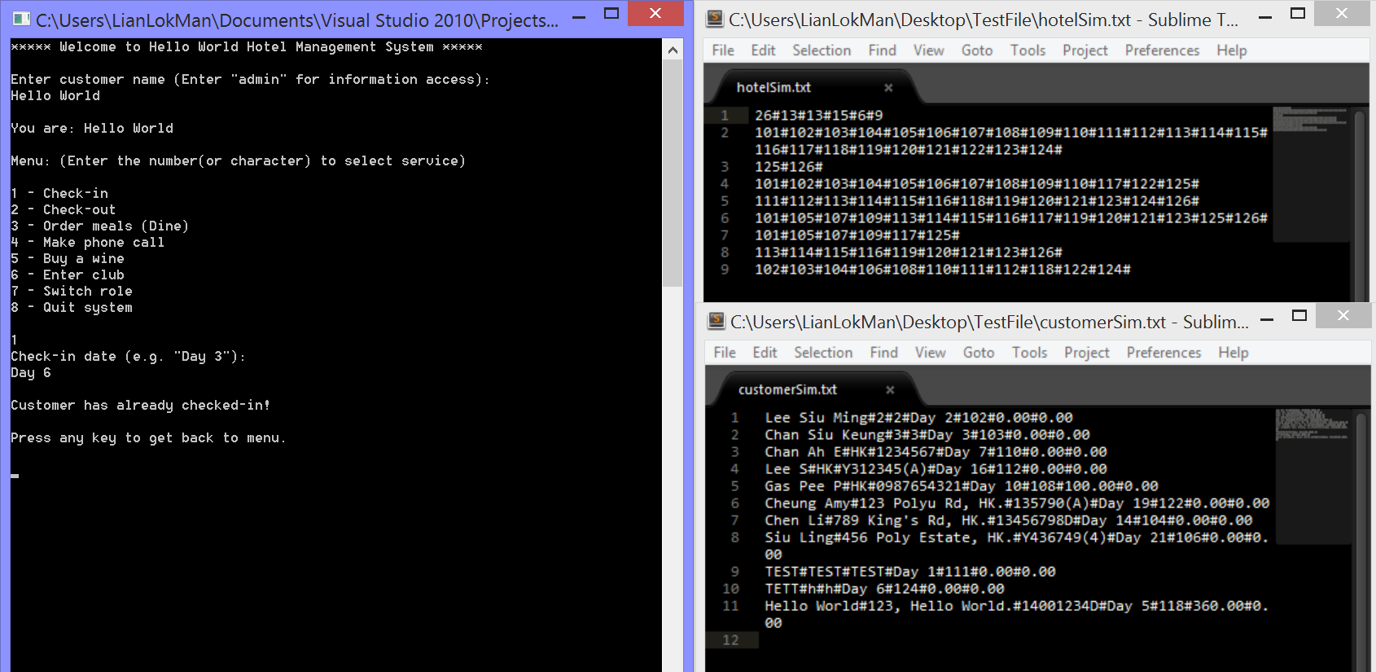

Order set-meal(s)

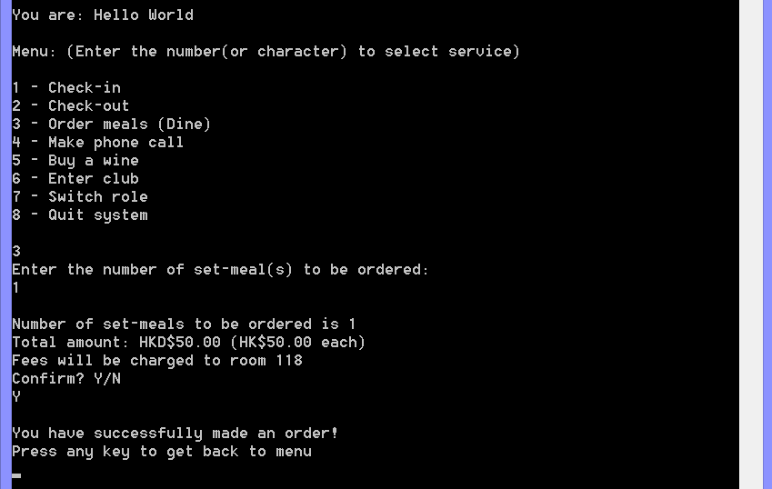

Make a phone call (local and long distance) +$50.0 + $20.0

Long distance phone call

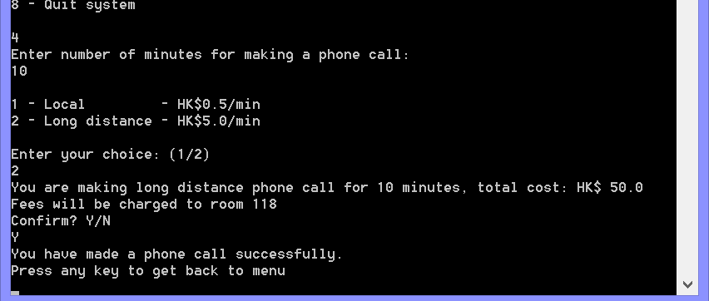

Local phone call

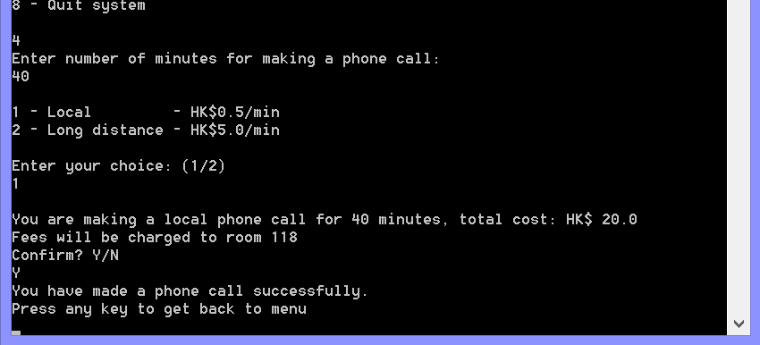

Order wine

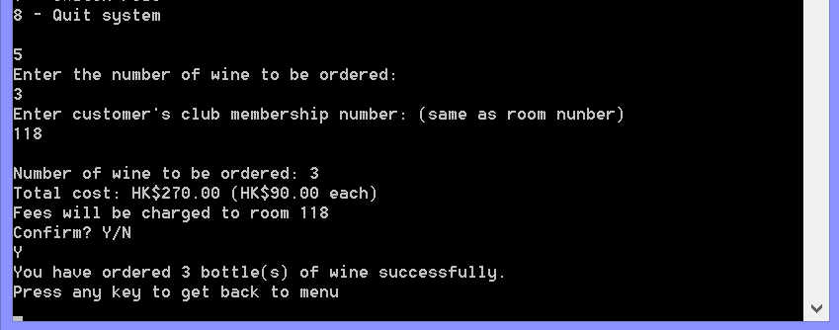

Club entrance and quit system

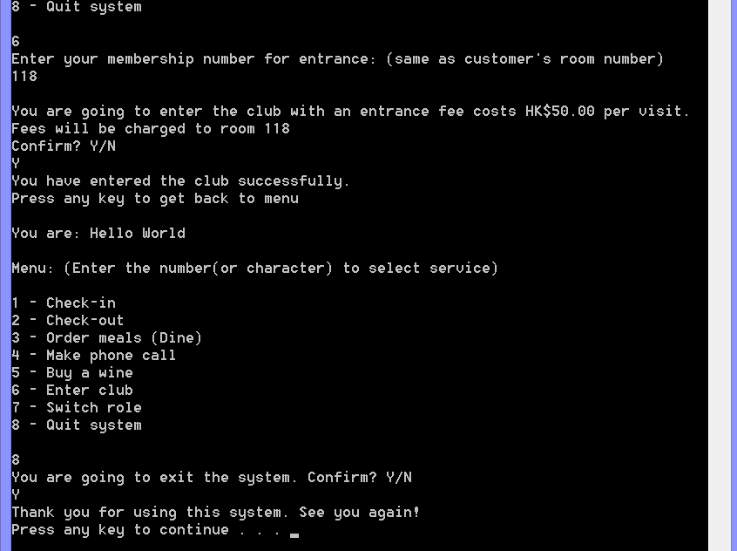

Updated customer’s room charges

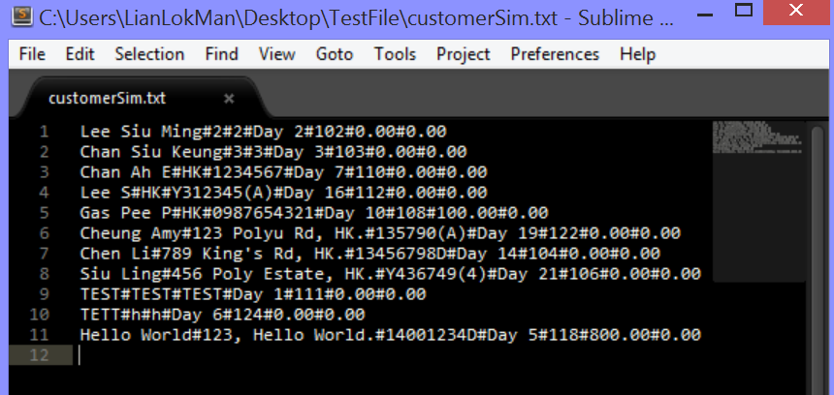

End the program first, then restart the system and check-out

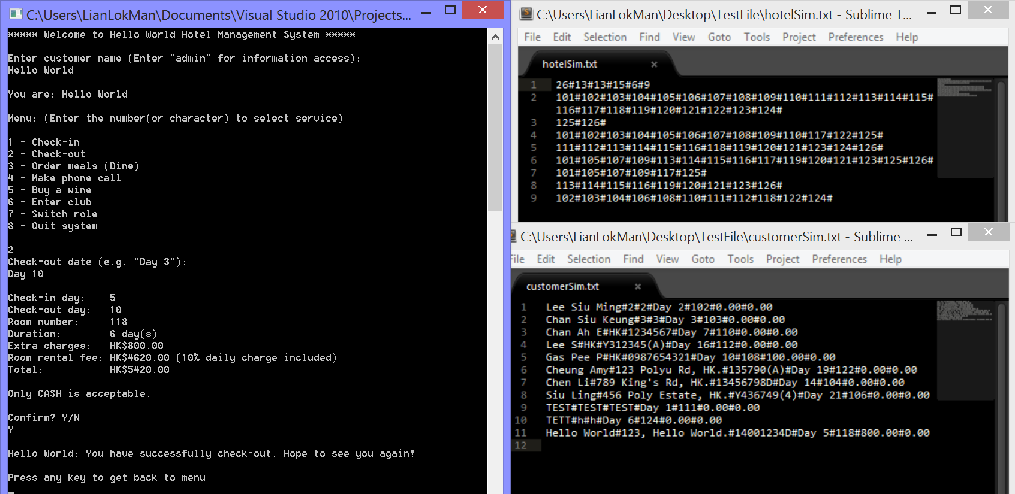

Updated text file after checked-out

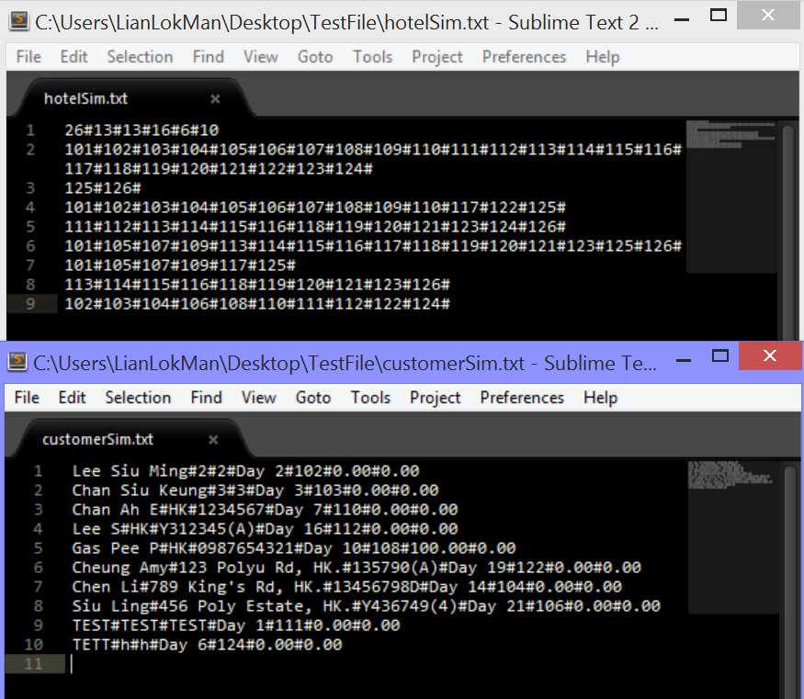

1. New customer (no record in the hotel)
2. Check-out

Customer has not checked-in

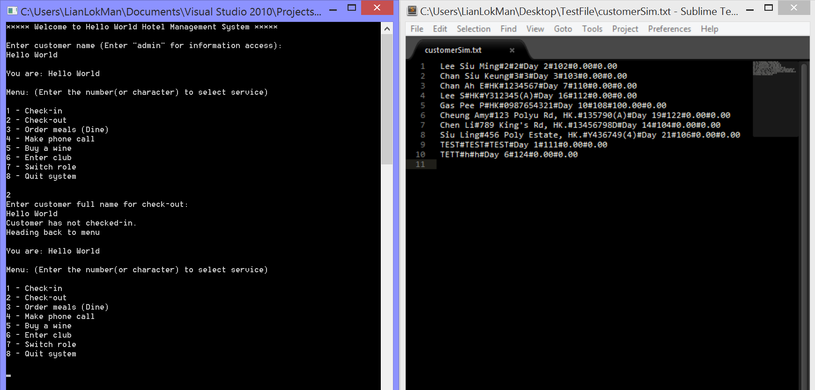

1. Order set-meal(s)

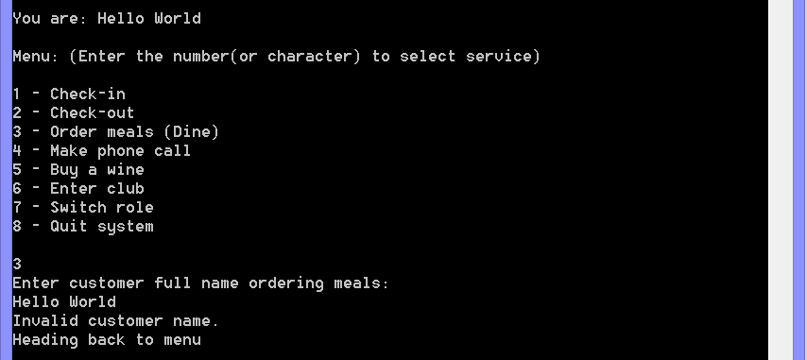

1. Make a phone call

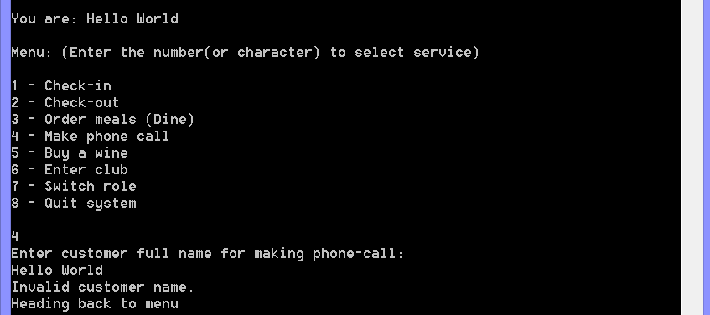

1. Order wine

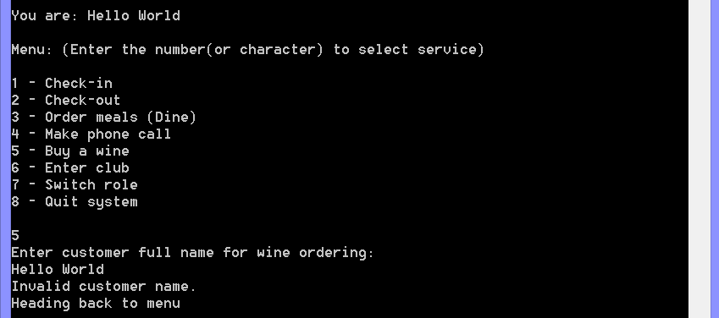

1. Club entrance

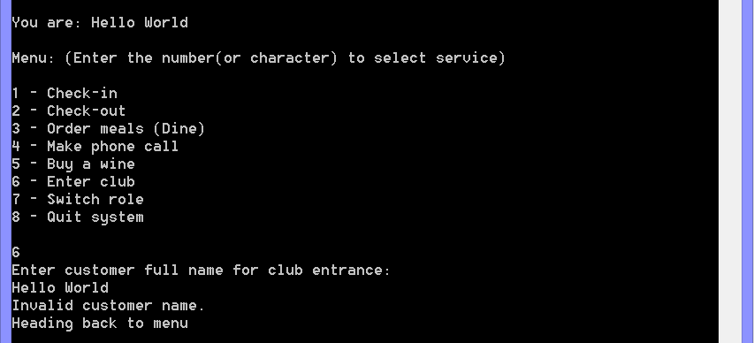

1. Check-in

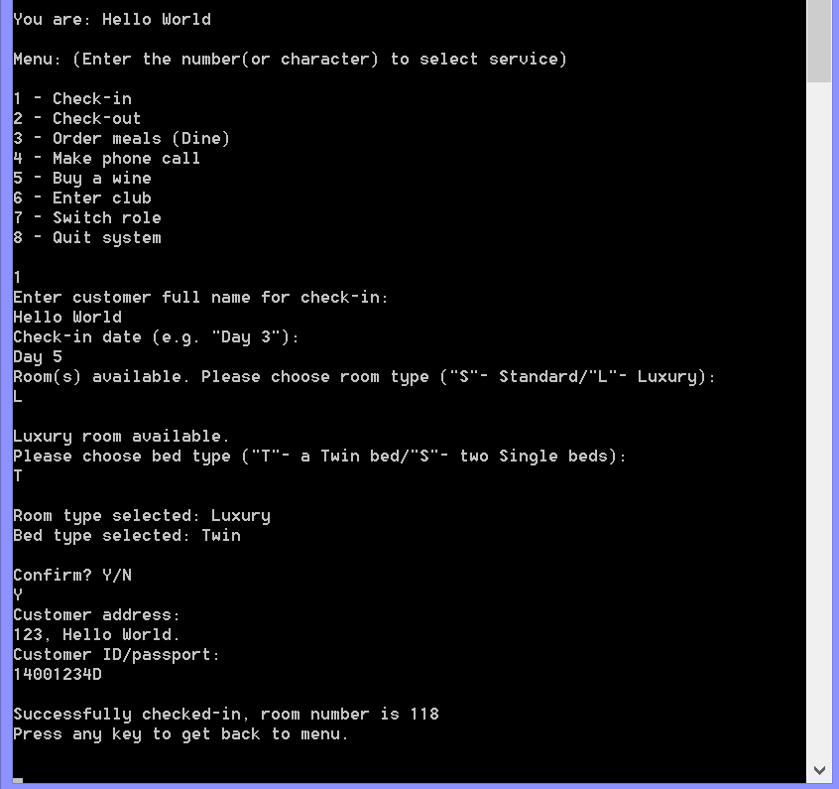

1. Updated text file after checked-in

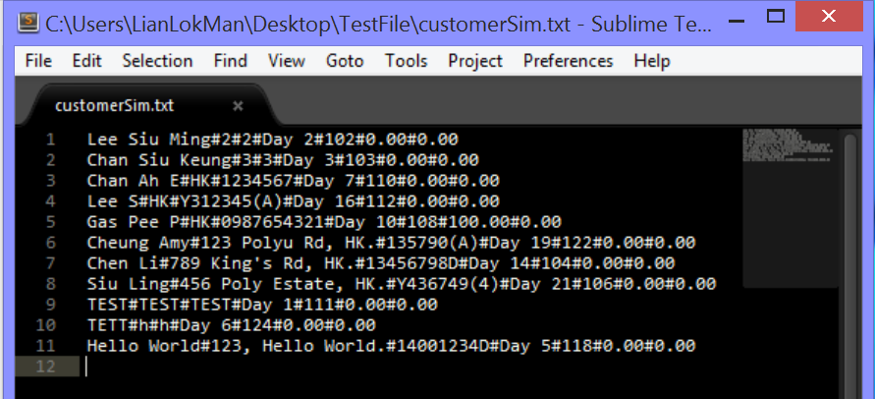

1. Customer information

Updated customers’ records after checked-in

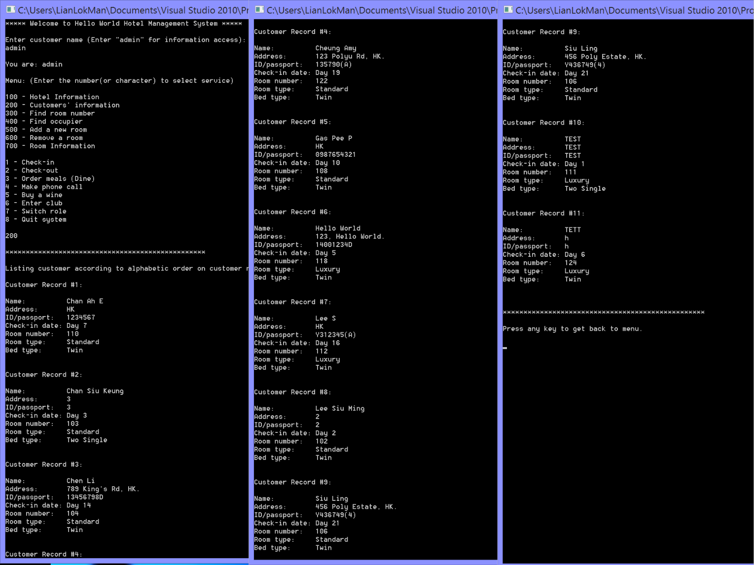

**Special Test Case – remove a room and build a new one**

in this case, a room will be removed and a new room will be built. This case prove that the program can find any skipped room numbers (which has been removed due to renovation before) and assign the skipped number as new room number when another new room is built.

1. Remove room 117

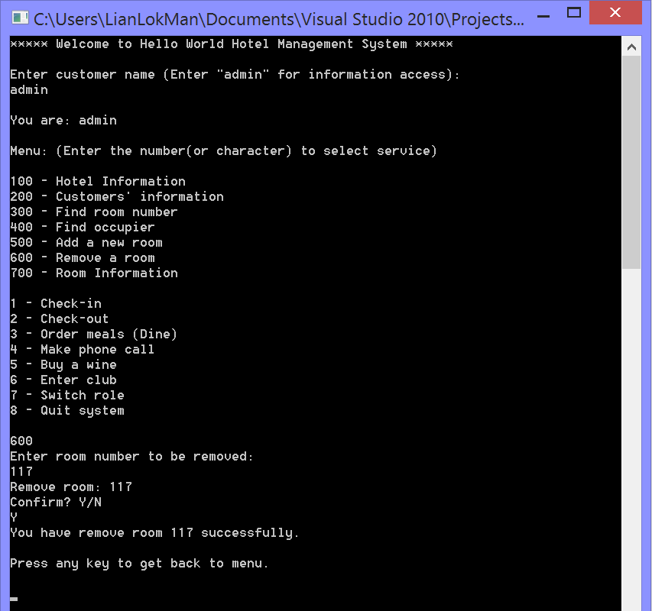

1. Updated hotel text file (117# removed)

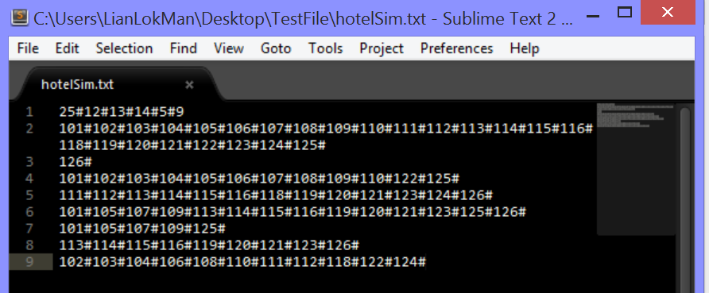

1. Add a new standard room, room number is assigned to be 117, which is the skipped room number as shown in the hotel text file on right-hand side

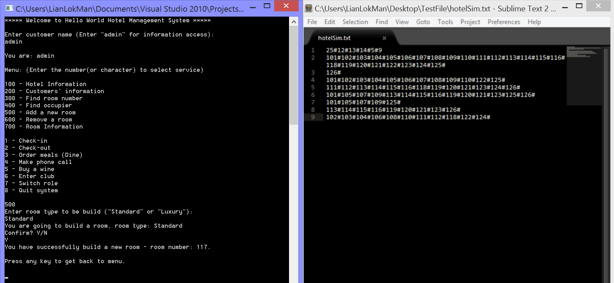

1. Updated room information, room 117 is available and is standard type

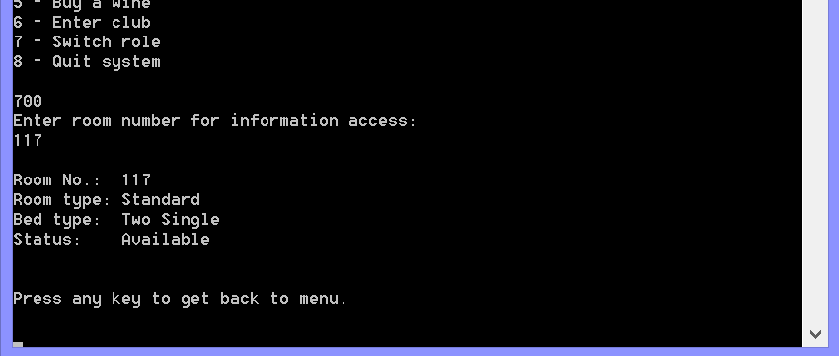

1. Updated hotel text file, 117# inserted into appropriate arrays

